












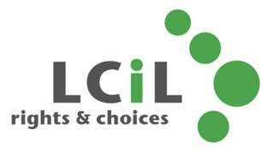

LCiL News
A u t u m n 2 0 2 6

Contents
Hello!
Welcome to new team LCiL Volunteers win award PA Survey
Our Digital Health Survey Peer Support Groups Canny Chef recipe
DAIS Service Info
New Energy Advice Service How we can support y ou Support our Work Membership / Contact Us

M O R E I N F O
Volunteers receiving award from Lord Provost (Page 5)

We hope you had a lovely summer. As autumn begins, we're pleased to welcome you back with our latest newsletter and all our news.
We're delighted to share that LCiL Volunteers have been recognised for the excellent work they do, receiving Volunteer Edinburgh's Ian McGinnes Award for Inclusion and Diversity. (Image above) (Read more on Page 5)
Remember, we're here to support you. Visit our website for the latest information about LCiL services, events and peer support groups near you.
S H A R E Y O U R N E W S
If you have any news that you would like to include in future newsletters, please email: communications@ lothiancil.org.uk
or call: 0131 475 2350. We'd love to hear from you!

W W W . L O T H I A N C I L . O R G . U K | 0 1 3 1 4 7 5 2 3 5 0 1







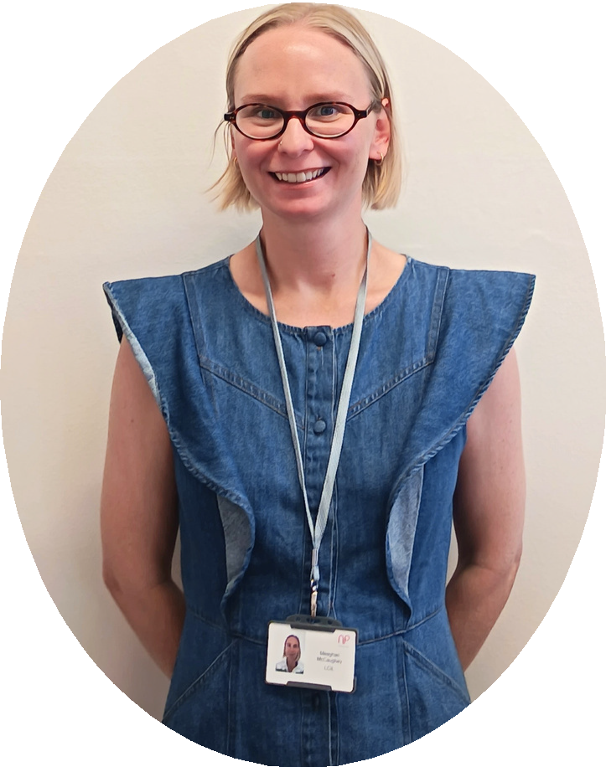
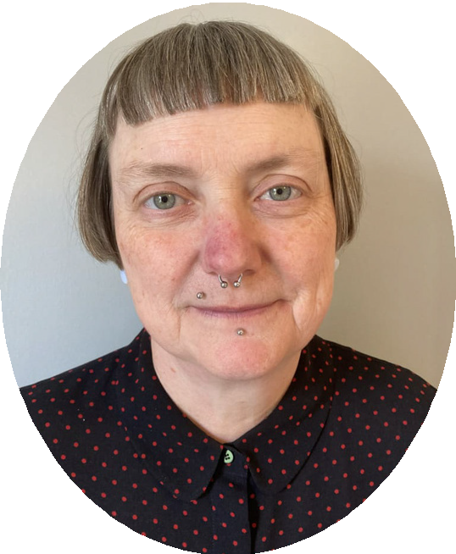

Welcome to LCiL's new team members!
We're delighted to welcome new staff to LCiL!

Natasha Stilwell
PA Support Coordinator - Independent Living Service
Hi, I'm Tash. My role is a partnership between LCiL and VOCAL (Voice of Carers Across Lothian). I support disabled people with becoming an employer; I will also be working on a new pilot project which will hopefully result in supporting and recruiting more PAs to the role. I have worked as both a PA and a PA Coordinator in the past and have been allied with the independent living movement.

Indigo Williams
Welfare Advice and Community Brokerage Officer - Disability Advice and Information Service
I'm excited to join the LCiL team in this new role,
as Welfare Advice and Community Brokerage Officer. I'm looking forward to bringing a person-centred approach to welfare advice and community support, helping people find clear information and practical guidance on a case by case basis.

Meaghan McCaughey
Volunteer Coordinator and Training Officer - Disability Advice and Information Service
Hi, I coordinate the volunteer programme and co-facilitate workshops for LCiL's Volunteers.
I am most interested in work that has a direct, positive impact on my community and the work LCiL does felt like a wonderful fit for both my values and my work experience. I am most looking forward to meeting and getting to know our volunteers; I have
heard so many wonderful things! 2








Welcome to new team members!

Lisa Jennings
Welfare Advice Officer -
Disability Advice and Information Service
As Welfare Advice Officer, I will be supporting people to access the welfare and benefits they may be entitled to, and advising on how to maximise income and what options people have.
I will be at LCiL's Community Hubs in East Lothian and Midlothian, which makes our services more accessible for those who need it. I will be delivering Welfare Advice with quick benefit eligibility checks and where requested helping people to make applications.
I'm passionate about creating welcoming spaces and conversations where people feel comfortable, listened to and supported. I'm looking forward to connecting with people in our Community Hubs.

Aukse Kerseviciute
Disability Advice and Information Officer - Disability Advice and Information Service
I have a background in supported employment and counselling, and I'm passionate about helping people access the support they need to live independently and confidently.
As a Disability Advice and Information Officer, I'll be providing information, advice and guidance to help people navigate the cost-of-living crisis, understand their rights, and access the financial support and services they're entitled to.
I'm looking forward to being part of a team that has such a positive impact within the community and building meaningful relationships with the people we support.

Rosa Lomar
Peer Support and Learning Facilitator - Peer Support and Learning
I've joined the wonderful PSL team, as facilitator! Peer Support groups are a place for people to get together to share with, and learn from one another - as well as having the opportunity to get information about different aspects of Self-Directed Support.
I'm looking forward to meeting everyone in our Peer Support groups and beyond.
3

LCiL Volunteers win Award!
We are delighted that our Volunteers have won the Ian McInnes Award for Inclusion and Diversity.

This award is for: Celebrating organisations or individuals who champion equality, diversity, inclusion, accessibility, and representation in volunteering. This award honours the legacy of Ian McInnes (1969-2017) and recognises initiatives that remove barriers and create safe, empowering spaces for all volunteers.




















LCiL's Volunteers (a group of lived experience volunteers) were nominated for an Inspiring Volunteer Award. The awards are given by Volunteer Edinburgh for commitment to volunteering in the third sector across Edinburgh.

The nomination was for the work the Volunteers did with Edinburgh Napier University social work students.
Volunteers brought their lived experience and expertise to teach the students in a way that was engaging and impactful.
They were involved in shaping the sessions and making content as relatable as possible to the students.

A trusting and lucrative relationship had been built with Napier over the years, and this was a great example of the importance of lived experience in Social Work training and education.

LCiL Volunteers and PSL team at Inspiring Volunteer Awards - June 2026.

LCiL Volunteers receiving award certificate from Robert Aldridge, The Rt. Hon. Lord Provost and Lord Lieutenant of the City of Edinburgh at the Inspiring Volunteer Awards Ceremony in June.

4

















Personal Assistant Survey
For Personal Assistants who live or work in Midlothian
Are you a Personal Assistant who lives or works in Midlothian, or do you know someone who is? If so, then please take a few minutes to fill out this short survey.

Personal Assistant Survey – Fill in form

Your views can help improve support for Personal Assistants.

For further information, contact
i
Natasha Stilwell, PA Support Coordinator
Natasha.Stilwell@lothiancil.org.uk Mobile: 07927 963 430
5

Our Digital Health Survey

Two of our volunteers Colin and Shawn recently took part in a research survey aimed to learn about barriers to digital health support and access to digital health services. Such as online NHS letters and appointments and mindfulness and wellbeing apps, which could be faced by people with a learning disability.
Kirsty from the Peer Support team joined Colin and Shawn for a presentation of the findings in Dundee recently.
This is an NIHR funded study which is being run by Liverpool John Moores University in partnership with Dundee University, Manchester Metropolitan University and others.

Colin and Shawn in Dundee for presentation on research findings













Find out more about the research project and what they hope to achieve:
www.ourdigitalhealth.com

6

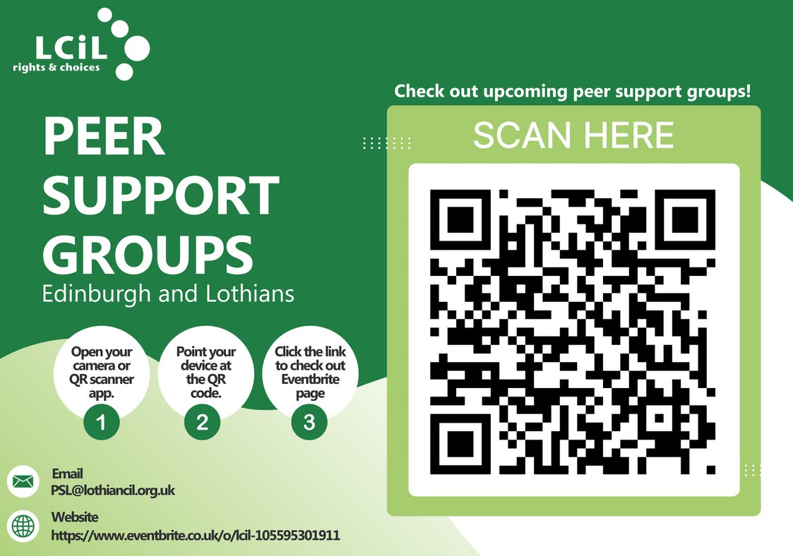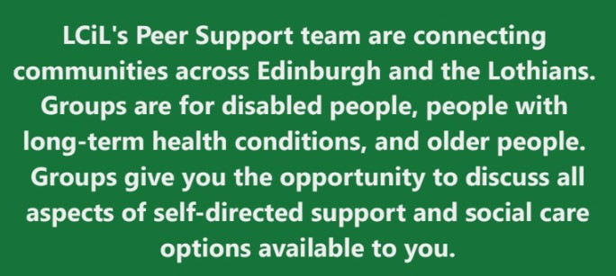
Get the latest information about groups in your area: Email PSL@lothiancil.org.uk, scan the QR code above, or visit Eventbrite: https://www.eventbrite.co.uk/o/lcil-105595301911
7

Canny Chef: Black Bean & Quorn Chilli
Hi from LCiL Canny Chef! This time I rustled up a delicious veggie chilli.
This colourful Black Bean and Quorn Chilli combines protein-rich Quorn mince and black beans with vegetables, tomatoes and gently warming spices. It is easy to adapt, making it suitable for different tastes—simply reduce or leave out the chilli powder and Tabasco if you prefer a milder flavour.
This recipe is also ideal for batch cooking, so you can enjoy one portion straight away and save the rest for another day. Serve with rice, or try it with a baked potato - Enjoy!
Do you have any other ideas of what could be added to this? I would love to hear from you! Email: communications@lothiancil.org.
Ingredients
Low cal spray
- onion roughly chopped
- carrots peeled and sliced 2 sticks of Celery thinly sliced
- garlic cloves crushed
- tsp ground cumin
- tsp ground coriander



Instruction
- Spray a large non stick pan with low calorie spray and put on a medium heat.
- Add onion, carrots and celery and cook for 5 minutes, keep stirring.
- Stir in the garlic for 1 minute - then add the spices and cook for another minute.
- Add the chopped tomatoes, stock, peppers, Quorn, black beans, sweetcorn and a splash of Tabasco. Stir well and bring to the boil.
- Lower heat and continue cooking for 30 minutes.
1 heaped tsp of chilli powder (maybe less if you don’t like it too hot!)
2 x 400g cans of chopped tomatoes
300ml boiling veg stock 500g Quorn mince thawed if frozen
1 red and 1 orange pepper deseeded and cut into small chunks
400g can of black beans, drained and rinsed
200g of sweetcorn Tabasco sauce
8

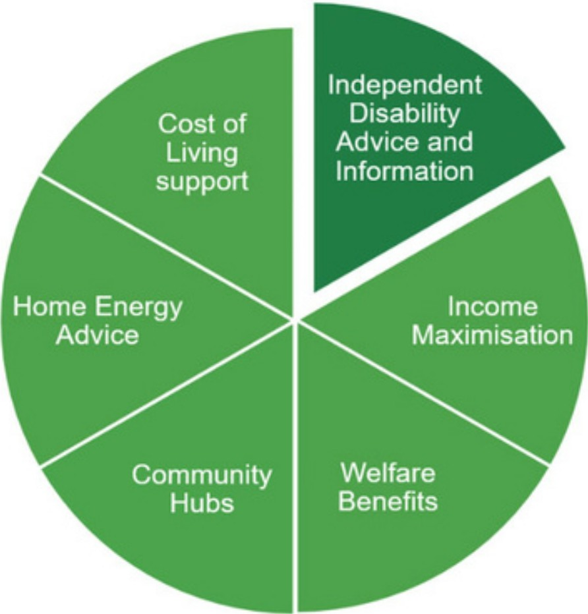
LCiL's Disability Advice and Information Service (DAIS) provides independent, accessible information for disabled people, those with long term conditions, and older people living in Edinburgh and the Lothians.

How we can help


The disability advice and information team can provide this support through:

Telephone appointments
Local 1:1
email advice community hubs appointments Workshops




All of our material is availab e in additional formats including Easy Reacl.

LCIL'S FREE NEW ENERGY ADVICE SERVICE


energy advice@lothiancil.org.uk 0131 475 2350
www.lothiancil.org.uk
Funded through the Energy Industry Voluntary Redress

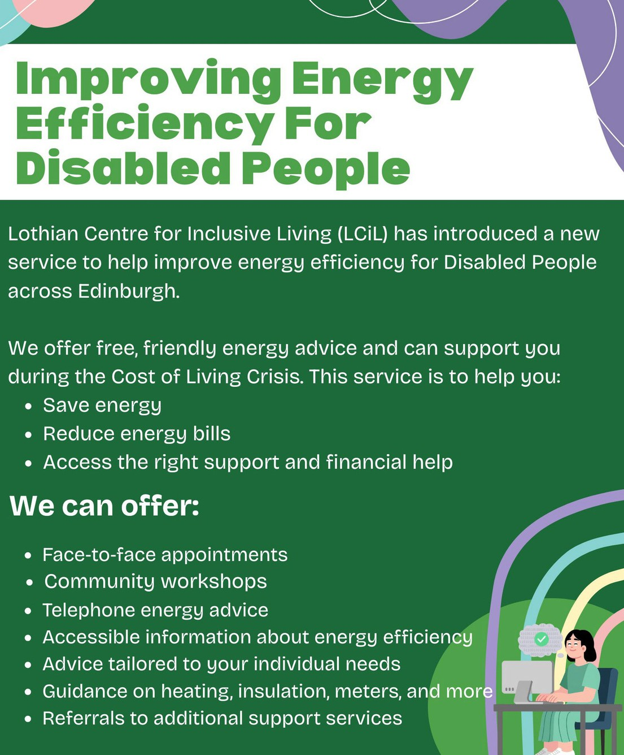



Scheme 1 0

How we can support you
We support disabled people, people with long-term health conditions and older people. Find out more at www.lothiancil.org.uk

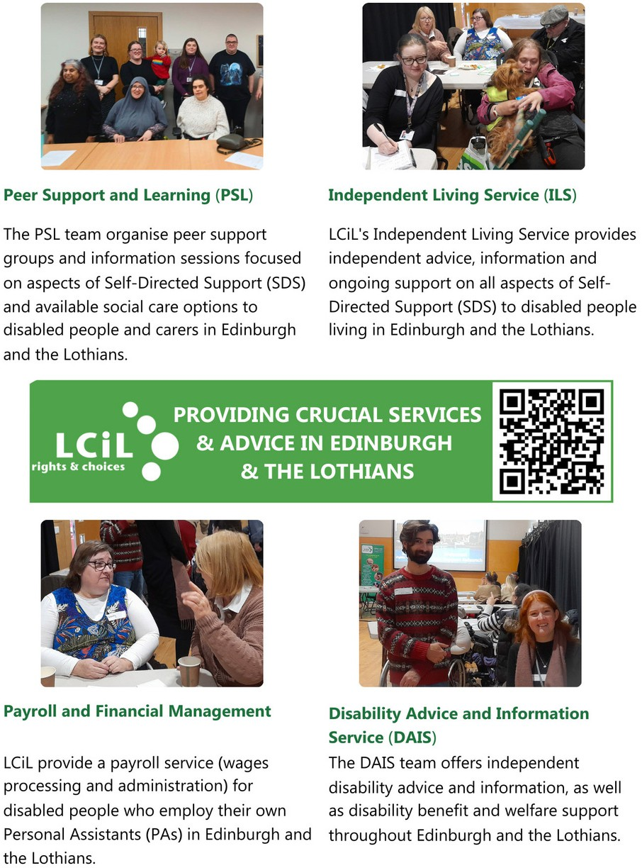


PROVIDING CRUCIAL SERVICES FOR DISABLED PEOPLE, PEOPLE WITH LONG-TERM HEALTH CONDITIONS,
AND OLDER PEOPLE IN EDINBURGH & THE LOTHIANS

.
1 1

HELP US MAKE INDEPENDENT LIVING A REALITY
LCiL supports disabled people, people with long-term health conditions, and older people across Edinburgh and the Lothians to take control, make choices, and live with confidence.

When you donate, you're giving someone the chance to say:

LCiL gave me the confidence to employ my own personal assistant—someone I chose and trust.”

I didn’t know what benefits I was entitled to until I spoke with LCiL. They changed my life.

Meeting others in a peer group made me feel less alone, less worried and more hopeful.”

Your support changes lives. Thank you!













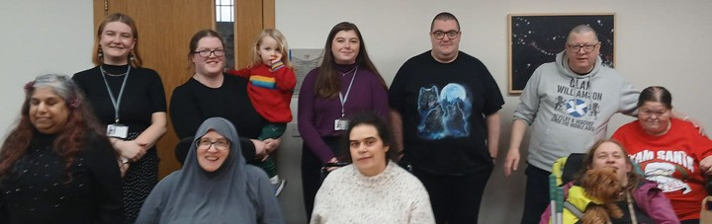




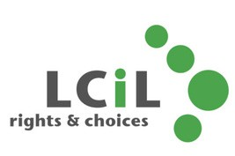

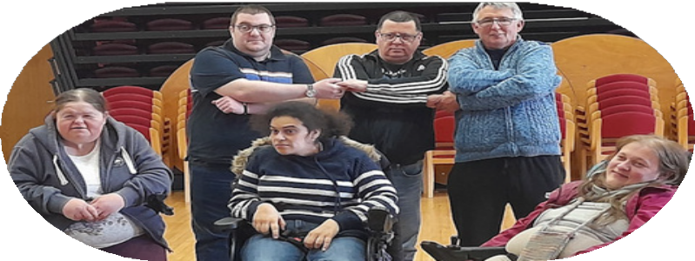



SUPPORT OUR WORK - DONATE TODAY!
Every donation helps support the work we do to provide services, advice and support for disabled people, people with long-term health conditions, and older people to live an independent life!

DONATE
www.lothiancil.org.uk/sup port-us/make-a-donation 12

LCiL Membership

We are in the process of revamping our membership - keep an eye on our website and our socials for more information - coming soon!

Feedback
If you have questions or comments about anything you have read in this newsletter, or have feedback or news and information you'd like to share - we'd love to hear from you!

Please email: communications@ lothiancil.org.uk

Contact Us
admin@lothiancil.org.uk 0131 475 2350
www.lothiancil.org.uk

Follow Us

Find out the latest info, news and events on our social media channels!
Lothian Centre for Inclusive Living (LCiL) is a Company Limited by Guarantee, Registered in Scotland No 129392. Scottish Charity No SC017954
Lothian Centre for Inclusive Living (LCiL)
Norton Park, 57 Albion Road
Edinburgh EH7 5QY 1 3

