Lothian Centre for Inclusive Living (LCiL)

Newsletter

Autumn 2026

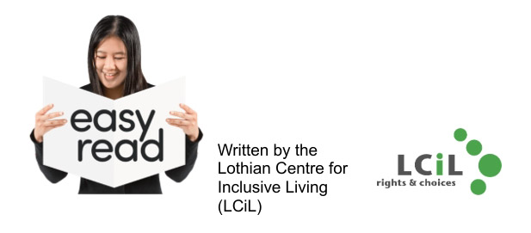

 | Hello and welcome to LCiL’s autumn newsletter.
 | This newsletter will tell you more about:  - New LCiL Staff members  - Peer Support Groups  - LCiL Volunteers winning an award  - New energy advice service  - Disability Advice and Information Service  - Our digital health survey  - How LCiL can support you  - Support us  - LCiL information
 | If you have any news you would like to share with us, you can email the Communications team.  The email is: Communications@lothiancil.org.uk

  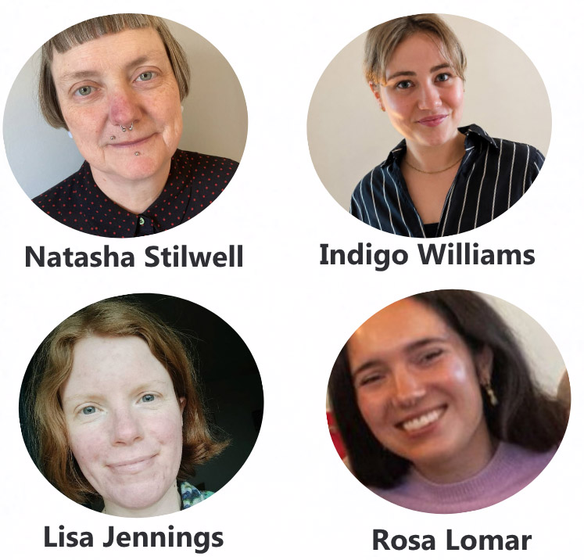 | Welcome to new LCiL staff  LCiL welcomed new staff to the team.  Here are their names and job titles for information.  Natasha Stilwell is PA Support Coordinator  Indigo Williams is Welfare Advice and Community Brokerage Officer  Lisa Jennings is Welfare Advice Officer  Rosa Lomar is a Peer Support Facilitator
 | Meaghan McCaughey is our new Volunteer Coordinator and Training Officer

 | Peer Support Groups  Our peer support groups are for anyone looking for support with social care in Edinburgh, East Lothian, Midlothian, West Lothian or online.  Our peer support groups are free.  We provide tea, coffee, and lunch at our peer support groups.  You can meet people like you and get advice from people who are in similar situations.
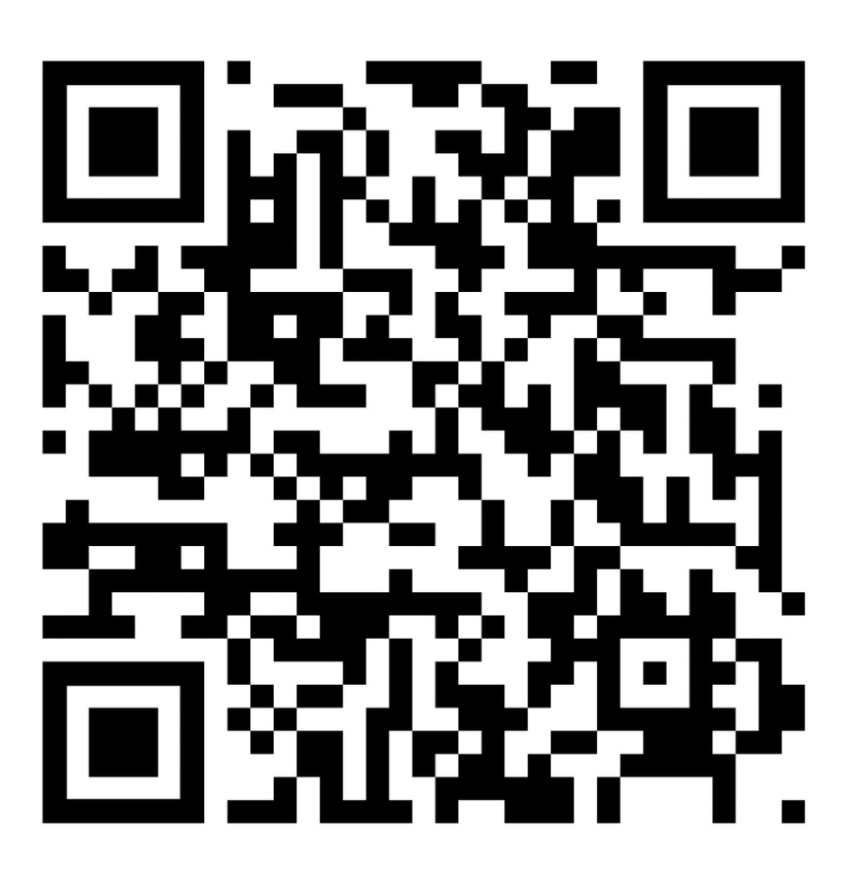   | To find out more and get tickets for the next events, you can:  - Click on this link: https://www.eventbrite.co.uk/o/lcil-105595301911  - Scan the QR code  Or  - Email the Peer Support team. Their email is: PSL@lothiancil.org.uk

      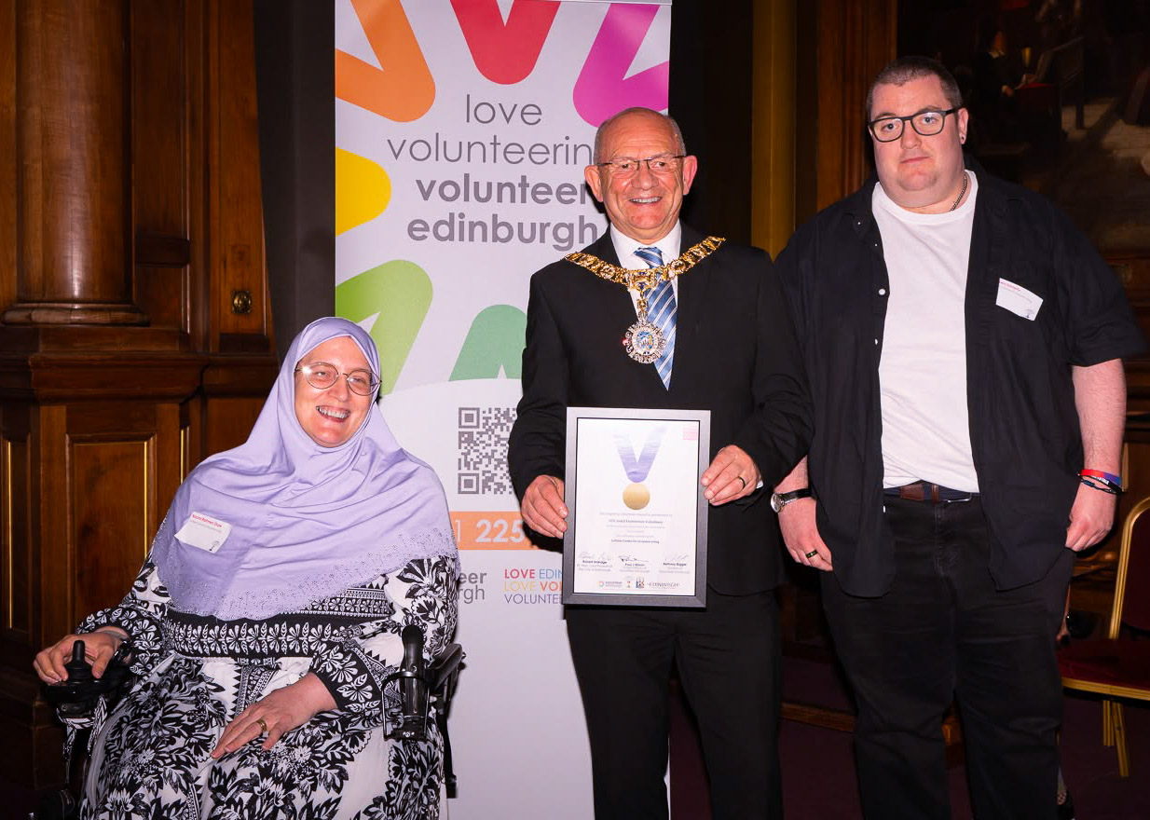 | LCiL Volunteers win award  LCiL’s Volunteers won the Ian McInnes Award for Inclusion and Diversity.  This was given by Volunteer Edinburgh for the great work they do.  The award was for the work the Volunteers did with Napier University social work students.  The Volunteers shared their lived experience with the students.  This learning was engaging and impactful.  Volunteers were given the award certificate by the Lord Provost at the Inspiring Volunteer Awards Ceremony.  LCiL’s new energy advice service  LCiL has a new, free energy advice and support service.  This service is to help you:  - Reduce energy  - Save energy bills and costs  - Access support and help  For more information email: energyadvice@lothiancil.org.uk or call: 0131 475 2350.

     | Personal Assistant Survey  This is a survey for Personal Assistants in Midlothian to help LCiL’s PA Support Coordinator.  Link:https://forms.cloud.microsoft/pages/responsepage.aspx?id=4YnlY-YT3E605sqdrzrP4X4SKrvkxblIpxAIiVIG8htUMThPMTBTMkcxMzlaQVYyMzFQWUYwREsxNi4u&route=shorturl  For more information contact: Natasha.Stilwell@lothiancil.org.uk  Disability Advice and Information service (DAIS)  LCiL’s Disability Advice and Information Service will help you find the information you need.  You can access this through:  - Email and phone appointments  - Community hubs in Edinburgh and the Lothians  - Workshops  You can contact the DAIS team by phone: 0131 475 2350 or email: DAIS@lothiancil.org.uk

  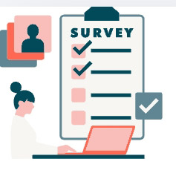 | Our Digital Health Survey  Two LCiL Volunteers, Colin and Shawn took part in a digital health survey.  They went to Dundee to find out the results.  The survey looked at barriers to digital health support and services.  These included: NHS letters and appointments and wellbeing apps.  This survey will help change digital services for disabled people and people with learning disabilities.  Find out more about the survey: www.ourdigitalhealth.com

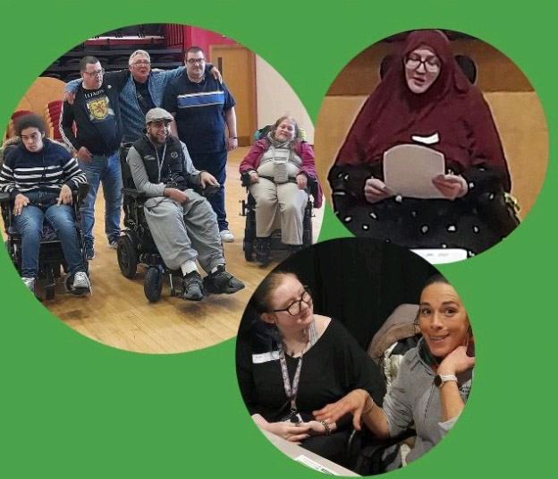 | LCiL Services and how we support people  This section is about us at LCiL.  We help disabled people, those with long-term health conditions, and older people in Edinburgh and the Lothians.
 | We provide services that support independent living. Our services include:  - Peer Support groups  - Payroll Service and Financial Management  - Independent Living Support  - Disability Advice and Information

 | Support LCiL and the work we do  Donations help us to provide services to support people to live independent lives.  If you can, and want to, you can donate to LCiL.  You can donate by scanning the QR code or following this link: www.lothiancil.org.uk/make-a-donation/support-us/
 | You can also support us by becoming a member.  We are updating our membership programme.  We will keep you updated in future newsletters and on our website.

Contact Information
 | You can find more information about LCiL on our website. Scan the QR code or go to this link: www.lothiancil.org.uk  If you want to get in touch:  - Call us on 0131 475 2350  - Email us at admin@lothiancil.org.uk

