Lothian Centre for Inclusive Living (LCiL)

Newsletter

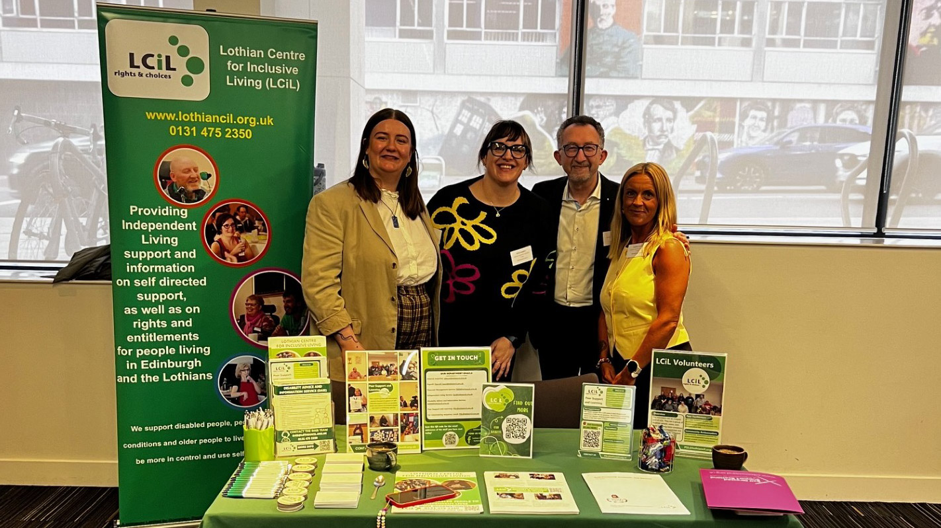
Summer 2026


LCiL staff at the Self Directed Support Scotland (SDSS) event in Glasgow in March.

Hello and welcome to LCiL’s summer newsletter.
LCiL had an information stall at the Self Directed Support Scotland (SDSS) event in March.
We shared information about LCiL’s services and support.
 | This newsletter will tell you more about:  - Peer Support Groups  - LCiL’s new Convenor: Lyn Pornaro  - New energy advice service  - Omar Haq goes to Scotland’s Disability Summit  - Our digital health survey  - How LCiL can support you  - Support us  - LCiL information
 | If you have any news you would like to share with us, you can email the Communications team.  The email is: Communications@lothiancil.org.uk

Join our Peer Support Groups
   | Our peer support groups are for anyone looking for support with social care in Edinburgh, East Lothian, Midlothian, West Lothian or online.  Our peer support groups are free.  We provide tea, coffee, and lunch at our peer support groups.  You can meet people like you and get advice from people who are in similar situations.
   | To find out more and get tickets for the next events, you can:  - Click on this link: https://www.eventbrite.co.uk/o/lcil-105595301911  - Scan the QR code  Or  - Email the Peer Support team. Their email is: PSL@lothiancil.org.uk

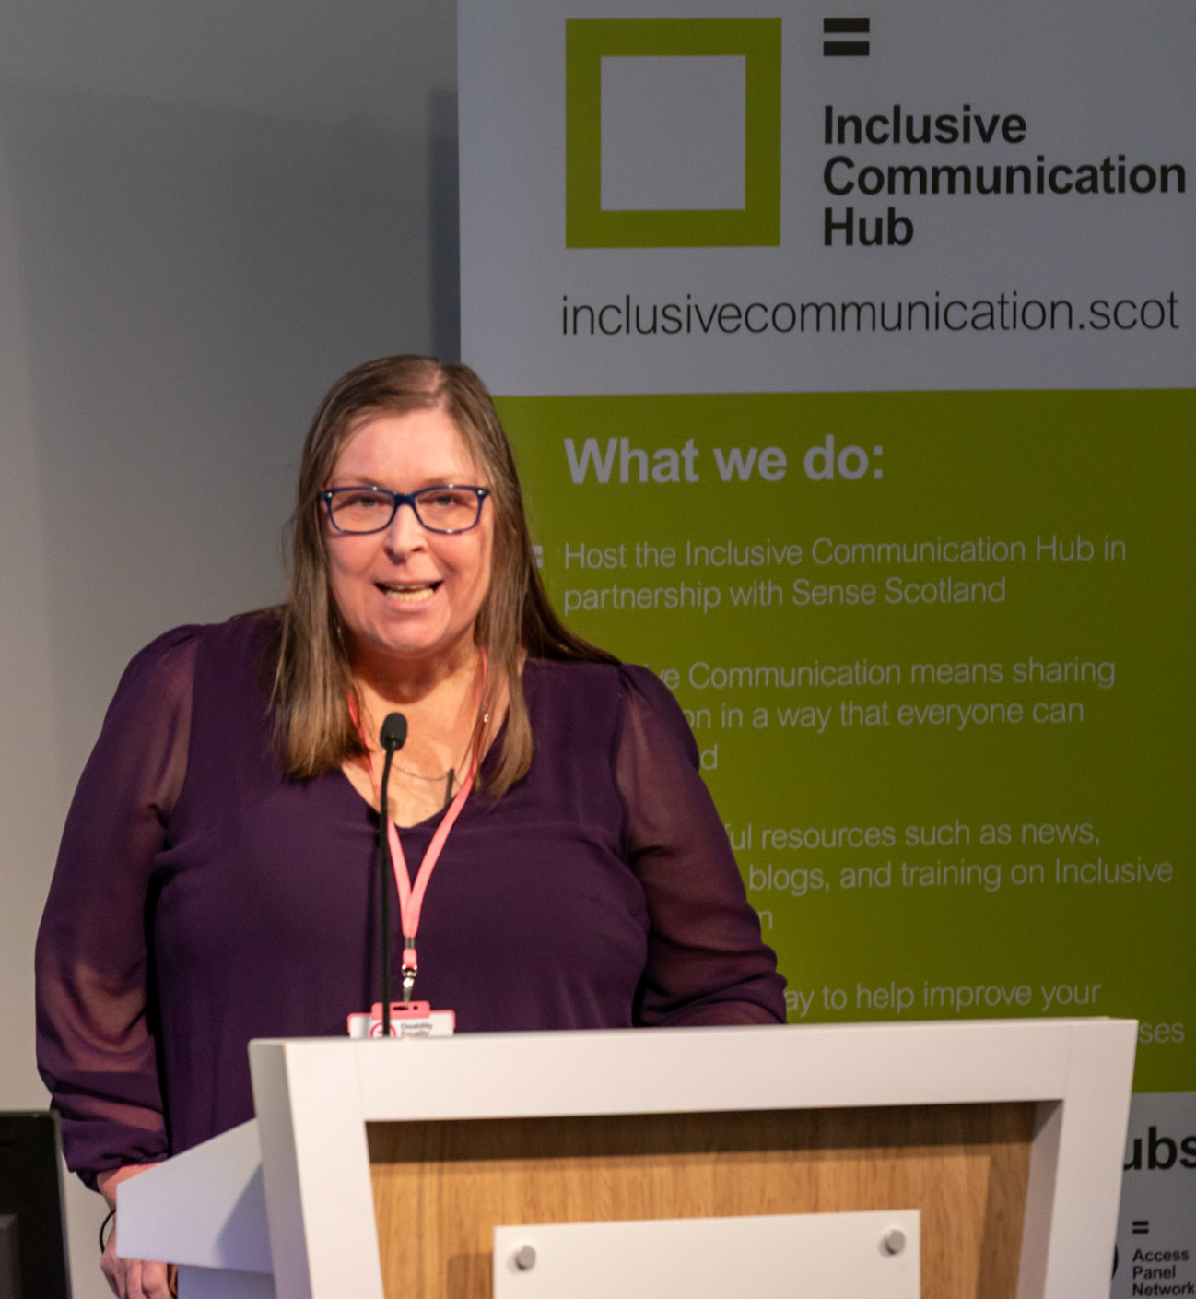     | LCiL welcomes new Convenor: Lyn Pornaro  LCiL welcomes new Convenor: Lyn Pornaro.  Lyn is delighted to take on this new role to support the organisation, staff and fellow Trustees.  LCiL is here for you. We are here to support disabled people, people with long-term health conditions and older people to live independent and fulfilling lives.  LCiL’s new energy advice service  LCiL has a new, free energy advice and support service.  This service is to help you:  - Reduce energy  - Save energy bills and costs  - Access support and help  For more information email: DAIS@lothiancil.org.uk or call: 0131 475 2350.

Omar Haq goes to Scotland’s Disability Summit
   | Omar from the peer support team went to Scotland’s Disability Summit at Scottish Parliament in February.  It was a chance to look at the good things that have happened and what changes need to happen to make lives better for disabled people.  Main areas talked about were: voting, education, social care, the social security system and transport for disabled people.
 | The Summit closed with the wish that Scottish Parliament progress with equality and full inclusion for disabled people in Scotland.

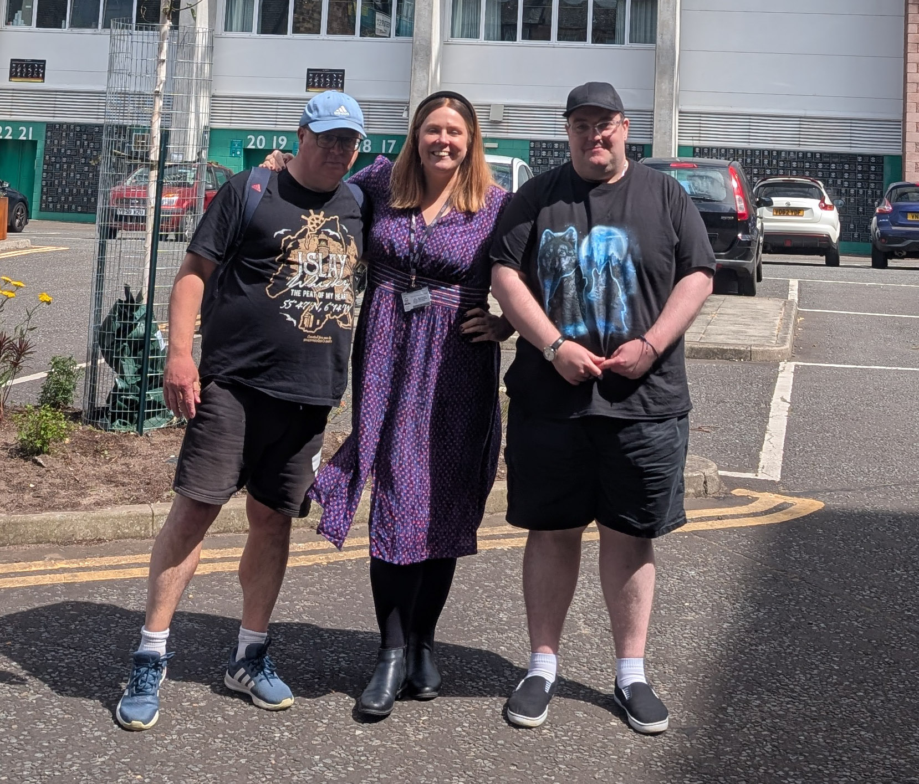   | Our Digital Health Survey  Two LCiL Volunteers, Colin and Shawn took part in a digital health survey with Charlotte Hardacre from Manchester Metropolitan University.  The survey looked at barriers to digital health support and services.  These included: NHS letters and appointments and wellbeing apps.  Colin and Shawn hope this survey will help change digital services for disabled people and people with learning disabilities.  Find out more about the survey: www.ourdigitalhealth.com

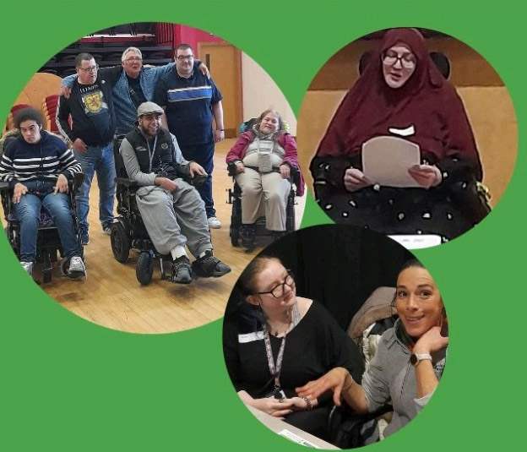 | LCiL Services and how we support people  This section is about us at LCiL.  We help disabled people, those with long-term health conditions, and older people in Edinburgh and the Lothians.
 | We provide services that support independent living. Our services include:  - Peer Support groups  - Payroll Service and Financial Management  - Independent Living Support  - Disability Advice and Information

 | Support LCiL and the work we do  Donations help us to provide services to support people to live independent lives.  If you can, and want to, you can donate to LCiL.  You can donate by scanning the QR code or following this link: www.lothiancil.org.uk/make-a-donation/support-us/
 | You can also support us by becoming a member.  We are updating our membership programme.  We will keep you updated in future newsletters and on our website.

Contact Information
 | You can find more information about LCiL on our website. Scan the QR code or go to this link: www.lothiancil.org.uk  If you want to get in touch:  - Call us on 0131 475 2350  - Email us at admin@lothiancil.org.uk

