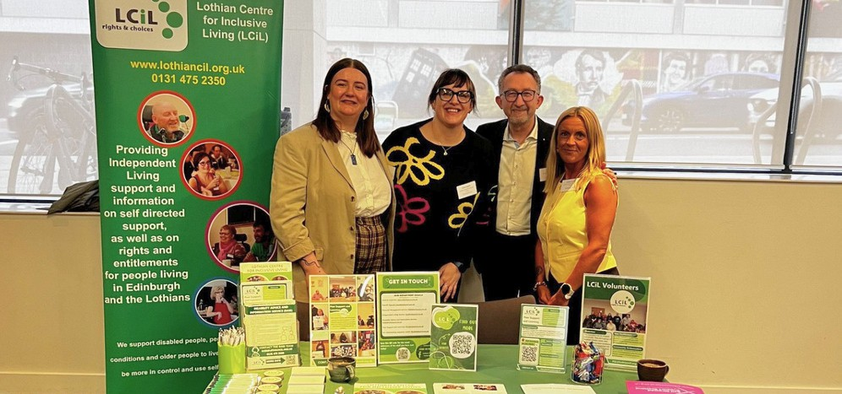
LCiL News
S u m m e r 2 0 2 6
Image: LCiL team at SDS National Voice Conference

Hello!

Contents
Hello
Q&A with LCiL's Convenor: Lyn Pornaro
Omar Haq at Disability Summit
Our Digital Health Survey Peer Support Groups
New Energy Advice Service Canny Chef recipe time How we can support y ou Support our Work
Membership / Contact Us
It's almost summer! The days are definitely getting lighter and we hope this latest newsletter makes you feel brighter!
We had an infomation stall at the recent SDS National Voice event in Glasgow (image above). It was a great opportunity to reach out to more people who will benefit from LCiL's support and services. The main themes were Learning and Leadership, which gave the chance for open and varied discussion.
Don't forget we're here to support you - please check out all our peer support groups coming up in Edinburgh, East, Mid and West Lothian.


M O R E I N F O
G . U K | 0 1 3 1 4 7 5 2 3 5 0
1
S H A R E Y O U R N E W S
If you have any news that you would like to include in future newsletters, please email: communications@lothiancil.org.uk
or call: 0131 475 2350. We'd love to hear from you!
W W W . L O T H I A N C I L . O R

Q&A with LCiL's new Convenor: Lyn Pornaro
What inspired you to take on role of Convenor, and what does LCiL mean to you?
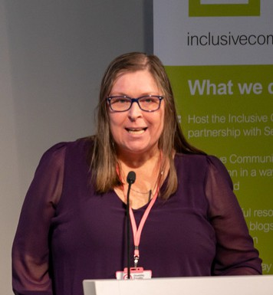
LCiL has a special place in my heart – not just the organisation, but the staff and service users. I joined LCiL in 2018 for a 6 month contract supporting the SDS Development Project (now PSL),
I then became the Co-ordinator for the project, then Depute CEO and subsequently CEO before I left in October 2022. Becoming LCiL trustee seemed a natural fit for me as a disabled woman, mum of 2 disabled children (and 3 others) and in my work capacity over the past 11 years in the disability sector.
It will be great to be able to support other trustees and staff in my role as Convenor.
What are the top priorities for LCIL over the next few years?
It would be easy for me to say – just keep doing what it has been doing. Whilst that is part of it, the 3rd sector landscape is changing. As we move into a digital age, we have to keep ahead of these changes, adapt and be resilient. Mostly, however, we must not forget the reason LCiL exists – to support disabled people to live independent, and fulfilling lives.
How do you plan to ensure that the voices of disabled people and service users remain central to decision-making?
Growing our membership, asking and consulting with them, keeps that lived experience at the heart. As a board (where the majority of trustees are disabled people), we bring our unique lived experience. We must be able to listen and hear, and whilst decisions may be challenging, keeping the rights of disabled people at the heart of them, will make them the correct decisions.
What are the current challenges faced by disabled people that LCiL is addressing? Social care and cuts. Social care is in a very dire place just now across the whole of Scotland. Not enough support, challenging budgets to gain that support and, of course, social care charges. We are still campaigning as a community for these to be removed. Our Welfare Rights Officers work hard to ensure that disabled people gain access to all the social security payments and benefits they are entitled to. However, if social care charges take that away, it leaves no one in a better or fair position.
What message would you like to share with service users, staff, volunteers and partners, as you begin your time as Convenor?
I am hear to listen and hear you. I may have the designation of Convenor of the Board, but LCiL is your organisation. Work with the board and Narek, as CEO. Help us to make LCiL the best organisation to work for, to gain support and to have opportunities with.
2

Omar Haq from Peer Support shares his experience at Scotland's Disability Summit 2026
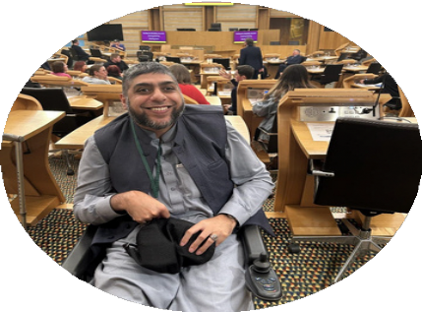
It was a privilege to attend Scotland’s Disability Summit at the Scottish Parliament in February, representing LCiL.
Disabled delegates and representatives from Disabled People’s Organisations gathered from across Scotland to take part in the summit. Everyone came to celebrate what has been achieved and acknowledge that more needs to be done to fight for the rights of disabled people.
The Summit opened with a welcome address by The Presiding Officer, followed by The Minister for Equalities Kokab Stuart MSP,
and the Convenor of the Cross-Party group on disability Jeremy Balfour MSP. Followed by speeches from disabled members of the Scottish Youth Parliament and co- winner of the Traitors Merrill Williams who outlined their hopes for the day.
Phase two of the day centred around breakout sessions focusing on several key areas:

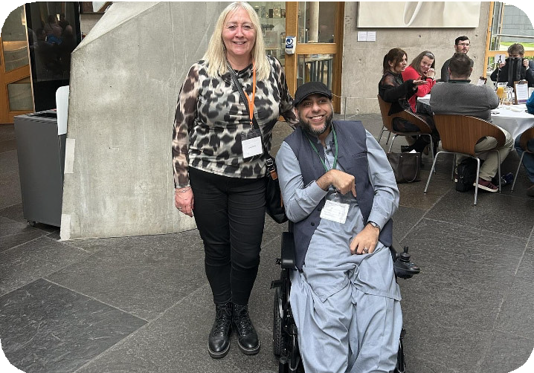
- Voting and Disabled People.
- Disabled People and Transport.
- Disabled People and the Social Security System.
- Disabled People and Education.
- Disabled People and Social Care.

Image: Omar Haq & Joanna McGee (GCiL) I attended the session on disabled people and education. A variety of topics were raised here including challenging issues around autism and dyslexia in school education, as well
as the difficulties faced by those disabled people requiring support in further and higher
education.
After lunch delegates gathered once again in the parliament chamber to hear
what was discussed in the breakout sessions. Various themes were discussed, including better transport links a further streamlining of the Social Security and Social Care systems. It was also highlighted that any change should involve disabled people and their organisations to value the important role of lived experience.
The Summit closed with the desire for the next parliament to drive meaningful progress towards equality and full inclusion for disabled people. It was promising to see such positive sentiments end the summit after a productive day. However, it remains to be seen if the next government will really commit to driving this change. Disabled people and Disabled People’s Organisations are ready to hold the next government accountable

for this change, ensuring this Summit is heard and valued, not ignored.
P A G E 32

Our Digital Health Survey
Two of our volunteers Colin and Shawn recently took part in a research survey with Charlotte Hardacre from Manchester Metropolitan University. The survey aimed to learn about barriers to digital health support and access to digital health services. Such as online NHS letters and appointments and mindfulness and wellbeing apps, which could be faced by people with a learning disability. The research project was a longitudinal study which means the participants complete the survey twice over the course of a year. Colin and Shawn have now completed this both times.
Colin and Shawn each received a £20 love to shop voucher for taking part. They both enjoyed taking part in this project and are keen to hear the results. Both are hopeful this will change how digital health services interact with disabled people and those with learning difficulties in future.
The survey they took part in is part of a wider research project. This was stage 2. We look forward to the outcome of this research.
This is an NIHR funded study which is being run by Liverpool John Moores University in partnership with Dundee University, Manchester Metropolitan University and others.
Find out more about the research project and what they hope to achieve: www.ourdigitalhealth.com
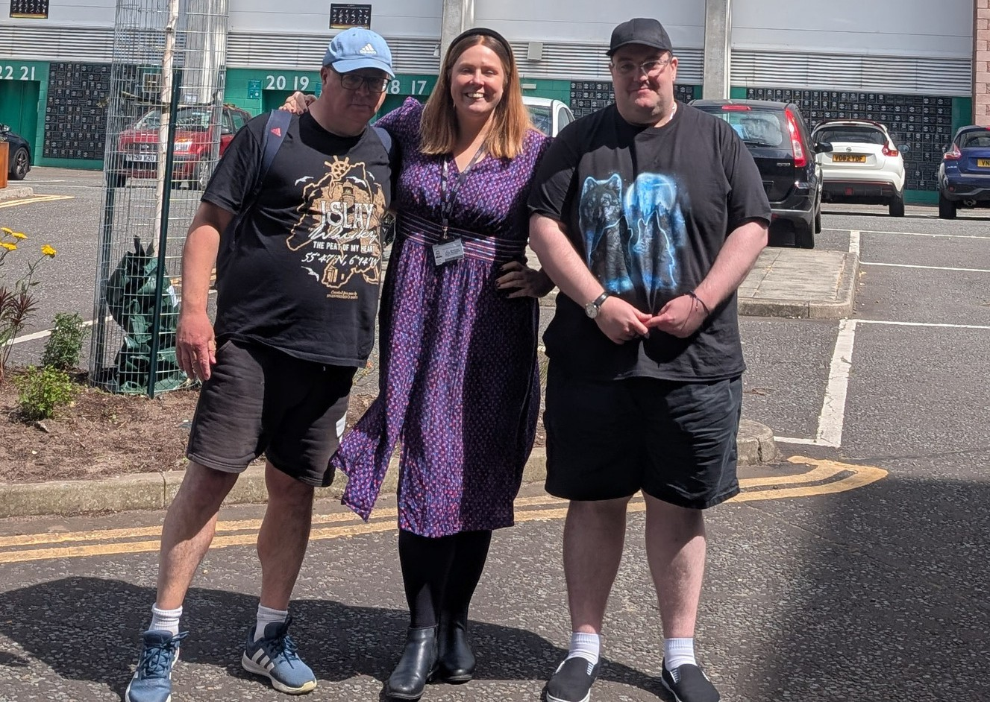
Colin and Shawn with Charlotte Hardacre
4

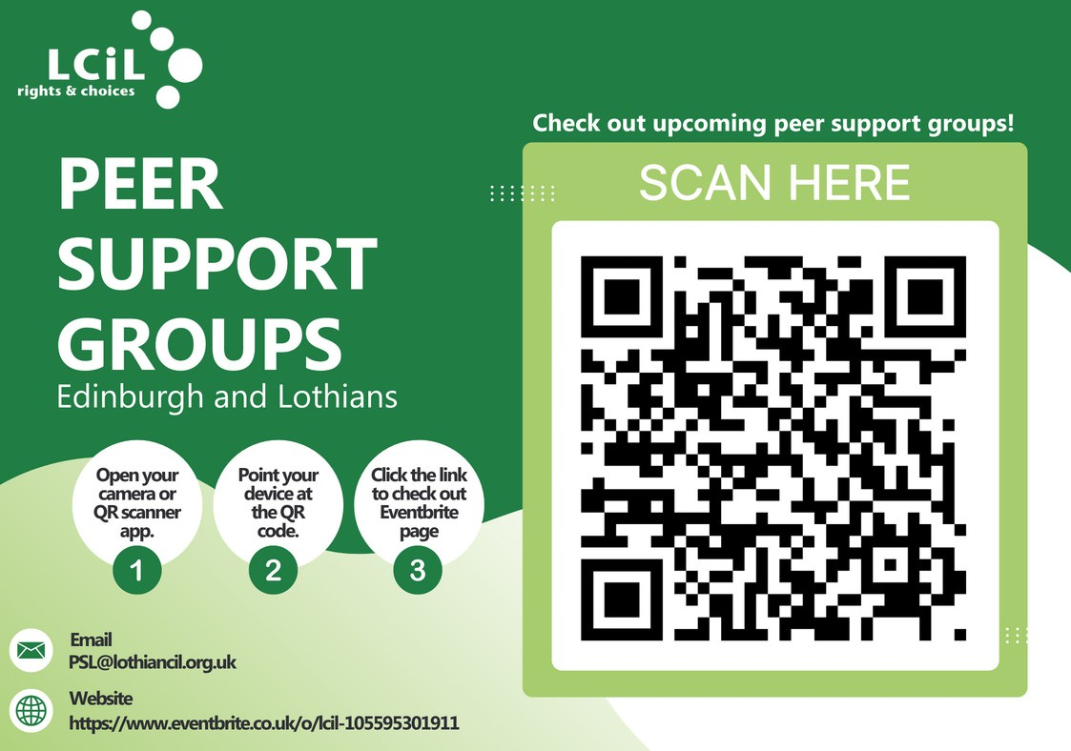
LCiL's Peer Support team are connecting communities across Edinburgh and the Lothians.
Groups are for disabled people, people with long-term health conditions, and older people. Groups give you the opportunity to discuss all aspects of self-directed support and social care options available to you.
To find out about your nearest support group and dates, please scan QR code or click link to eventbrite or contact: PSL@ lothiancil.org.uk
5

LCIL'S FREE NEW ENERGY ADVICE SERVICE

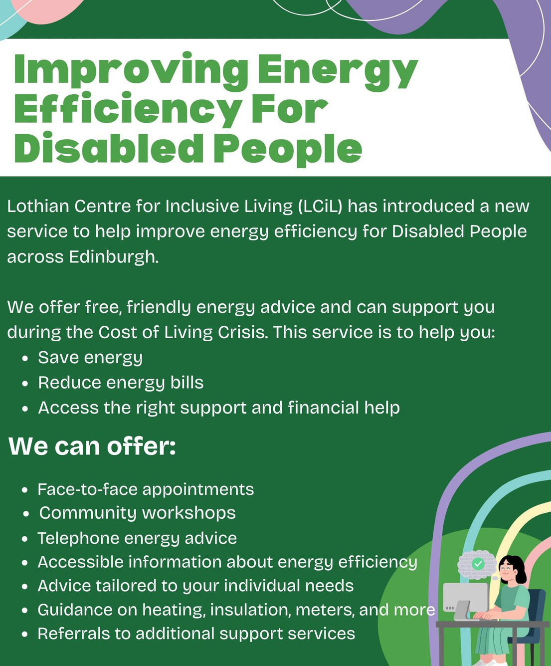


CONTACT THE DAIS TEAM
DAIS@lothiancil.org.uk 0131 475 2350
www.lothiancil.org.uk
Funded through the Energy Industry Voluntary Redress
Scheme 6

Canny Chef: Pasta Surprise!
Hi from LCiL Canny Chef! This month I tried something a little different and gave AI a go. I had some tomatoes, 2 red peppers, 2 courgettes, and a red onion in the fridge, so I teamed them up with smoked paprika, garlic passata, and pasta to make a quick and easy pasta dish — and it tasted even better the next day!
I dished up some up for dinner and put the rest after it cooled into the fridge, I had some the next day, I also added some cheese to give it more flavour.

Do you have any other ideas of what could be added to this? I would love to hear from you! Email: communications@lothiancil.org.uk




Instruction
- To start, chop the tomatoes, onion, peppers and courgettes.
- Roast the above with a little oil in a baking tray in the oven at 200c for 20 minutes.
- Cook pasta.
- Heat the garlic passata in a pan.
- Drain pasta and add to passata.
- Add the roast veg to the passata sauce and serve (add cheese to make it tasty!)

Ingredients
tomatoes
1 red onion
2 courgettes
2 red peppers Smoked Paprika
Jar of Garlic Passata Pasta of your choice

7

How we can support you
We support disabled people, people with long-term health conditions and older people. Find out more at www.lothiancil.org.uk

PROVIDING CRUCIAL SERVICES FOR DISABLED PEOPLE, PEOPLE WITH LONG-TERM HEALTH CONDITIONS,
AND OLDER PEOPLE IN EDINBURGH & THE LOTHIANS

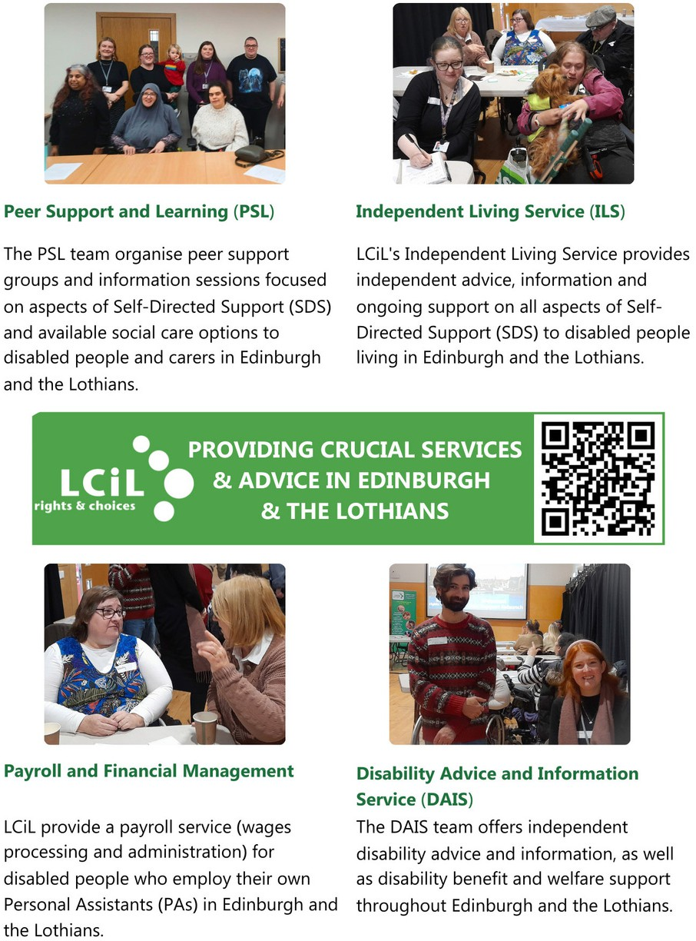

.
8

HELP US MAKE INDEPENDENT LIVING A REALITY

LCiL supports disabled people, people with long-term health conditions, and older people across Edinburgh and the Lothians to take control, make choices, and live with confidence.
When you donate, you’re giving someone the chance to say:
“LCiL gave me the confidence to employ my own personal assistant—someone I chose and trust.”
“I didn’t know what benefits I was entitled to until I spoke with LCiL. They changed my life.”

“Meeting others in a peer group made me feel less alone, less worried and more hopeful.”

I can finally manage my support without feeling overwhelmed Service User
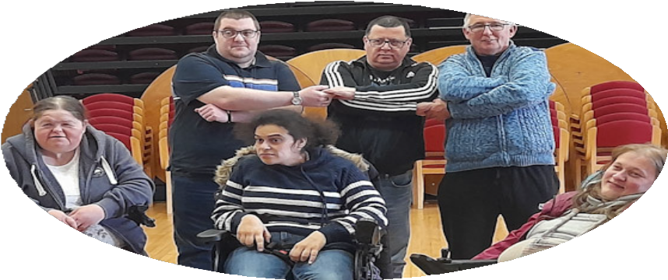


SUPPORT OUR WORK - DONATE TODAY!
Every donation helps support the work we do to provide services, advice and support for disabled people, people with long-term health conditions, and older people to live an independent life!
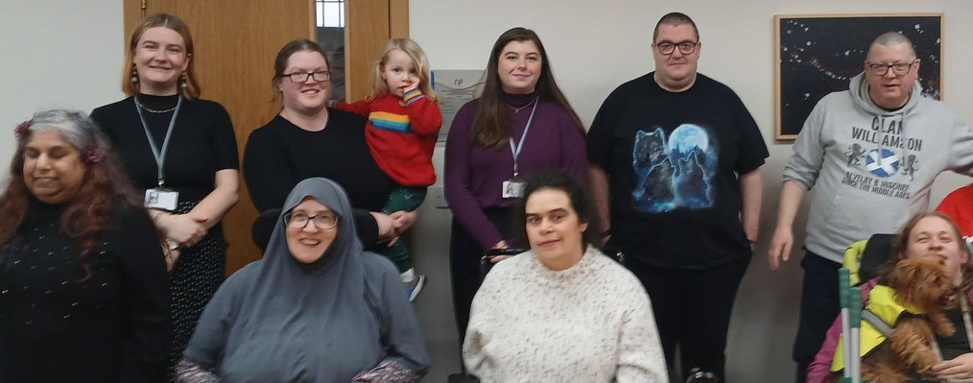
www.lothiancil.org.uk/sup port-us/make-a-donation



9

LCiL Membership

We are in the process of revamping our membership - keep an eye on our website and our socials for more information - coming soon!

Feedback
If you have questions or comments about anything you have read in this newsletter, or have feedback or news and information, you'd like to share - we'd love to hear from you!

Please email: communications@ lothiancil.org.uk

Contact Us
admin@lothiancil.org.uk 0131 475 2350
www.lothiancil.org.uk

Follow Us

Scan for web









Find out the latest info, news and events on our social media channels!
Lothian Centre for Inclusive Living (LCiL) is a Company Limited by Guarantee, Registered in Scotland No 129392. Scottish Charity No SC017954
Lothian Centre for Inclusive Living (LCiL)
Norton Park, 57 Albion Road
Edinburgh EH7 5QY 1 0

