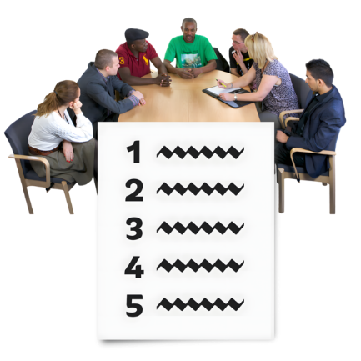  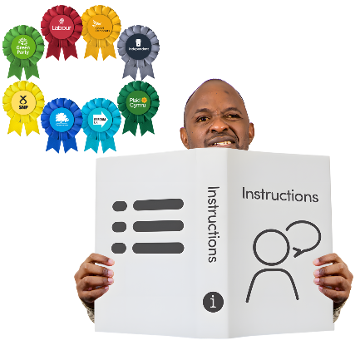   | Inclusion Scotland – Access to Politics  Inclusion Scotland want to make real change across political parties in Scotland.  They are creating a new Access to Politics Charter.  A charter is a document that explains how to do things well.  This charter is about how political parties can and should involve disabled people in politics.  Inclusion Scotland are bringing disabled people together to write the charter.  Taking part would involve:  - Sharing your lived experience,  - Learning from others,  And  - Creating practical ideas for change.
   | If you want to be part of the Charter you need to fill in a form online.  Click here to fill out the form online.  The PSL team can help you fill the form in.
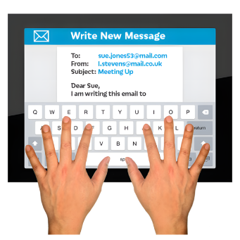 | If you have any questions about the charter you can email Inclusion Scotland.  Their email is: info@inclusionscotland.org

