Lothian Centre for Inclusive Living (LCiL)

Newsletter

Winter 2025 - 2026
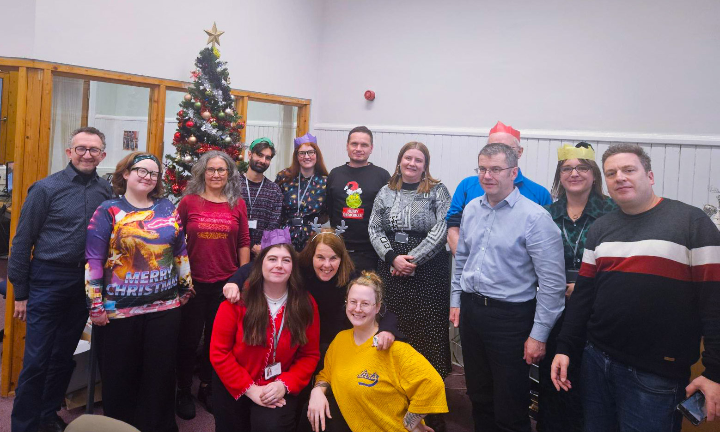

LCiL staff in the office - wishing you a happy new year ahead.

Happy New Year
 | Happy New Year from all the team at Lothian Centre for Inclusive Living (LCiL).
 | This newsletter will tell you more about:  - Peer Support Groups  - LCiL volunteers at a Social Worker Conference  - Upmo Project success  - Article: Recent scams  - Butternut and Bean soup recipe  - New book by Sarah Burchett-Cook  - How LCiL can support you  - Support us  - LCiL information
 | If you have any news you would like to share with us, you can email the Communications team.  The email is: Communications@lothiancil.org.uk

Join our Peer Support Groups
   | Our peer support groups are for anyone looking for support with social care in Edinburgh, East Lothian, Midlothian, West Lothian or online.  Our peer support groups are free.  We provide tea, coffee, and lunch at our peer support groups.  You can meet people like you and get advice from people who are in similar situations.
   | To find out more and get tickets for the next events, you can:  - Click on this link: https://www.eventbrite.co.uk/o/lcil-105595301911  - Scan the QR code  Or  - Email the Peer Support team. Their email is: PSL@lothiancil.org.uk

LCiL Volunteers Speak at Social Worker Conference
  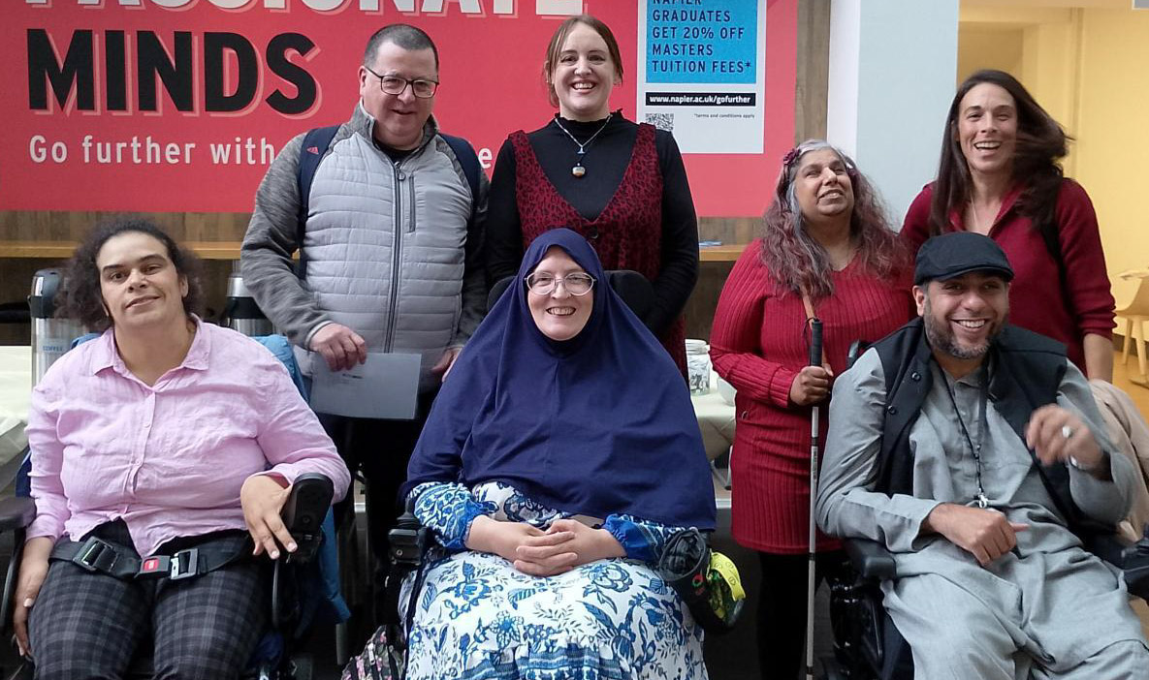 | LCiL Volunteers spoke at Edinburgh Napier University.  The talk was to help new social workers understand why lived experience matters.  Our LCiL volunteers and students did social care exercises together.  The students and academic staff learnt about what matters to disabled people and how they feel.  This helped students feel what it is like to be assessed and understand how to better help disabled people.
 | The students wanted to know more and asked the volunteers many questions and gave great feedback about them.

UPMO Project Success
   | The Peer Support team recently completed a training programme with Upward Mobility (Upmo).  6 Upmo students finished a 10 week course.  Some of them now want to become LCiL volunteers.
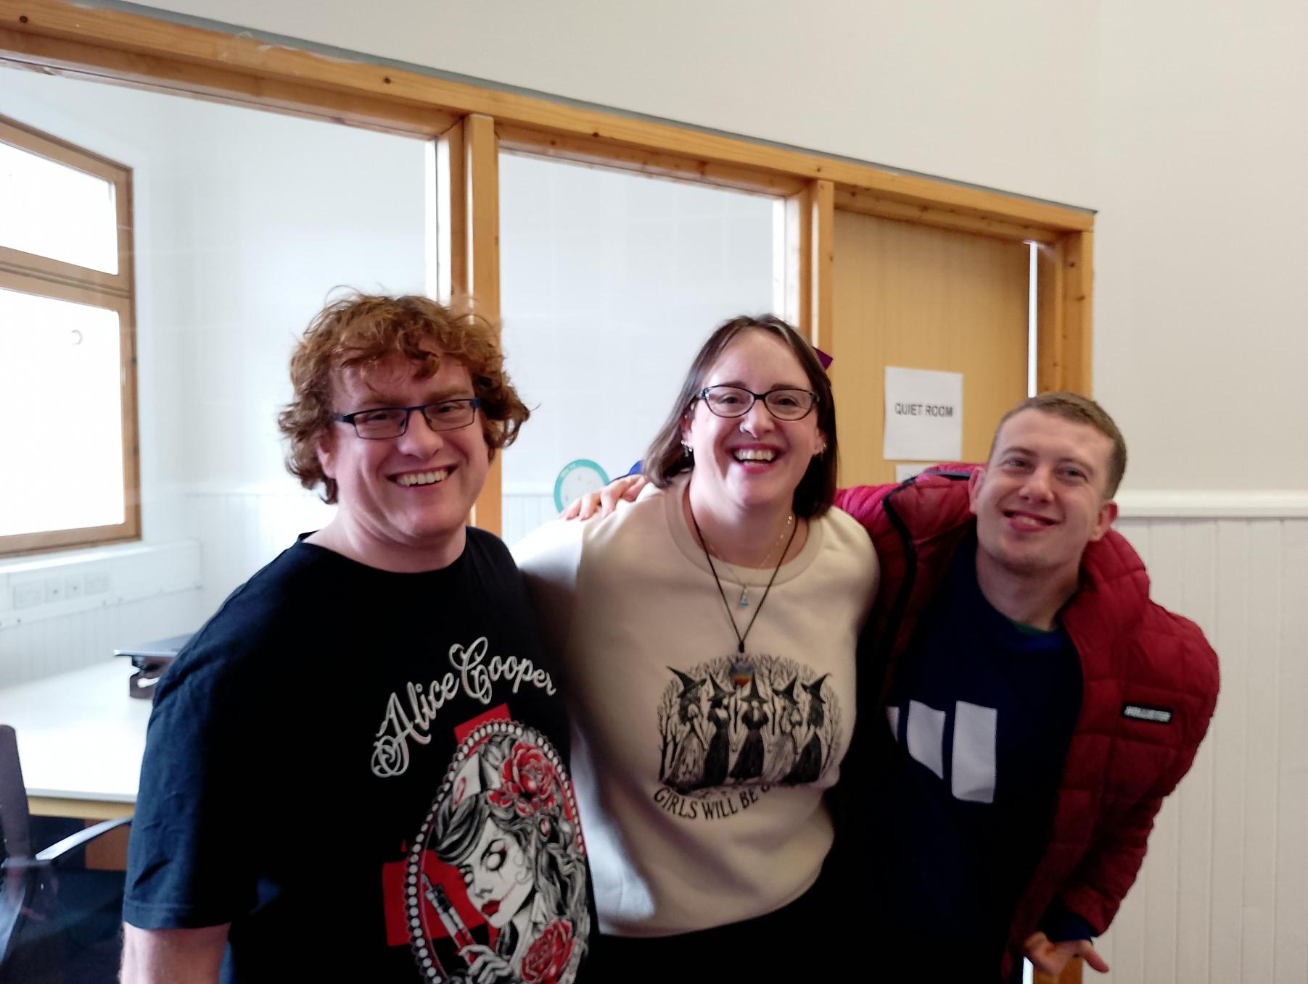   | The course taught them about disability equality, what peer support is, and peer facilitation skills.  The students also came to LCiL’s office.  They met the staff and found out more about what we do.

Recent Scams
   | This section is to warn you about a scam that we have heard is happening.  A scam is when someone tries to trick you into giving them information or money.  You do not need to be worried.  This section gives you information and tips about what you should do if you think you might be getting scammed.

 | If you are not sure about something or have a bad feeling about it, speak to someone you trust before giving anyone your information.
   | There is a scam using Amazon branding asking for your account details. They use fake websites to trick you.  If you get an unusual call, email or text asking for money or your details – do not share your information.  Amazon will not call asking for payments or to install any apps.
   | You could get a message that looks like it is from Amazon.  It might say they have found someone breaking the rules and they are giving you a refund and a new product.  If they ask for any payment details or personal information, this is a scam.  If something is a scam, you should ignore it and report it to Amazon.

 | If you are unsure about a message from Amazon, check your Message Centre in your account.  This will show all real messages from them.

Butternut and Bean Soup Recipe
 | This section has a recipe for Butternut and Bean soup.  The whole recipe costs around £2.  It will make 4 portions.  You can keep it in the fridge for up to 4 days.
   | We made this recipe by using using an app we were told about in our Cost of Living workshops that told us the cheapest places to buy different ingredients.
 | This is a list of all the ingredients you will need:  The list includes food from Tesco and Asda. You can go to other shops if that makes more sense for you.
   | From Tesco:  - 1 onion  - 1 garlic clove  - Frozen bag of butternut squash  - Pack of 10 vegetable stock  - 1 small jar of parsley  From ASDA:  - 400g can of Cannellini beans  - 1 medium potato
   | To make the soup, follow the steps below.  - Chop up the onion, garlic, and potato  - Mix 2 stock cubes with boiling water to make 1 litre of stock  - In a pan, add the onions and 3 tablespoons of water.  - Cook for 10 minutes.  - Add the garlic and stir  - Wait 1 minute  - Add the butternut squash, the potato, and the stock.  - Simmer for 10 minutes.  - Drain the beans and then add them.  Finish the soup by adding parsley to garnish.

New book from Sarah Burchett-Cook
 | Sarah Burchett-Cook is part of our Payroll team.  She also writes books and is a published author.  She has a new book called ‘Someone Else’s War.  It is her second book in the series called the ‘Rosa Chronicles Trilogy’.  Find out more: www.sarahburchettcook.co.uk

LCiL Services and how we support people
 | This section is about us at LCiL.  We help disabled people, those with long-term health conditions, and older people in Edinburgh and the Lothians.
 | We provide services that support independent living. Our services include:  - Peer Support groups  - Payroll Service and Financial Management  - Independent Living Support  - Disability Advice and Information

Support LCiL and the work we do
 | Donations help us to provide services to support people to live independent lives.  If you can, and want to, you can donate to LCiL.  You can donate by scanning the QR code or following this link: www.lothiancil.org.uk/make-a-donation/support-us/
 | You can also support us by becoming a member.  We are updating our membership programme.  We will keep you updated in future newsletters and on our website.

Contact Information
 | You can find more information about LCiL on our website. Scan the QR code or go to this link: www.lothiancil.org.uk  If you want to get in touch:  - Call us on 0131 475 2350  - Email us at admin@lothiancil.org.uk

