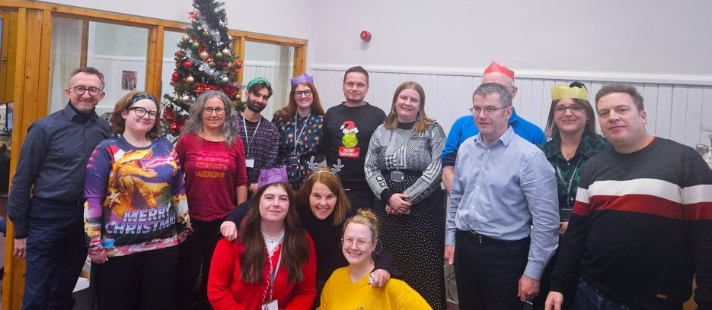



LCiL News

W i n t e r 2 0 2 5 - 2 0 2 6

Image: Happy New Year from the LCiL team!

Happy New Year from all the team at LCiL!
Contents
Hello
Volunteers speak at Napier Upmo Project
Peer Support Groups Recent Scams
Canny Chef recipe time Must-reads Wordsearch fun
How we can support y ou Wordsearch answers Support our Work Membership / Contact Us
We hope you all had a restful festive period and wish you a happy new year ahead!
We're here to support you - please check out all our peer support groups in the coming months, and keep an eye on our website for any other relevant information. Groups are free and give you the opportunity to connect with like-minded people and get expert advice and support near you! (taking place in Edinburgh, East, Mid and West Lothian)

M O R E I N F O
S H A R E Y O U R N E W S
If you have any news that you would like to include in future newsletters, please email: communications@lothiancil.org.uk
or call: 0131 475 2350. We'd love to hear from you!
W W W . L O T H I A N C I L . O R G . U K | 0 1 3 1 4 7 5 2 3 5 0 1

LCiL Volunteers speak at Napier Uni Conference
In September LCiL Volunteers (Colin, Ashleigh, Naomi, Kirin and Kate - picture below) were asked to talk at the Social Worker Conference at Napier University. The conference was for newly qualified social workers and academics from across all universities providing the social work degree course in Scotland. LCiL Volunteers have been working with Napier for several years using their lived experience to educate social workers on person-centred and informed approaches to social work practice.
Volunteers were asked to think about why the relationship they have with Napier and the work they do together is important, what they would like newly qualified social workers to know about the importance of lived experience, and what they would like academics to know about lived experience education.

Volunteers then spoke about the importance of the trust that Napier have in them to be able to work in ways they feel will be most impactful. For example when they were asked if students could do a mock social care assessment with them. Most volunteers had experienced difficult interactions with social workers in the past - so we asked if we could do the social care assessments with the students instead. Students were then picked to answer questions from the social care assessment that volunteers had previously found difficult to answer, students could answer as themselves or invent a scenario where they were someone who needed support. Afterwards students shared how they had felt being assessed - most felt vulnerable, nervous, put on the spot or that it was stressful. This exercise worked well to create empathy and understanding within the student group.
Volunteers also shared experiences they'd had with social workers in the past and how they had felt and why working in a
person-centred way and being treated as an individual was so important. There is no one size fits all when working with people!
For academics they discussed the importance of lived experience being part of social work education, but also the importance of valuing the lived experience volunteers and training
them in the practice that is being taught, so they know how to work in line with social work frameworks.
Volunteers received great feedback, with students asking lots of questions - interested in what they do! This was a very positive experience for LCiL Volunteers -

reiterating why they do what they do.
P A G E 22

UPMO Project


(Supported by funds from Pontin Trust)
UPMO students receiving their certificate

LCiL's Peer Support and Learning team (PSL) have been working with 6 students from UPMO, who have now completed their 10-week course with us. During this course they were trained in disability equality, peer facilitation and they learnt all about Self-Directed Support (SDS). They also enjoyed a visit to the LCiL office, where they met staff and learned about the different parts of the organisation, and they have all completed a mock peer support group where their new facilitation skills were put to the test, by PSL staff and volunteers. Two of the students have already decided to become volunteers with LCiL and we hope some others may follow them or put their newfound skills into use somewhere else. We will continue to maintain a relationship with the UPMO students to see how they progress.

If you're interested in LCiL's Volunteer Programme
Please contact the team: PSL@lothiancil.org.uk

UPMO students visiting the LCiL PofAficGeE 2
3

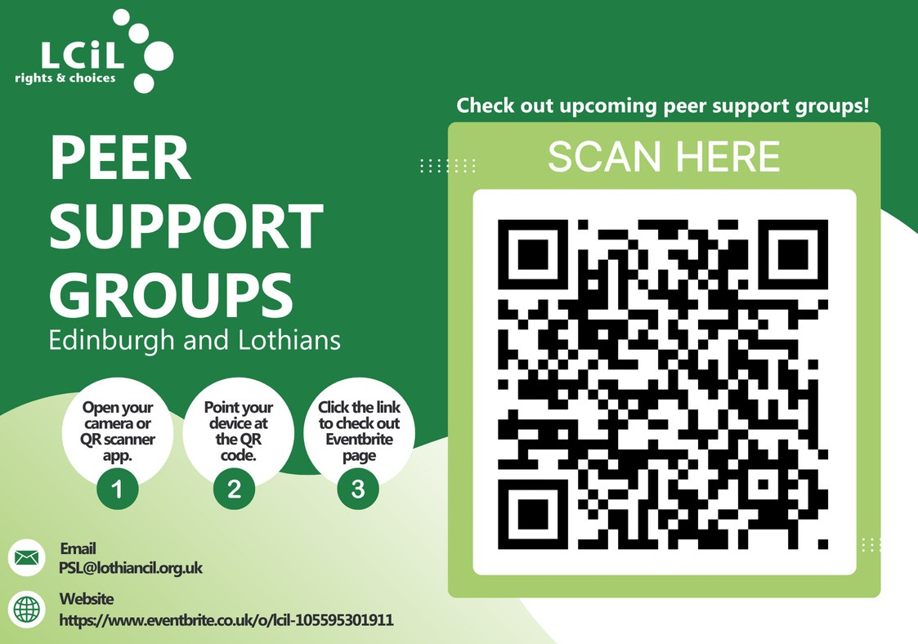
LCiL's Peer Support team are connecting communities across Edinburgh and the Lothians.
Groups are for disabled people, people with long-term health conditions, and older people. Groups give you the opportunity to discuss all aspects of self-directed support and social care options available to you.
To find out about your nearest support group and dates, please scan QR code or click link to eventbrite or contact: PSL@ lothiancil.org.uk
4

Advice: Recently Reported Scams
In the last newsletter we discussed scams and how to spot them. At the moment there is an Amazon scam, we thought it would be good to make you aware of.
One recent scam message reads:
"Our investigation confirmed that the seller violated Amazon's policies by offering non-compliant products. This seller has now been permanantly removed from our marketplace and penalized. To resolve this we're providing you with a full refund and a free replacement of a quality-compliant product. Visit the link below to view the details and secure the refund."
The message makes no mention of a specific product and the link provided leads to a copycat website which uses Amazon logos and branding to appear legitimate.
Here, you are asked to enter your Amazon account details and contact details, supposedly to allow your refund to be processed.
Some people have also received messages saying they have made a payment to Amazon. The messages include a 'helpline' number to call if they have not authorised the payment.
One woman who received this message was worried as she did not have an Amazon account, so phoned the number and spoke to someone who said he worked for the company. He apologised for the mistake and asked the woman to download an app to get a refund. This allowed the scammer to gain access to the woman's computer and therefore to her bank account details.


Shortly after the call, she noticed that over £2,000 had been taken from her bank account in two payments.



Advice & how to avoid
Amazon advise that if you receive a suspicious call, email or text which asks for personal information, a payment, or offers a refund you don't expect, you should not give out any personal information.
Amazon will never cold call you to ask you to make a payment. They will never call and ask you to install an app or download software which will allow them to access your computer remotely.
If you are not sure if a text message or email that appears to be from Amazon is legitimate, you can check the Message Centre via your account, which displays a log of authentic communications. 5

Canny Chef: Butternut & Bean Soup
LCiL's Canny Chef is back with another great recipe for only £2 (for 4 servings).
Thanks for the great feedback from our last recipe - someone contacted us to say they had used quorn instead of beef mince and it worked just as well.
This time it's a yummy soup to warm you up! I have given costs using the app from the cost of living workshops allowing me to shop around without having to go out in that really cold weather!
This soup will last 2-3 days in the fridge - remember to reheat thoroughly - ENJOY!


Instruction
- To start, chop the onion, garlic and butternut squash, and dice the potatoes.
- Put the onion with 3 tbsp water in a large non stick saucepan over a low heat.
- Cover and cook for 10 minutes or until soft.
- Uncover the pan add the garlic, and cook for 1 minute.
- Add the butternut squash, potato, 1 litre of stock and simmer for 10 minutes or until the potato is cooked.
- Drain the beans and stir into the mix and serve hot with parsley to garnish.

Ingredients

1 onion (12p - Tesco) 1 Garlic clove (28p - Lidl)
1 Butternut Squash (£1.50 each - Sainsbury's or frozen from Tesco for £1.25 - can use again & saves time cutting up too!)
1 medium Potato diced (79p for pack of 4 - Asda)
1 litre Veg Stock (95p for pack of 10 - Tesco) 400g can Cannellini beans (49p - Asda)
1 small bottle of dried parsley (£1 a jar - Tesco)

F O R M O R E T O P T I P S J O I N O U R C O S T O F L I V I N G W O R K S H O P S

6



Must-reads from Sarah in our Payroll team!
We're delighted and excited that Sarah Burchett in our Payroll team has a new book out. Sarah has been an avid writer for many years. Having published
2 non-fiction books as a co-author during her academic years, she now writes fiction – some light fantasy blended with history (like the book/series below) and some high fantasy. 4 novels and 1 collection of 3 linked novellas are now published, with more work in the pipeline.
NEW OUT: ‘Someone Else’s War’ by Sarah Burchett-Cook is the 2nd book in the ‘Rosa Chronicles Trilogy’. The 1st book, ‘Across the Veil’, was published in December 2024.
The story follows Rosa, a woman of mixed background – her father, a lighthouse keeper from Scotland, her mother a descendent of the long-lost, dark-haired Epiddi tribe. Rosa inherits certain abilities, (that some might call magic), and extreme long life from her mother’s side. But her mass of fair locks, inherited from her father, leads a shaman to call her ‘the golden-crowned child of two worlds’ – a woman with a destiny written long before she was born.
These two worlds are separated by a ‘Veil’ that few can cross, but Rosa leads a double-life on both sides of this invisible barrier, until one day everything changes.
Both these books, (and the other publications) are available from Amazon under the author name – Sarah Burchett-Cook. Book 3 in the trilogy is expected to be published in late spring or early summer.
You can also check out Sarah's website for more information on: https://www.sarahburchettcook.co.uk/

7

Have fun with our LCiL themed wordsearch!

Can you find all the words?







PAYROLL ADVICE INFORMATION KNOWLEDGE
PERSPECTIVE VOLUNTEERS EXPERIENCE AMBASSADORS
8

How we can support you
We support disabled people, people with long-term health conditions and older people. Find out more at www.lothiancil.org.uk

PROVIDING CRUCIAL SERVICES FOR DISABLED PEOPLE, PEOPLE WITH LONG-TERM HEALTH CONDITIONS,
AND OLDER PEOPLE IN EDINBURGH & THE LOTHIANS

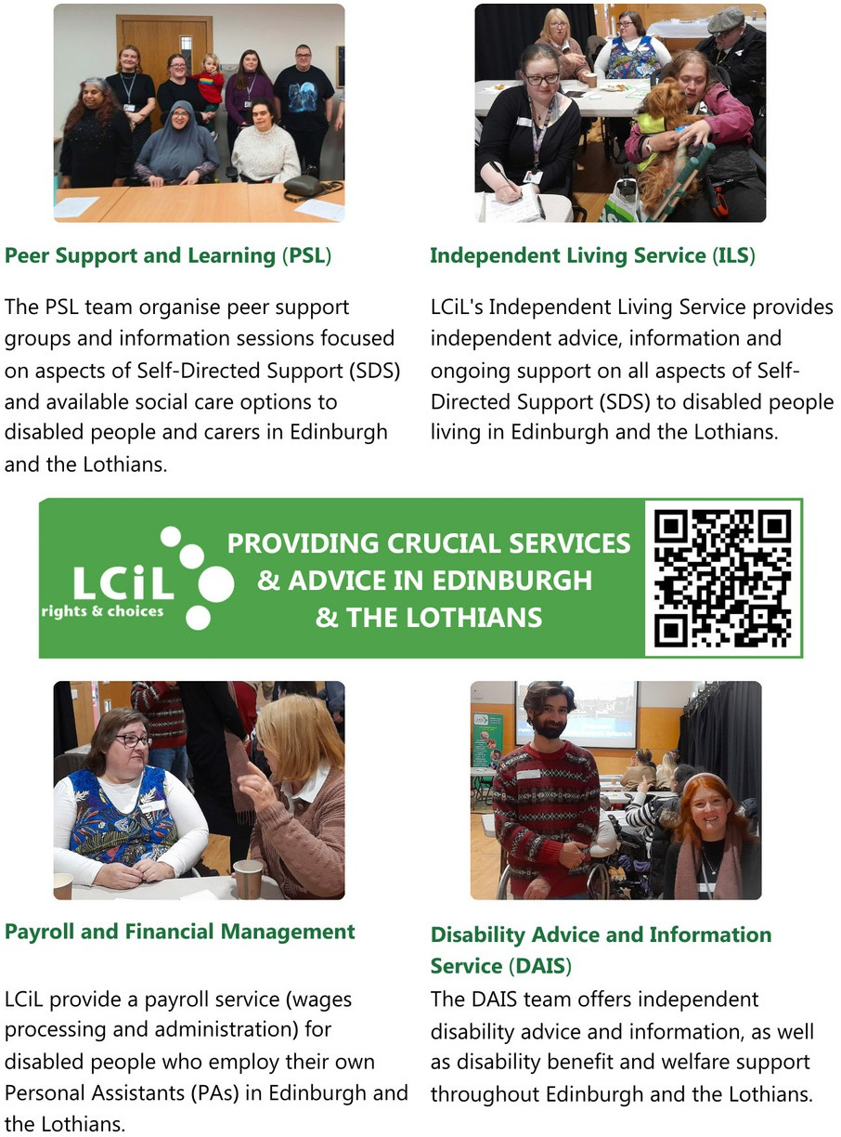

.
9



Did you find all the words...?

Wordsearch answers

1 0

HELP US MAKE INDEPENDENT LIVING A REALITY

LCiL supports disabled people, people with long-term health conditions, and older people across Edinburgh and the Lothians to take control, make choices, and live with confidence.
When you donate, you’re giving someone the chance to say:
“LCiL gave me the confidence to employ my own personal assistant—someone I chose and trust.”
“I didn’t know what benefits I was entitled to until I spoke with LCiL. They changed my life.”

“Meeting others in a peer group made me feel less alone, less worried and more hopeful.”

I can finally manage my support without feeling overwhelmed Service User
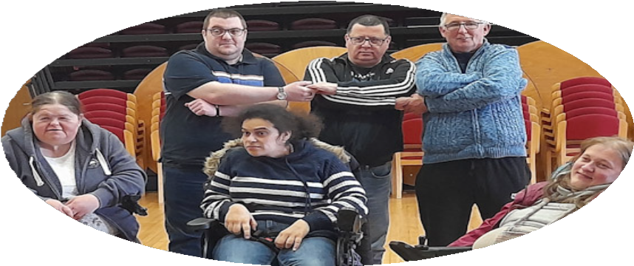

SUPPORT OUR WORK - DONATE TODAY!
Every donation helps support the work we do to provide services, advice and support for disabled people, people with long-term health conditions, and older people to live an independent life!
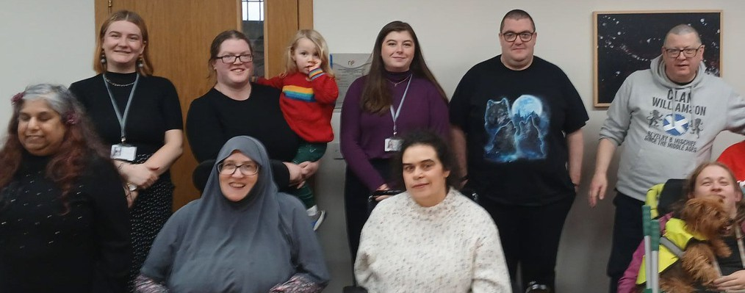
www.lothiancil.org.uk/sup port-us/make-a-donation



1 1



LCiL Membership

We are in the process of revamping our membership - keep an eye on our website and our socials for more information - coming soon!

Feedback

If you have questions or comments about anything you have read in this newsletter, or have feedback or news and information, you'd like to share - we'd love to hear from you!

Please email: communications@ lothiancil.org.uk

Contact Us

admin@lothiancil.org.uk 0131 475 2350
www.lothiancil.org.uk



Follow Us

Scan for web

Find out the latest info, news and events on our social media channels!

Lothian Centre for Inclusive Living (LCiL) is a Company Limited by Guarantee, Registered in Scotland No 129392. Scottish Charity No SC017954
Lothian Centre for Inclusive Living (LCiL)
Norton Park, 57 Albion Road
Edinburgh EH7 5QY 1 2

