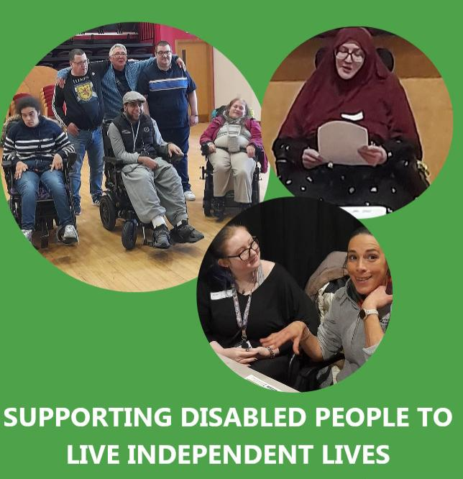

Lothian Centre for Inclusive Living (LCiL)

More info - Lothian Centre for Inclusive Living (LCIL)

Join Us as a Trustee and Help Shape a More Inclusive Future

Are you passionate about Disabled People’s Organisations, Independent Living, and creating real change? We are looking for enthusiastic and committed Trustees who bring skills relevant to Board governance and share our vision of equality, dignity, and choice for disabled people.

About LCiL - The Lothian Centre for Inclusive Living (LCiL) is a user-led, charitable organisation. We work alongside disabled people of all impairments, people with long-term conditions and older people, as well as parents and carers. Our work supports individuals and communities across Edinburgh, West Lothian, East Lothian, and Midlothian.

At the heart of everything we do is Independent Living. For us, Independent Living means disabled people having the same freedom, choice, dignity, and control as other citizens – at home, at work, and within the community. It is not about doing everything alone, but about having the right support, practical assistance, and opportunities to live an ordinary, fulfilling life.

Our Aims - LCiL exists to:
- Provide a range of services to support Independent Living, developed and managed by and for disabled people.

- Support the right for disabled people to live independently and take control of their own lives.

- Provide the opportunity for disabled people to further their own personal and professional development, including through peer support.

- Challenge the attitudes, and the physical and social barriers that create disability.

LCiL Management and Governance - The Lothian Centre for Inclusive Living operates as a charitable company with limited liability. There is a membership and an elected Board of Directors. As a Disabled People’s Organisation (DPO) more than half of the Board of Directors must be disabled people and the Chair must also be a disabled person.

Current Trustees: Balkishan Agrawal, Dugald McArthur, Elizabeth Pearston, James Nicol, Lucy Tait, Lyn Pornaro and Mandy Orr.

The Opportunity - LCiL is delighted to be recruiting up to three new Board members to join us at a truly pivotal and energising time in our journey. This is an exciting opportunity to help shape the next chapter of a vibrant, values-led Disabled People’s Organisation.

We are particularly keen to hear from people with lived experience of disability, people living with long term conditions, or those with a strong commitment to Independent Living and disability rights, who can also bring professional skills and fresh perspectives to our governance.

Who We are Looking For - We welcome applications from people with a wide range of backgrounds and experiences. At present, we are especially interested in individuals with skills or experience in:

- Business development
- Customer care and service design
- Volunteer coordination and support
- Communications and digital engagement
- Human Resources (HR)
- Governance and Company Secretarial matters
- Finance and fundraising
- Policy development

That said, we would love to hear from you even if your skills fall outside these areas. If you believe your experience, insight, or enthusiasm would strengthen LCiL, we are very happy to have a conversation.

Time Commitment and Support - Board meetings take place quarterly, are scheduled up to a year in advance, and are held online from 2.00–4.00pm.

Board members are also invited to attend our annual event for staff, volunteers, and trustees, usually held on a weekday.

You will be fully supported in your role, with:
- A welcoming induction programme
- Compulsory Disability Equality Training (DET)
- Ongoing support from fellow Board members, the CEO, and staff

Why Join LCiL? - As a Board member, you will have the opportunity to:
- Provide leadership and support to a Disabled People’s Organisation rooted in the Independent Living Movement
- Help shape the future of LCiL at a crucial moment of growth and renewal
- Support and challenge the CEO and Senior Management Team to make informed, values-led decisions
- Be part of a committed team ensuring LCiL remains accountable to its mission and to disabled people

What the Board Does - The Board works collectively to:
- Monitor and evaluate the organisation’s work and impact
- Set, review, and refine LCiL’s strategic objectives
- Plan for both the short- and long-term future of the organisation
- Oversee governance matters including policies, employment responsibilities, and organisational wellbeing
- Support staff through the Chief Executive to ensure policies and decisions are effectively implemented

What Being a Board Member Involves - Board members are asked to:
- Attend and actively participate in Board meetings
- Read and consider papers in advance and contribute thoughtfully to discussions
- Follow up on agreed actions
- Act in line with LCiL’s governing documents and values
- Represent LCiL professionally and positively ( when required)
- Maintain confidentiality at all times
- Help ensure the organisation is financially sound, well-governed, and legally compliant

Person Specification - LCiL Directors must:
- Be willing to become full members of LCiL
- Be committed to equality and inclusive practice
- Be open to learning and working within the Social Model of Disability
- Support the philosophy of the Independent Living Movement
- Have an interest in, or knowledge of, disability issues and the Disabled People’s Movement
- Be reliable, organised, and able to manage their time effectively
- Enjoy working collaboratively as part of a supportive team

Support and Accessibility - We are committed to removing barriers to participation. LCiL can arrange support to help Board members fulfil their role, including:
- Personal assistant support for meeting preparation and attendance
- Transport to in-person meetings when required
- Support when representing LCiL externally
- Payment of reasonable expenses

Before applying, we recommend arranging an informal conversation about the role, the Board, and the wider work of LCiL. Our CEO, Narek Bido, would be very happy to have a chat and answer any questions. To arrange this, please email HR@lothiancil.org.uk .

To apply, please send either:
- A letter of interest (maximum two sides of A4), or
- A short video (up to 5 minutes)

Please tell us:
- Why you would like to become a Trustee of LCiL
- What skills, experience, or perspective you would bring
- How LCiL could support you in your role
You may also include your CV if you wish.
Applications should be sent to HR@lothiancil.org.uk by 12 noon on Tuesday 21 April 2026.

Following review, shortlisted applicants will be invited to an informal interview (usually online). If both you and the Board feel the role is a good fit, we will offer a place on the Board on a trial basis.

Disability Confident Employer - LCiL is proud to be a Disability Confident Employer. We actively encourage applicants to share any access or support requirements with us at any stage of the process by emailing HR@lothiancil.org.uk.

We warmly look forward to hearing from you and welcoming new voices into the LCiL community.

