

**Application** **Pack**

**Chief** **Executive Officer**



**April 2025**

**Message from the Board**

Dear applicant,

Thank you for your interest in the exciting and important position of LCiL Chief Executive. As a Board committed to the success of LCiL, to Independent Living and to equal opportunities for disabled people, people with long-term conditions and older people, we are looking for an outstanding and dynamic individual to lead our organisation, its staff and volunteers.

Our leader will have the ability to articulate LCIL’s vision, aims, and strategies in a way that inspires and engages the teams, our service users, funders, allies and policy makers. They will understand and practice the social model of disability, have an understanding of, and believe in, Independent Living and will see as one of their main roles to embed these values in all levels of the organisation. They will champion diversity and inclusion while supporting person-centred support to service users, staff and volunteers. They will work with the ethos of “nothing about us without us” underpinning their practice.

Knowledgeable in the field of health and social care the LCiL Chief Executive will also have the skills to lead and manage our organisation through the current financial and policy landscape, supporting and enabling the Board to make fully informed strategic decisions.

Very importantly, while the role requires all features of a good communicator and of an individual with strong interpersonal skills, it also demands strength, resilience and ability to make difficult decisions when necessary.

To support our CEO in their role we will offer a strong induction process, a thorough handover from our current Interim CEO (including an overlapping period), ongoing mentoring and coaching if requested and training. We will introduce our Leader to other leaders in the Independent Living Movement and allies amongst disabled people, carers and colleagues from statutory services who work with our organisation. We know that they will be warmly welcomed by our friends and supporters.

Very importantly we, as members of the Board, will work with the successful candidate so that we have a strong, trusted and effective relationship to move the organisation forward. We are currently recruiting new trustees and may have just under half of its members new to the organisation when the new CEO starts the job. Although this may be a challenge this is also an opportunity to shape this important relationship.

For further information please feel free to contact me either by email [Florence@lothiancil.org.uk](mailto:Florence@lothiancil.org.uk) or by phone Monday to Wednesday on 07512 093024.

I wish you all the very best with your application.

Kind regards,

Florence Garabedian

Interim CEO

**Lothian Centre for Inclusive Living**

**Job** **Description**

**Job Title:** Chief Executive Officer

**Salary scale:** £50,000 to £55,000

**Responsible to:** The Chair and Board of Trustees

**Responsible for:** The Senior Management Team

**Job Purpose**: The Chief Executive is responsible for leading and developing LCiL. They will work collaboratively with the Board, staff, volunteers and other stakeholders to develop and implement a strategy for the organisation, ensuring LCiL employees are developed and supported in delivering their workplans, and to establish and maintain excellent collaborative relationships with all stakeholders to enable the delivery of the strategic aims, mission and vision of the organisation.

**Hours**: Flexibility between four or five days per week

**Location:** Based in Edinburgh with hybrid working arrangements (minimum 3 days working from the office).

Key Accountabilities

* Lead and develop the organisation in line with its Person-led roots.
* Provide inspirational leadership, direction and support to enable the development and delivery of an impactful and relevant strategy/strategic framework, working closely with the Board, staff and other stakeholders.
* Create a positive and trusting culture within the organisation to enable staff to self-empower, take initiatives and become positive agent of excellence on behalf of the organisation.
* Provide leadership and good governance to ensure LCiL’s financial resources are managed effectively, promoting a culture of financial transparency, identifying risks and taking appropriate action so that LCiL remains in good financial health, updating the Board on a regular basis.
* Work with the Board and employees to generate momentum and engagement in shaping LCiL as a one-stop-shop organisation.
* Ensure the Board is supported in meeting its legal governance responsibilities by managing the organisation well in line with role accountabilities, ensuring reporting meets governance requirements, relationships are positive and it has the overview of matching funding and resources to deliver LCiL strategic aims.
* Seek out, develop and nurture beneficial partnerships with supporters and funders so that there are opportunities to raise sufficient funds and ensure organisational sustainability.
* Represent LCiL and engage with national and local policy decision making process, in line with the roots of the organisation and the Independent Living Movement.

**Detailed Responsibilities**

Organisation/Internal Leadership and Management

* Be accountable to the Board of LCiL and support them in meeting their legal governance responsibilities.
* Lead the development and regular review of a refreshed organisational strategy/strategic framework.
* Lead and motivate staff and volunteers to deliver services and projects in line with the strategy/strategic framework.
* Directly line manage the Senior Management Team - Services and Development Lead, and Operations and Finance Lead.
* Fosters a culture of trust with and between staff members, operating with honesty, ethics, and transparency in both internal and external communications.
* Initiate and support a culture of cooperation between services and between members of staff.
* Work closely with the Services and Development Lead in promoting reflection, monitoring & evaluation and learning across the organisation.

Overall Overview of the Organisation’s Finances and Resources

* Take executive responsibility for the overall financial health and sustainability of the organisation.
* Provide detailed reports to the Chairperson, the Board of Directors and committees as required and to LCiL's Annual General Meeting.
* Support the Finance Officer and the Operations and Finance Lead in ensuring that the organisation’s infrastructure and work practice are fit for purpose.
* Working closely with the fundraiser, have the overview of matching funding and resources to the organisation’s strategic ambitions.
* Clearly communicate the organisation’s financial position to staff, board and key stakeholders ensuring ongoing transparency.

External Strategic Leadership and Planning

* Working closely with the Communications and Events Officer, develop, sustain and monitor LCIL’s public profile and ensure that the organisation’s values, strategies, plans and objectives are effectively communicated and promoted internally and externally.
* Strategically represent and promote the aims and objectives of LCiL throughout Edinburgh, the Lothians, and the rest of the UK.
* Have an overview of key local and national policy development relevant to LCiL's work and advise the Board of Directors and sub-committees.
* Maintain links with the wider disability movement and to ensure that the work of LCiL is informed by it and other new initiatives.
* Liaise with the Board of Directors, the Management Team and, where relevant, members, service users and other DPOs to prepare policy papers and / or respond to policy and legislative consultations as required.

**Supervision Received:**

The post holder will receive regular individual and group support and supervision in accordance with the terms and conditions of service. The post holder will be expected to attend staff meetings, team meetings, training courses, LCiL events and other meetings deemed appropriate to the functioning of the work.

**Complexity and Creativity:**

Lothian Centre for Inclusive Living (LCiL) is an innovative and demanding organisation which has a significant impact on the lives of disabled people, their carers, and families.

The provision of support which enables disabled people to increase their level of self-control in all aspects of their lives is highly complex. It requires sensitivity, a knowledge of services which are available to disabled people, up-to-date knowledge of relevant legislation, an understanding of the concerns of disabled people, a commitment to the Social Model of Disability, and an understanding of the Independent Living philosophy.

The CEO will take initiative on a wide range of tasks and work as part of the leadership team to ensure LCiL maintains an integrated approach. The post holder must be able to work under pressure within a challenging and sometimes uncertain social, political, and financial climate.

LCiL is a disability confident employer. It is essential that the post holder can work within an organisation which is led and managed by disabled people.

**Job Title:** Chief Executive Officer

**Job** **Specification**

|  |  |  |
| --- | --- | --- |
|  | **Essential** | **Desirable** |
| **Education and Qualifications** | * University or equivalent qualifications | * Qualification in health and social care |
| **Skills and Abilities** | * Strong leadership and management skills * Strong planning, organisational and time management skills. * Strong financial skills and ability to manage multi-funded budgets * Excellent communication skills * Ability to capture, evaluate and interpret data * Skilled in preparing and presenting reports and management information on key performance indicators to internal and external stakeholders * Ability to develop a supportive and performance-focused team * Good IT skills. * Ability to work positively with service users, partners, and a variety of different stakeholders. |  |
|  | * Understanding of independent living philosophy and the social model of disability * Experience or proven knowledge of the Third Sector * Knowledge of the health and social care landscape, SDS in particular * Experience of working with partner agencies * Knowledge of data protection compliance * Experience of working in a person-centered, outcome-focused ways * Experience of monitoring and evaluating programmed or services. * Demonstrable understanding of equal opportunities and anti-discrimination practices and requirements | * Knowledge of Self-Directed Support legislation, strategy, and policy. * Work or personal experience in a user-led environment. |

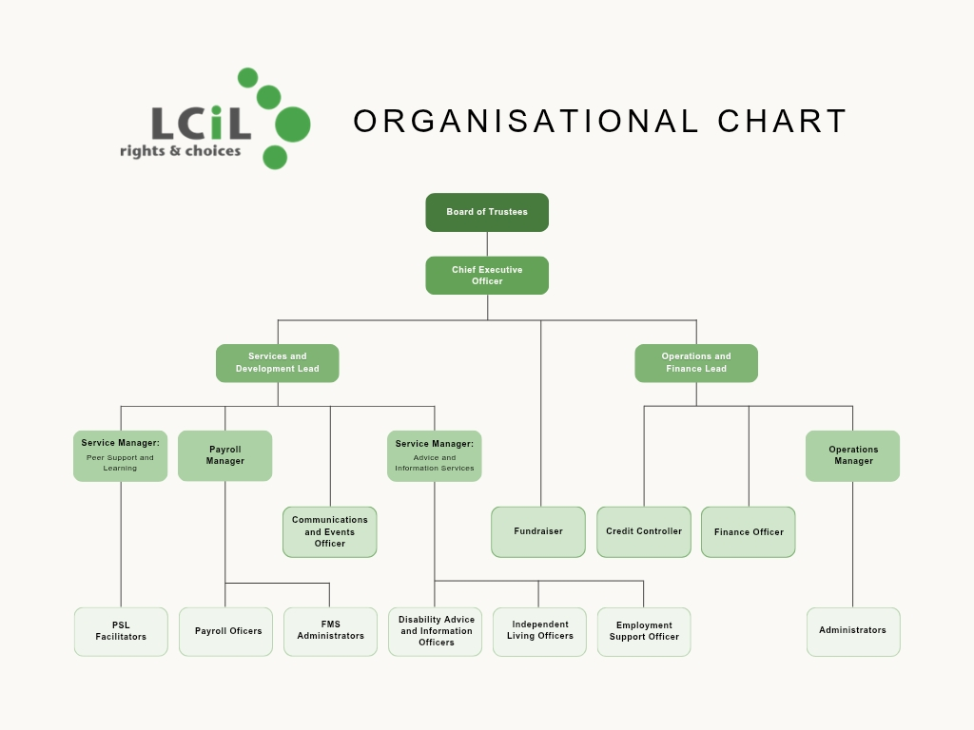

**Job Title:** Chief Executive Officer

**Recruitment process**

Please send a CV and covering letter of interest demonstrating that you have the skills and experience to do the job.

Please also complete and send Equal Opportunities and Criminal Convictions forms.

Please send to: [HR@lothiancil.org.uk](mailto:HR@lothiancil.org.uk)

**Closing date for applications is 14 May at 5pm.**

**Interviews** of successful applicants will take place in person and in two stages, on

* 28 May 2025
* 3 June 2025

They will be attended by the Interim CEO, the Services and Development Lead and one or two Board members.

The successful candidate will have a 6 months probation period, with an extensive induction programme and regular reviews.

If you have any questions or would like to discuss aspects of the position please email the Interim CEO, Florence Garabedian [Florence@lothiancil.org.uk](mailto:Florence@lothiancil.org.uk) or phone her on 07512 093024 Monday to Wednesday.

LCIL is an equal opportunities employer. Applications from disabled people are particularly welcome. We are also a disability confident employer and as such, if you require any support during any part of the recruitment process, please contact [HR@lothiancil.org.uk](mailto:HR@lothiancil.org.uk).