Lothian Centre for Inclusive Living (LCIL)  LCIL is a user-led organisation providing a range of services that enable Disabled People to live independently in the community of their choice. | 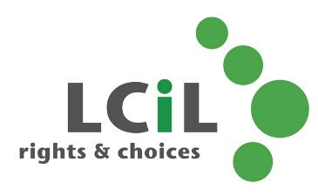
Service Manager – SDS Financial Support Services – 30 hours per week

£29,911 (FTE 35.75hrs) pro rata

This is an exciting opportunity to join our team and help shape and develop our work with disabled people across Edinburgh and the Lothians.

We’re looking for an experienced Manager who enjoys working in a fast paced environment, providing day-to-day leadership & guidance to our payroll and financial management service teams to ensure accurate, seamless, efficient and timely execution of our payrolls in accordance with UK laws, regulations and company policies, and drive process improvement/standardisation across payroll activity.

Our Payroll Team currently provides a comprehensive, computerised payroll service for an average of 650+ Personal Assistant Employers who are employing around 1,000+ Personal Assistants per month. The Personal Assistant Employers figures continue to increase at a steady rate. The number of PAs employed fluctuates on a monthly basis.

The Financial Management Service provides financial support of holding bank accounts in service users’ names to ensure that they are able to access SDS care packages. This service means that we ensure all payroll is paid on time and correctly, we also support the service user with the management of this account. The number of service users can also fluctuate however, an average of around 150-200 service user’s access this service per month.

Please refer to the job description and personal specification for further information.

This is a part time role to be worked over 30 hours per week, preferably over 5 days.

We offer generous pension & death in service schemes, as well as a supportive working environment.

Closing date – Monday 30th October at 12 noon
Interview dates – tbc

If you wish to have an informal discussion about this role, please call Caitlin McPherson or Gaby Nolan on 0131 475 2350.

LCIL is an equal opportunities employer. Applications from disabled people are particularly welcome.

LCiL are a disability confident employer and as such, if you require any support during any part of the recruitment process, please contact HR@lothiancil.org.uk

A company Limited by Guarantee. Registered in Scotland 129392. Charity No SC/017954

