**The Cost-of-Living Crisis’ Effect on the Nation’s Mental Health**

**What is the ‘Cost of Living Crisis’?**

It’s when the prices of essentials increase, such as:

* Food
* Gas
* Electricity
* Fuel for vehicles

In 2022, the cost of living has increased at the fastest rate in 40 years [1].

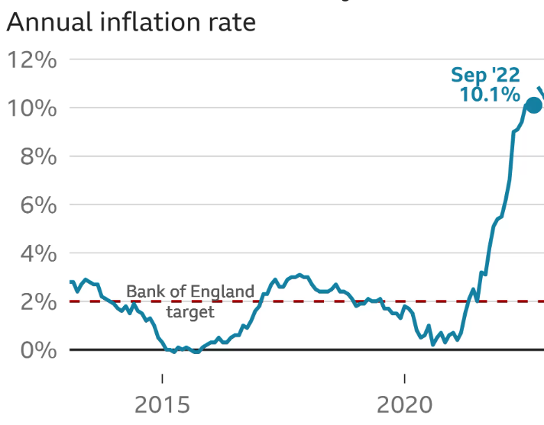[1]

**What does this mean for people’s mental health?**

* Around three in four adults (77%) reported feeling very or somewhat worried about the rising costs of living [1]
* Women were more likely than men to report being worried Women (81%) were more likely than men (73%) to report feeling very or somewhat worried about the rising costs of living.
* A proportion of men (7%) reported being not at all worried about the rising costs of living than women (3%).
* Those aged between 30 and 69 years were more likely to report feeling very or somewhat worried than those aged 70 years and over. 82% of those aged 30 to 49 years reported feeling very or somewhat worried about the cost of living, compared to just 70% of those aged 70 years and above

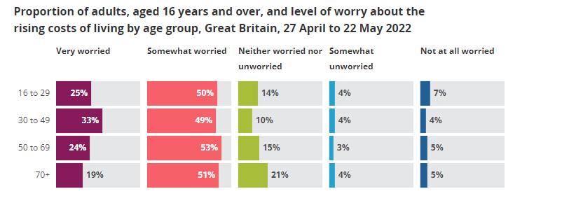

* Those aged 16 to 29 years were generally more likely than other age groups to feel somewhat unworried or not at all worried (11%)
* 82% of disabled people (four in five) said they were feeling very or somewhat worried about the cost-of-living crisis, compared with 75% of non-disabled people [2]

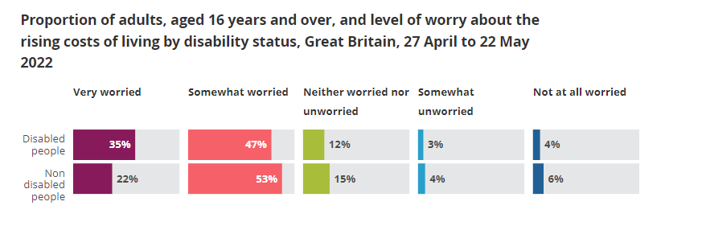

* 90% of those living with a dependent child aged 0 to 4 years (9 in 10 parents) report feeling very or somewhat worried about the cost-of-living crisis, compared with 76% of non-parents or parents not living with a dependent child [3]

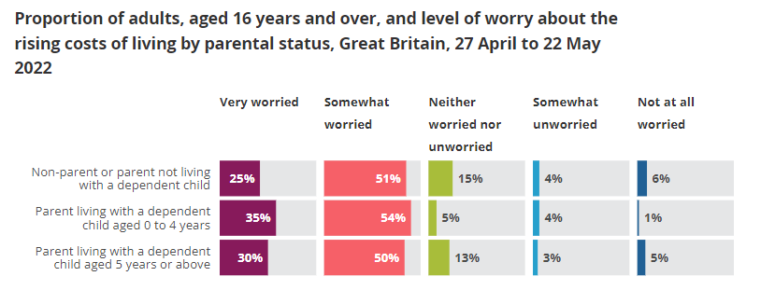

* 3 in 10 adults (31%) earning less than £10,000 or more per year felt very worried about the rising costs of living compared with just 1 in 10 adults (12%) with a gross personal income of £50,000 or more per year. Therefore, adults were less likely to feel very worried about the rising costs of living as their gross personal income increased [4]

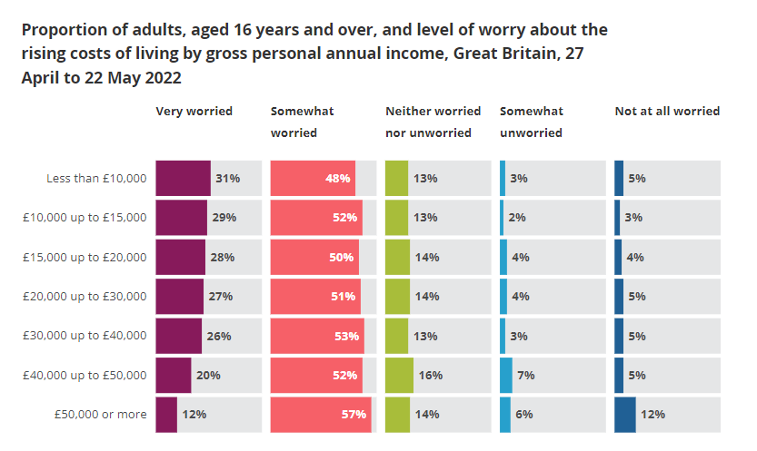

* Unemployed adults (36%) were more likely to be very worried compared with retired adults (18%) [5]
* Adults who were divorced or separated (36%) were more likely to be very worried than adults who were widowed (21%) [6]
* Adults who rent their home (85%) and adults currently paying off their mortgage, or who have taken out a loan to help purchase their property (78%), were more likely to be very or somewhat worried compared with adults who own their house outright (69%) [7]

**References**

[1] https://www.ons.gov.uk/peoplepopulationandcommunity/wellbeing/articles/worriesabouttherisingcostsoflivinggreatbritain/apriltomay2022

[2] https://www.bbc.co.uk/news/business-12196322

[3] https://commonslibrary.parliament.uk/world-mental-health-day-rising-cost-of-living-and-mental-health/

[4] https://www.moneyandmentalhealth.org/money-and-mental-health-facts/

[5] https://www.ons.gov.uk/peoplepopulationandcommunity/personalandhouseholdfinances/expenditure/articles/whatactionsarepeopletakingbecauseoftherisingcostofliving/2022-08-05

[6] https://www.ageuk.org.uk/information-advice/money-legal/cost-of-living/

[7] https://www.bristol.ac.uk/news/2022/september/disabled-households-and-cost-of-living-crisis.html

1.