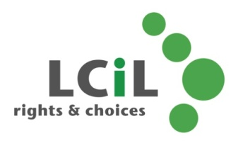

Lothian Centre for Inclusive Living

Volunteer peer group co-facilitator

Closing date for applications: end of day Wednesday 26th May 2021

If you have any questions or need support when filling out the application form, please get in touch with us at SDS@lothiancil.org.uk and we’ll do our best to help!

Lothian Centre for Inclusive Living

Volunteer peer group co-facilitator application form

Name
Address
Postcode
Phone
Mobile
Email

Please complete the following sections. Use as much space as you need to, adding extra pages if necessary.

Relating your answers to the person specification and role description, please tell us about:

- Your lived experience as a disabled person/ person with a long-term condition/ parent carer. Please only share as much as you are comfortable with – confirming you have lived experience is enough!

- Any relevant training or education that you would like to tell us about (you can leave this blank).
- Relevant skills, knowledge or experience that will help you to carry out the role of peer group co-facilitator (these might come from your personal life, volunteering or work).

- Why do you want to be a group facilitator? What’s exciting about it for you?

Signed: | Date:

Please return your completed form to:
sds@lothiancil.org.uk

or post to:

SDS Team
Lothian Centre for Inclusive Living
Norton Park
57 Albion Road
Edinburgh
EH7 5QY

