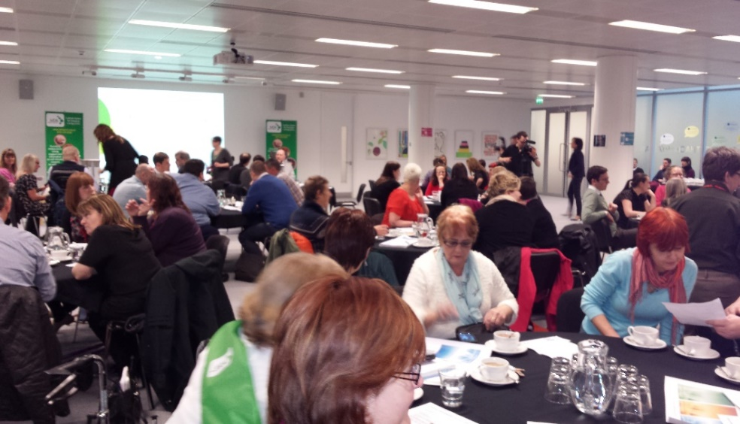

Spring 2019

**Lothian**

**Disability**

**News**

**News**



**Spring 2018**

**A step in the right direction for social security…timeline in Scotland**

Over the next few years Scotland will have more powers to administer certain benefits. A new Social Security Agency for Scotland has already been set up to start delivering a small number of benefits to certain groups of people including carers and families on a low income.

**Inside this edition:**

A step in the right direction for social security…page 1

New Midlothian parent and carers peer support group…page 3

A day in the life off LCiL operations…page 6

Assertive communication workshop…page 8

News from elsewhere…page 9 onwards

Eventually, it will have responsibility for administering other benefits, including some disability and older people’s benefits. Based on what we know at present, we have provided a brief timescale of what is happening when, with the new social security arrangements in Scotland:

**2017-2021** Experience Panels are up and running, providing ‘user input’ into the design and delivery of new Social Security Agency. Certain groups of people are being targeted to give specific feedback e.g. those in rural communities and ethnic minorities.

**September 2018** - Carers Allowance Supplement becomes available to carers who are already claiming Carers Allowance. It is a twice annual payment of £221 paid directly to carers – there is no need for carers to claim this – those eligible will receive a letter directly in advance to let them know when a payment will be made to them.

**November 2018** - New regulations issued about the functions of tribunals hearing social security cases in the devolved Scottish system.

**December 2018** - Best Start Grant Pregnancy and Baby Payment take over Sure Start Grants in Scotland. Pays £600 on the birth of a first child and £300 for each sibling born thereafter.

Two additional payments of £250 will help with the costs of early learning and school preparation costs and will be open for applications by summer 2019.

To be eligible for the Pregnancy and Baby Payment, the family must live in Scotland and be in receipt of a qualifying benefit (low income)

Payment is open for applications via the freephone helpline on 0800 182 2222, by post or online at [www.mygov.scot/pregnancyand-baby-payment](http://www.mygov.scot/pregnancyand-baby-payment)

**January 2019 –** The Draft Social Security Charter published. This is subject to approval by the Scottish Parliament.

**February 2019 -** The Scottish Government is consulting on eligibility criteria and format of the Job Grant, a new benefit which will be delivered to support young people moving back into employment. The grant will be paid to 16-24 year olds (up to 26 years old for care leavers) who have been out of paid employment for 6 months or more and who have been in receipt of a qualifying benefit specified by the Scottish Government. You can find the consultation via the link below and the consultation will remain open until 9 April 2019: <https://consult.gov.scot/social-security/job-grant-eligibility-criteria-consultation/>

**Summer 2019** - Launch of a new Funeral Expense Assistance benefit. (Replacing the UK Government's Funeral Payment, the new Funeral Expense Assistance).

**Autumn 2019** introduce a Young Carer Grant from autumn 2019 to help carers aged 16, 17, and 18 if still in school.

**2020: Benefits for disabled people and people with ill health to be devolved to Social Security Agency (include currently):**

* Disability Living Allowance (DLA).
* Personal Independence Payment (PIP).
* Industrial Injuries Disablement Benefit (IIDB).
* Attendance Allowance.
* Severe Disablement Allowance (SDA): (now closed to new applicants).

More info: [https://www.gov.scot/policies/social-security/](https://www.gov.scot/policies/social-security/benefits-disabled-people-ill-health/) Social Security Scotland, are available on 0800 182 2222.

**Other news from services at LCiL:**

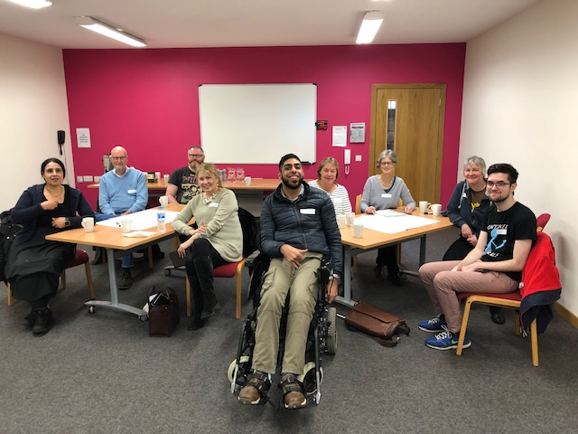Last month LCiL Trainer, Omar Haq delivered Disability Equality Training (DET) to the Leith branch of the Labour party. Here’s the photo from the event. For more details about DET training visit our website at: <http://www.lothiancil.org.uk/our-services/training-service/services-training-training-for-organisatins/> or contact us directly on 0131 475 2350 or email: [admin@lothiancil.org.uk](mailto:admin@lothiancil.org.uk)

**New peer support group for parent carers in Midlothian**

In November last year LCiL and VOCAL worked in partnership to host a ‘Getting it Right for Your Child’ Workshop.  The workshop is for parent carers of disabled children and children with additional support needs.  This workshop provides a space for parent carers to get together and explore opportunities around support options, find out what their rights are in regards to self-directed support and the benefits system and increase their confidence when it comes to seeking and asking for support. Additionally it was a great opportunity for parent carers to hear about the specific support they can get from LCiL and VOCAL.  We received good feedback from participants including;

*“I learned about lots of different support systems. Good advice on preparing for an assessment.”*

*“I really enjoyed working in groups and getting to know other parents carers.”*

Following the good feedback LCiL and VOCAL received we decided to start a new peer support group for parent carers in Midlothian.  We held the first meeting of this peer support group in January, where parent carers could help us design the group format.  It was decided that the group will meet once a month at VOCAL Carers Centre in Dalkeith and will be jointly facilitated by LCIL and VOCAL.  The next peer support group meeting is **Monday 18th March 10.30-12.30 followed by lunch** (see the flyer below for details).  If you are interested in attending please contact VOCAL Midlothian on 0131 663 6869 or email [midlothian@vocal.org.uk](mailto:midlothian@vocal.org.uk)



**Parent and carer peer support group**

Please join us for a new peer support group for parents and carers of disabled children and children with additional support needs. The parent and carer peer support group gives parents and carers the opportunity to:

* Meet other parents and carers
* Explore ideas and opportunities around support
* Find out practical information, resources and information on who to ask
* Develop skills and build confidence
* Hear from guest speakers and organisations on a range of topics

**When:** Monday 18th March 10.30-12.30 followed by lunch

**Where:** Midlothian Carer Centre, 30/1 Hardengreen Estate, Dalhousie Road, Dalkeith, EH22 3NX

Lunch and refreshments will be provided

To book a place or to find out more information about the group, please contact VOCAL Midlothian on 0131 663 6869 or email [midlothian@vocal.org.uk](mailto:midlothian@vocal.org.uk)

**New faces at LCiL:**

**Here we welcome some new faces at LCiL to the staff team…**

**Name**: Lyn Pornaro

**Job Title**: Self Directed Support Programme

Co-ordinator

**What does your role at LCiL involve?:** The SDS Development Programme runs to engage with, and provide self-empowering opportunities to, Disabled People and those with Long Term Conditions, in order to live an independent life. We also work with parent carers of disabled children and those with additional support needs. My role is to co-ordinate and develop the programme, whilst also assisting with the facilitation of our workshops and peer support groups.

**If a film was made about your life what would it be called?** ‘Itchy Feet’ - Having suffered from chronic atopic eczema all my life, I am very itchy! When I was 9 we moved from Scotland to South Africa and after returning, I have itchy feet in where I live and also how I live my life – always wanting to get things moving and not standing still!

**Name:** Kirsty Summers

**Job title**: SDS Development Worker

**What does your role at LCiL involve**: I started with LCiL in January 2019 and work part time, along with Lyn and Emma, my colleagues in the SDS Development Programme team. I deliver a programme of workshops and peer support groups for disabled people and people with long term conditions and parents and carers. These groups and workshops offer people the chance to learn new skills, increase their knowledge, meet new people and increase their confidence. Peer support is built on respect, empathy, shared responsibility and mutual benefit.

**If your life story was made in to a film, who would you want to play you and why**? I would pick Sandra Bullock to play me in a film, mainly because she doesn’t seem to take herself too seriously. I have a bit of a tendency to float through life but I’m not afraid of a challenge – and Sandra doesn’t seem too afraid of that either. She collected her Razzie in person after all…

**Day in the life of…LCiL Operations:**

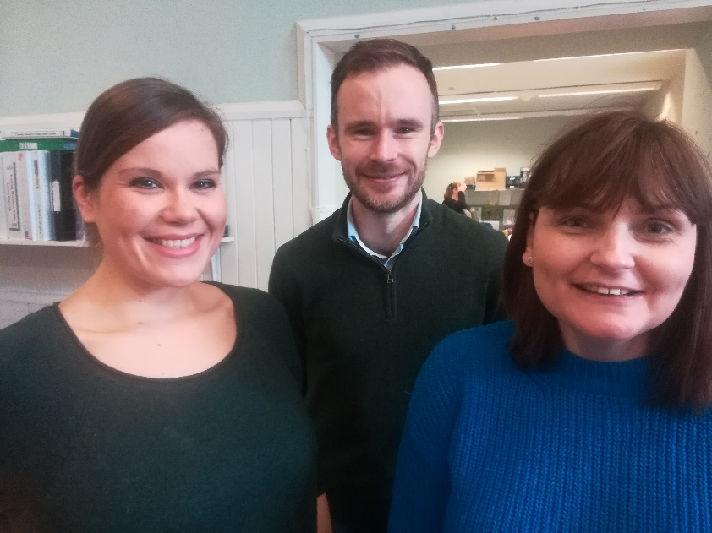Kelly Jack, Lisa Milburn, and Matthew Curry are many people’s first point of contact with LCIL, either by telephone or in person. Together they provide assistance and guidance with your queries. If you are looking to know more about what services LCIL can provide, or if you are an existing service user, they are happy to help with directing you to the relevant department or answering your query directly.

Kelly is the Administrator for LCIL. Kelly provides administrative support, and guidance to outside queries by telephone or email. Kelly is also very hands on with the Personal Assistant (PA) Recruitment database. She is also getting into the payroll processing aspect of the organisation and is an extremely valuable member of the team. She loves helping people, and is a super cat-mother to Smudge and Milly.

From left to right: Lisa, Matthew and Kelly the LCiL Operations team.

Lisa works three days a week as LCIL’s Administrator, and two days as the Administrator for the Self Directed Support Program. She also provide administrative support to training events and is a very personable point of contact for people who would like to know more about training and development opportunities. She can be heard in the office, usually eating carrots and/or cucumbers, probably was a rabbit in a previous life…

Matthew is the Financial Management Service Administrator. His role is mainly focused on the management of Enhanced Service Users’ information and administration of invoices and payroll. He is also involved in the administration of the office including the recording of incoming mail. His favourite part of the role is meeting the expectations of, and providing value to service users.

**Winter Fuel Payments…don’t miss out:**

If you were born on or before 5 November 1953 you could get between £100 and £300 to help you pay your heating bills. This is known as a ‘Winter Fuel Payment’ and is usually paid automatically if you are eligible and you get the State Pension or another social security benefit (not Housing Benefit, Council Tax Reduction, Child Benefit or Universal Credit).

Most payments are made automatically between November and December. You should get your money by 14 January 2019. If you haven’t been paid and/or became eligible for this, the deadline for claiming payments for winter 2018-19 is the 31st of March 2019. If you do not get your payment, call the office that pays your benefits - their details are on any letters they sent you.

**Voluntary living wage:**

The voluntary living wage has increased by 25p per hour, rising from £8.75 to £9.00 an hour for employees working across the UK, as announced by the Living Wage Foundation.

The voluntary living wage is distinct from the statutory national living wage, which is paid to employees aged 25 and over. The national living wage rate is currently set at £7.83 an hour; this is due to increase to £8.21 an hour from April 2019, in line with the Autumn Budget 2018.

**August 2020: Childcare costs:**



The Scottish Government have asked all councils to extend the provision of free childcare to 1140 hours, the equivalent to 30 hours a week for all children aged 3 and 4, by the year 2020. At present this is 600 hours across a year. Children will receive funding from the term after their 3rd birthday. Visit your local council's website to find out what is available in your area.

**City of Edinburgh Council – apply for Discretionary Housing Payments online:**

****City of Edinburgh Council have a new service for people who can claim a Discretionary Housing Payment (DHP) online. DHPs are for people who are struggling to meet their rental costs. It can help, for example:

* Are seeking more affordable accommodation and require assistance with a deposit, rent in advance or removal costs.
* Are affected by the introduction of the benefit cap and are seeking employment.
* Have been affected by previous Housing Benefit changes such as the extension of the Local Housing Allowance shared room rate to under 35s.
* Have higher living costs because of an impairment or long term condition.

The award of a DHP is a discretionary decision and there is no statutory right to a payment. Each application will be treated strictly on its own merits. Any payment is likely to be for a short period only. More information and the application is available at: <http://www.edinburgh.gov.uk/dhp>

**Assertive communication workshops**

**Are you a disabled person, or someone with a long-term condition?**

**Do you live in Edinburgh or the Lothians?**

**Do you want to learn how to:**

* be more assertive?
* give yourself the best chance of getting what you need

by preparing well for meetings or assessments?

* challenge decisions?

**…and would you like to:**



I’d like …

* meet new people?
* increase your confidence?

**in a relaxed and friendly atmosphere…**

**…then come along to our workshops!**

**There will be two sessions:**

**Assertiveness 1**

10.30am – 2.30pm, **Tuesday 26th March 2019**

Norton Park Conference Centre, Albion Road, Edinburgh EH7 5QY

At this workshop we’ll cover different ways of communicating and their effects, and you’ll have a chance to think about and plan how to make a case for something you need.

**Assertiveness 2**

10.30 – 2.30pm, **Tuesday 9th April 2019**

Norton Park Conference Centre, Albion Road, Edinburgh EH7 5QY

This workshop will give you the chance to discuss how you used what you learned in Assertiveness 1 and to take your skills further.

**Please note:** you **must** do Assertiveness 1 before you do this workshop.

It’s great if you can come to both, but you’re welcome just to do Assertiveness 1 on its own.

Lunch and refreshments will be provided, and if needed we can organise and pay for transport if you live in Edinburgh or the Lothians.

To find out more and to book, contact: **Lisa Milburn** at LCiL on **0131 475 2554**

or email[lisa.milburn@lothiancil.org.uk](mailto:lisa.milburn@lothiancil.org.uk)

**Getting it Right for your Child**

**Are you a parent or carer of a disabled child or young person, or a child with additional support needs?**

**Do you want to:**

* Meet other parents and carers?
* Explore opportunities around support?
* Improve your knowledge of your rights?
* Increase your confidence to ask for the support you need?
* Find out about practical information, resources and who to ask for more help?



**In a relaxed and friendly atmosphere…**

**…then come along to our workshop!**

**Where and When**

**Session 2**

10.30am – 2.15pm, **Tuesday 19th March 2019.** Norton Park Conference Centre, Albion Road, Edinburgh EH7 5QY.

We’ll look at what support you need for your child, and how to prepare for an assessment or important meeting

The workshops are **free** and lunch and refreshments are provided. To find out more and to book, contact: **Lisa Milburn** at LCiL on **0131 475 2350/2510** or email[Lisa.Milburn@lothiancil.org.uk](mailto:Lisa.Milburn@lothiancil.org.uk)

**NEWS FROM ELSEWHERE:**

**GameChanger lunches:**

Cyrenians, working in partnership with Hibernian and NHS Lothian, provides free lunches at their weekly GameChanger events at Easter Road Stadium on a Monday at 12.00.

The aim is to provide a free nutritious meal whilst bringing people together to combat loneliness and create new friendships as part of the work of the GameChanger partnership.

For more information contact 0131 554 3900 or email: [amandasomerville@cyrenians.scot](mailto:amandasomerville@cyrenians.scot) or visit: [www.cyrenians.scot](http://www.cyrenians.scot)

**FREE GARDENING AND PLANTING WORKSHOPS, SPRING 2019**

**CRAIGMILLAR COMMUNITY GROWS (CCG)**

This Spring Craigmillar Community Grows are running some workshops and events, which are all designed to be as accessible and set at a low exercise level where possible. For more, details please see the contact details below.

13th March: HERBAL WORKSHOP, FRESH START GARDEN (takes places on the 2nd Wednesday of every month).

Meeting at the garden behind Robin Chapel’s court at the Thistle Foundation (which is based at: 13 Queen's Walk, Edinburgh EH16 4EA) on 13th of March, 1.00-3.00pm. Come and make some syrups to keep colds at bay using local herbs. Meets at on the **second Wednesday** of every month. Hot teas and coffees provided.

9th APRIL: HERBAL FORAGING WALK (ON PAVED PATH)

Come for a foraging walk with Carr Gomm and Edinburgh & Lothian Greenspace Trust and discover edible plants in your local park. Please, wear suitable clothing and waterproof protection if that applies. Meets outside Castleview Primary School (2D Greendykes Road, Edinburgh EH16 4DP), **9th of April, Tuesday at 10 am**. The program finishes at noon latest but participants are welcome to stay as long or as little as they would like to. The distance of the organised walk to cover is about half a mile, all on wheelchair accessible grounds and the stops can be flexible, based on the participants coming along. Interactive session!

17th APRIL: PLANTING WORKSHOP AT WAUCHOPE GARDEN

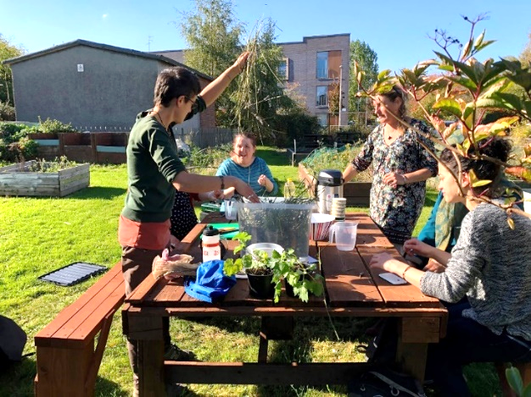Come and find out how to get started with your raised bed or garden. Meets at Wauchope Garden, at the bottom of Wauchope Terrace (655 Niddrie Mains Terrace, Edinburgh EH16 4NX) on Wednesday 17th of April from 1.00-3.00pm. The entrance of garden is accessible but not all of the garden grounds are fully, it can be muddy depending on weather also. Plants are placed in raised beds also. We will plant and give out free seeds, and tea and coffee will be available too.

Photo above 1 Karin the project coordinator running a herbal workshop at Wauchope Terrace.

For more details and any enquiries contact Karin Chipulina, Project Coordinator for the workshops on: 07824 8383 64 or email: [karinchipulina@carrgomm.org](mailto:karinchipulina@carrgomm.org)



**TIME 4 MUM**

**FIRSTHAND LOTHIAN’S EDINBURGH BASED PROJECT**

Time 4 Mum is a project from Firsthand Lothian, aimed at increasing the personal confidence and connections of Mums in Edinburgh. Mums benefit most from the project by recognising that setting aside 2 or 3 hours a week to do something they previously enjoyed or learn a new skill impacts positively on their own physical and mental wellbeing.

The 12 week period allows them time and space to do something for their own personal development regularly and get into a good routine with support. The hope is to be able to sustain this after the initial input.

Examples of support they have provided in the past includes:

* help with working on driving theory test;
* help getting set up with gym membership and buddying to the gym;
* accompanying to swimming;
* attending art and community cooking classes and volunteering sessions;
* linking in to ESOL (English as a Second Language) courses, and counselling.

Sometimes it is about accessing resources and information which is particularly difficult for mums new to the area, locality and or Scotland.

At present the program is for mothers who have childcare in place – the focus is on their free time activities. The sessions are accessible for disabled Mums but workers cannot assist with care and moving tasks. Personal Assistants can join to enable the participants

To find out more and get in touch contact Jan Holden, Project Coordinator on 0131 523 1322 or email: [Jan.Holden@firsthand-lothian.org.uk](mailto:Jan.Holden@firsthand-lothian.org.uk)

**Other facilities available for parents or carers by Firsthand:**

Firsthand Lothian aims to increase resiliency and improve wellbeing of vulnerable, disadvantaged families and families with a disabled child or children. Delivered in the family home and local community they provide support and regular respite for parents, children and families affected by having a child with an impairment, from birth to 18 years of age. Firsthand is contracted by the City of Edinburgh Council to deliver Early Years Services in the family home. More information is available also on their website at: [www.firsthand-lothian.org.uk/what-we-do](http://www.firsthand-lothian.org.uk/what-we-do)

#### **D:\Communication\Branding\Grapevine.jpgGrapevine Disability Information and advice**

#### Grapevine, part of LCiL, provides free and confidential disability information and advice to anyone in Edinburgh.

#### Our advice line is available Mon-Fri, 10am-4pm on 0131 475 2370.

#### Email enquiries: [grapevine@lothiancil.org.uk](mailto:grapevine@lothiancil.org.uk).

#### We also provide face-to-face appointments for people aged 16 and above in Edinburgh who require assistance with disability benefit forms, specifically Personal Independence Payment (PIP) (age 16-64) and Attendance Allowance (age 65 and above).

#### Grapevine is part of Lothian Centre for Inclusive Living (LCiL). LCiL works with disabled people, people with long-term conditions and older people, parents and carers in Edinburgh Lothians. A full range of support, services and workshops/events is available at: [www.lothiancil.org.uk](http://www.lothiancil.org.uk) or you can sign up to our mailing list via our website at: [www.lothiancil.org.uk](http://www.lothiancil.org.uk)

#### Alternatively get in touch with us directly on 0131 475 2350 (Mon-Fri, 10am-4pm), email us at: [admin@lothiancil.org.uk](mailto:admin@lothiancil.org.uk) or write to us at: LCiL, Norton Park, 57 Albion Road, Edinburgh, EH7 5QY

You can also find us on Facebook:

Or follow us on Twitter: @LothianCIL

LCiL is a registered charity, number SC017954