

**Winter**

**2019**

**Lothian**

**Disability News**

**Welcome to our Christmas Newsletter**

*In this Edition….*

* Christmas message from our CEO
* Grapevine News
* Independent Living Team News
* Payroll Team News
* SDS News & Workshop Dates
* Donations

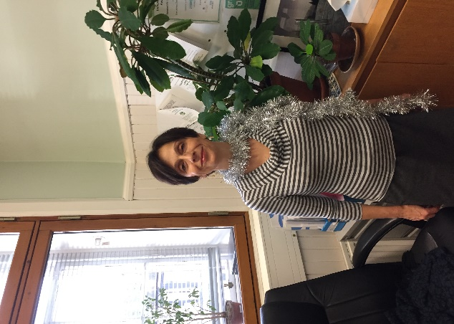

Dear readers,

As we are saying goodbye to 2019 and are wondering about 2020, I am reminded, mostly by the media, that this is not only the end of a year but also the end of the 2nd decade of the 21st Century!

For those with a nostalgic tendency, looking back can bring memories of great expectations and hopes which, in the end, may not have been fulfilled. For others looking back it may be about recognising how much they’ve grown, what they’ve learned, and how their lives have changed.

As an organisation, LCIL, over the last twenty years, has been full of growing, learning and change along with a number of unfulfilled hopes. People using our services will have seen and experienced this too. Continuous change can be a challenge for us all but it is needed to ensure that, not only do we survive but we can thrive and provide improved services.

These changes include; staff members moving on; changes in different laws bringing new ways for service users to engage with our services; decreasing resources made available to welfare, social care and support forcing conflicting priorities on us, sometimes at the expense of our individual and organisational wellbeing. Outwith LCIL, beyond the third sector and across many different types of communities, people’s ideas of how to build a future is changing radically. A growing number of people and organisations are saying that individualism, precarious standards of living, exclusion, the way we exchange goods and services and share resources, can no longer be sustained. We simply have to radically change and develop new ways of interacting with each other and share space, wealth, and resources.

LCiL was born out of this premise. Since I became LCiL CEO ten years ago, it was always clear to me (but also to the Board, staff and volunteers of LCiL) that the only way to enable disabled people, people with long term conditions and older people, to be part of the changing world, on an equal footing with others, was to radically change. Radically change and develop new ways of interacting with each other, build accessible spaces and living systems, and share wealth and resources, so that all could be supported to live a decent life. This is the reason why I am very happy and proud to be part of the Independent Living Movement, while I also strongly believe and witness every day that any change starts with our own willingness to change too. Our Movement recognised and asserted this message so that all of us could have a sustainable future, long before the current acknowledgement that we must move quickly to save our planet – so that we have a future.

Finally, and importantly, I would like to take the opportunity to wish you all a very Merry Christmas and a radically positive New Year!

**Thank You!**

From everyone at LCiL, thank you for supporting our work by subscribing to our quarterly newsletter!

Your feedback is important to us; we’d love to hear what you think about our Newsletter and articles. If you’d like to get in touch with us to pass on any views, comments, or suggestions for future articles, you can email us at:

grapevine@lothiancil.org.uk

Or call us on

0131 475 2370

Grapevine News Update

Kirstie Henderson left the service in July 2019 and LCiL thanks her for building up the Grapevine Service to what it is today. Following Kirstie’s departure, Grapevine has a new Information and Communications Co-Ordinator.

Nicola Djeala joined our team in September after a recent secondment to the Department of Work and Pensions and brings with her experience and knowledge of the new benefits systems.

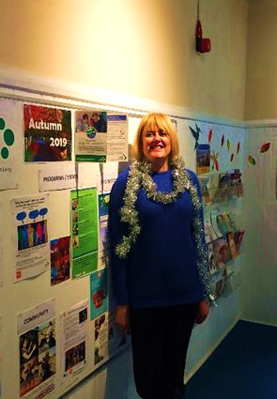**What does your role at LCiL involve?**

One part of my role is to maintain the operation of the Grapevine Service, providing information and advice to LCiL service users on all aspects of disability and independent living.

The other part is to maintain the profile and exposure of LCiL and its services through a variety of communication means such as our website, social media channels and newsletter.

**If a film was made about your life what would it be called?** Count on the Good, Don’t work on the bad……I’m an eternal optimist and believe if you put your mind to it, you can accomplish anything!

Scottish Governments PIP redesign research

LCIL’s Grapevine information and advice service has been approached by the Scottish Government Research partners Sopra Steria, who are currently conducting research for the government to redesign the Personal Independence Payment (PIP) form. LCIL would like to give you the opportunity to have your say in this important piece of work. If you have experience of filling in a PIP form and would like to be contacted by Sopre Steria about sharing your views and opinions please contact Dr Anna Dickinson on 07720 899068 or [anna.dickinson@soprasteria.com](mailto:anna.dickinson@soprasteria.com). Email is the best mode of communication for Anna.

Independent Living Team News

2019 has been a busy year for our five Independent Living Officers and the Independent Living Coordinator. In the 2018-2019 financial year, we supported almost 700 service users across four local authorities (City of Edinburgh, East Lothian, Midlothian and West Lothian) and by the end of the current financial year, we expect this number to have increased by 25%.

“*It is so helpful to have someone who knows what they are doing as we try to navigate this (SDS) as it is all brand new to us*.”- ILT service user, 2019.

While much of the focus of the team remains on supporting people with a direct payment to recruit and manage their own Personal Assistants, we have also been kept busy supporting our service users with social care reviews, liaising with local authorities and the Independent Living Fund Scotland on  behalf of service users and much more.

Christèle, Iain, Lucy, Omar, Srabasti and William look forward to continuing to support all of our service users to live independently in 2020 and beyond.

The Payroll Team News

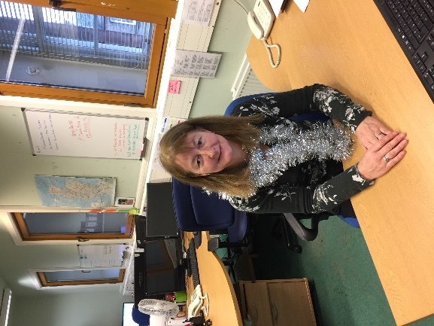**Name**: Anne Burgess

**Job Title**: Payroll Team Co-ordinator

**What does your role at LCiL involve?:**

My role is to ensure the smooth running of the payroll department. To make sure that all service users receive the best service possible.

**If a film was made about your life what would it be called?** Whats next – having moved house 10 times in the last 4 years, always up to new challenges and learning.

Our Payroll Service will be closed from Monday 23 December 2019 to Friday 3 January 2020.

*We will be open for business as usual on Monday 6 January 2020.*

We would also like to bring to your attention that from now on we can no longer take your PA’s hours over the phone, unless this is a real emergency. This is due to payroll regulations. . We therefore ask that all service users either fully complete a timesheet and email it to payroll.team@lothiancil.org.uk, or post it to us LCIL, Norton Park, 57 Albion Road, Edinburgh, EH7 5QY

Alternatively you may email your PA hours to us. If you choose to do this however, you need to include the following information on your email;

Your Run Number - if you do not have this then we can give you a note of this.

Employers Name; e.g. Joe Bloggs

Pay Period; e.g.13/13/13 to 14/14/14

Employee’s names; e.g. Barbie Kendrick

Hours – e.g. 49hrs

Annual Leave – e.g.20hrs

We thank you very much for your co-operation with this and we take the opportunity to wish you a very Merry Christmas

The SDS Development Programme news

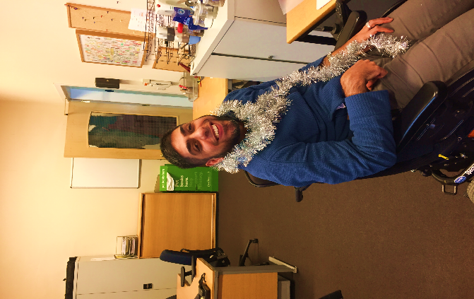Omar wears many hats within LCiL in both the Independent Living Team and SDS Team as well as being a PA employer using his direct payment (option 1). As an PA employer and development worker in the SDS team, Omar’s role has been to develop a series of Workshops predominately for PA employer and their carers to help increase their confidence and help them better manage their package of care.

“*As an experienced PA employer for over 13 years, my role allows me to draw on my own experiences and also enables me to put myself in others shoes, appreciating the challenges and rewards that employing a PA can bring. I learn just as much from my peers as they do from me.”*

We work with individuals to help them self-empower to have the knowledge, understanding and the confidence to assert their rights to live their own, independent life.  We do this by running Workshops, information sessions and peer support groups.   Generally, we provide lunch at each session and for disabled people sessions we can organise and pay for transportation.

We are holding various sessions across the three Lothian’s and in Edinburgh. These are the following sessions coming up:

Disabled People, those with long term conditions and older people:

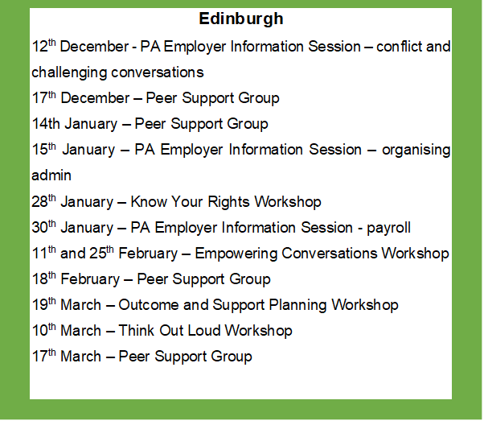

**Mid Lothian**

12th February - PA Employer Information Session and Peer Support Group – Relationships

**East Lothian**

29th January – Empowering Conversations Workshop

25th March – PA Employer Information Session and Peer support Group – Interview Skills

**West Lothian**

9th January – Peer Support Group

23rd January – Know Your Rights Workshop

28th January – PA Employer Information Session and Peer Support Group

6th February – Peer Support Group

13th February and 20th February – Empowering Conversations Workshop

26th February - PA Employer Information Session and Peer Support Group

5th March – Peer Support Group

12th March – Think Out Loud Workshop

17th March - PA Employer Information Session and Peer Support Group

**Parent Carers:**

**Edinburgh**

19th December – Peer Support Group

27th January – Peer Support Group

27th February – Peer Support Group

5th March – Empowering Conversations for Parents Carers

19th March – Outcome and Support Planning Workshop

26th March – Workshop 8

30th March – Peer Support Group

**West Lothian**

10th December – Peer Support Group

14th January – Peer Support Group

11th February – Peer Support Group

3rd March – Think Out Loud for Parent Carers

10th March – Peer Support Group

**East Lothian**

Dates to be confirmed for Know Your Rights, Empowering conversations and Think Out Loud Workshops.

**Mid Lothian**

27th January – Peer Support Group

5th February – Know Your Rights Workshop

27th February – Peer Support Group

Provisional Date 4th March – Empowering Conversations Workshop

30th March – Peer Support Group

For more information about the above please contact Lisa Milburn on 0131 475 2350 or email at [lisa.milburn@lothiancil.org.uk](mailto:lisa.milburn@lothiancil.org.uk).  If you wish to know more about the content of the workshops, please call the SDS team on 0131 475 2628.

You can Support LCiL

**Joanna LCiL’s fundraiser has a special Christmas message.**

**With Christmas coming up, please remember that easyfundraising is a great way to raise money for LCiL whilst you shop online!**

It's free and simple to use through the easyfundraising website or App.

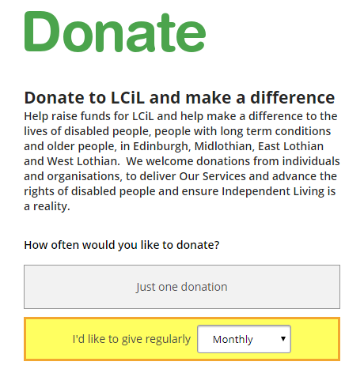Once you’ve registered, just go to easyfundraising first, and then start your online shopping as normal. The retailers will then make a small donation to LCiL to say “thank you”.

Over 3,700 retailers take part, including Amazon, M&S, John Lewis and Sainsbury’s.

To register go to [www.easyfundraising.org.uk](http://www.easyfundraising.org.uk)

and nominate LCiL – this is completely free and we can receive up to 15% from every purchase you make.

**Thank you for your support.**

**Your donations will be used to help fund our services, including Grapevine Advice and the Independent Living Team.**