Assertiveness 1
Four Stage Model

Questions to ask yourself

What do you want out of this situation – what would be a success?

What’s the worst that can happen?

What’s the best that can happen?

What’s most likely?

What is the risk of saying nothing?

- Say clearly what you want

- Explain what effect the behavior, attitude or issue has on you or others

- Give specific examples

- Ask for change
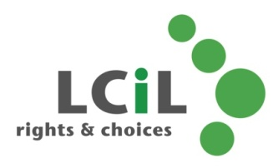

Lothian Centre for Inclusive Living
0131 475 2350
LCIL@lothiancil.org.uk

