Models of Disability
There are 2 Models of Disability

Medical
This model
says that the person is the problem

Social
This model thinks that it is society which is the problem.

What is Disability?

There are two distinct models of disability, the medical model and the social model. A model is framework for understanding information. However, new models are emerging and so we have included information on the Affirmative model also.

Through the medical model, disability is understood as an individual problem. It is seen as a condition of people who have impairments arising as a result of their impairments. If somebody has an impairment - a visual, mobility, or hearing impairment, for example - their inability to see, walk, or hear is understood as their disability.

The medical model is often known as the ‘personal tragedy model’ because it regards the difficulties that people with impairments experience as being caused by the ways that their bodies are shaped and experienced (Swain, J French, S & Cameron, C, 2003: 22).

Through the social model, disability is understood as an unequal relationship within a social world in which the needs of people with impairments are often given little or no consideration (Oliver, M 1996: 32).

People with impairments are disabled by the fact that they are excluded from participation within the mainstream of society as a result of physical, environmental and attitudinal barriers which prevent them from gaining equal access to education, employment, information, housing, public transport, leisure opportunities, and so on.

Using the social model, disability is no longer seen as an individual problem but it becomes a social issue. Disability emerges within a society which is organised to meet the needs of the majority of people who do not have significant impairments and which treats differently the needs of people who do.

‘People are disabled by society's reaction to impairment which prevents their participation as equal citizens.’ (Inclusion Scotland, 2004)

The Medical Model of Disability
The Medical Model
The two main groups to think about are:
Impairment
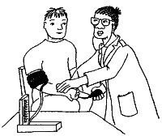
Your problem!

Disability
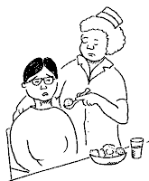
Your problem!

The Medical Model is best summarized by referring to the International Classification of Impairments, Disabilities and Handicaps developed by the World Health Organisation in 1980.

This classification makes the following distinctions:

Impairment is ‘any loss or abnormality of psychological, physiological or anatomical structure or function’

Disability is ’any restriction or lack (resulting from an impairment) of ability to perform an activity in the manner or within the range considered normal for a human being’

(Barnes, C. Mercer, G. & Shakespeare, T. 1999:23)

For instance, I may be a wheelchair user. My disability is regarded as being related to the facts, for instance, that I cannot climb the stairs in my house or walk to the shops.

I may be partially-sighted. My disability is regarded as being related to the fact, for instance, that I cannot read information in ‘standard’ size print.

I may be brain injured. My disability is regarded as being related to the fact, for instance, that I cannot speak as quickly as other people.

From a Medical Model viewpoint, the societies in which we live are considered as being just fine so long as the majority of people who do not have significant impairments (identified as ‘normal’) are able to go about their daily business within them. It is people who have impairments (identified as ‘abnormal’) who are identified as being the problem.

This is why disabled people often experience pressures to undergo treatment or therapy in order to be made ‘more normal’. Normality is highly valued and abnormality is thought of as being undesirable.

The Social Model of Disability
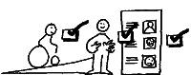

There are two main groups to think about in this model too.
Impairment
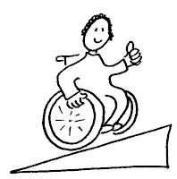
Is part of me
Disability
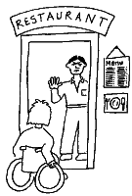
Is society’s problem
The Social Model of Disability

During the 1960’s and 1970’s disabled people started to challenge the way that they were treated and regarded within society. They considered the facts of having to live within residential institutions, for example, or being unable to find paid work, or being unable to go on public transport as social injustice.

They looked at the way in which society was organised and recognised the ways in which structures of education, employment, the provision of housing, information, leisure activities, and public transport systems were planned and delivered without taking the needs of people with impairments into account.

The Union of the Physically Impaired Against Segregation (UPIAS) developed their own definitions of impairment and disability. These definitions formed the basis of what is known as the Social Model:

Impairment: lacking part or all of a limb, or having a defective limb, organ or mechanism of the body

Disability: the disadvantage or restriction of activity caused by a contemporary social organisation which takes little or no account of people who have physical impairments and thus excludes them from participation in the mainstream of social activities

(Swain, J. & Cameron, C. 1999:69)

UPIAS stated that:

‘In our view it is society which disables physically impaired people. Disability is something imposed on top of our impairments by the way we are unnecessarily isolated and excluded from full participation in society.’

(Oliver, M. 1996:33)
In this way, the meaning of disability is changed from something
Using the Social Model all disabled people have a right to a part of society.
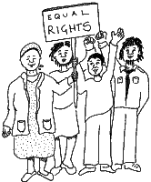

Society needs to change not disabled people
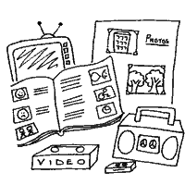

that we have to something that is done to us.

We do not have disabilities.

We are disabled by society.

The Social Model was later extended in order to include people with impairments other than physical impairments. In 1981 the Disabled People’s International (DPI) made the following distinctions:

Impairment is the loss or limitation of physical, mental or sensory function on a long-term or permanent basis

Disability is the loss or limitation of opportunities to take part in the normal life of the community on an equal level with others due to physical and social barriers

(Barnes, 1994:2)

We are disabled by society as a result of the inaccessible environments within which we live and by the judgments and assumptions that other people make about us.

When people identify disability as ‘our problem’ they will respond to us as victims in need of ‘special’ treatment and requiring ‘special’ services.

When people identify disability as a problem with the way society is organised, they will work to remove the barriers by which we have been prevented from taking part in society (Oliver, M. 1990:4).

The Affirmative Model
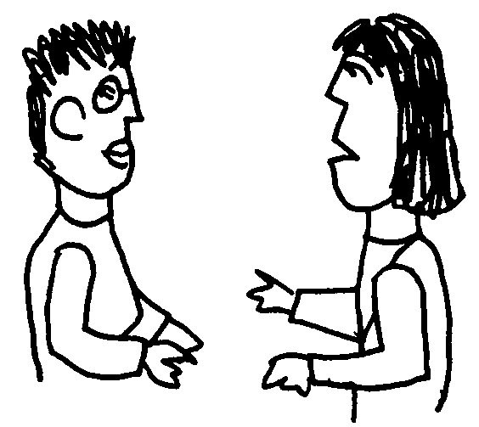
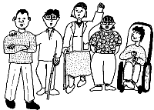
We’re ok!
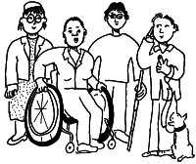
Disabled People
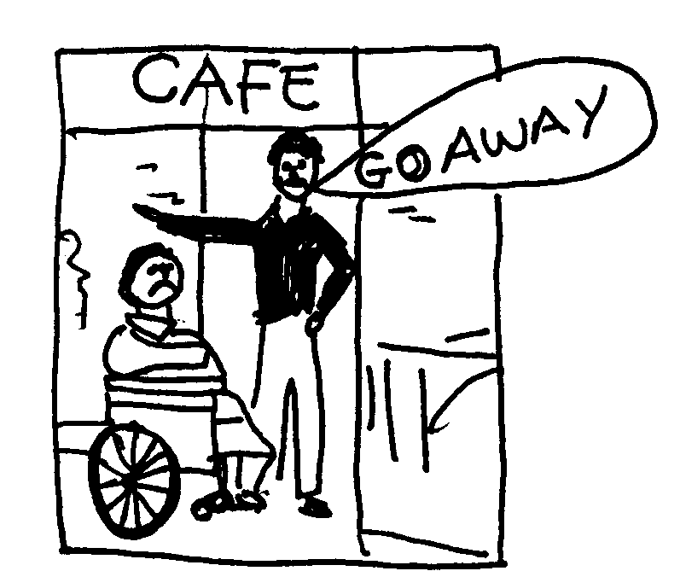
Being stopped from being a part of things
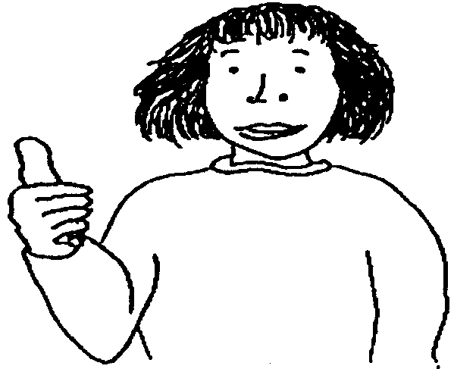

The Affirmative Model of Disability

In the 1990’s two disabled academics, building upon the Social Model started looking at other ways that disability and impairment could be viewed and they developed a framework which they called the Affirmative Model.

This is essentially a non-tragic view of disability and impairment which includes a positive way of looking at who disabled people are, both as individuals and collectively.

The Affirmative model, build upon the existing social model by providing a framework for personal understanding of who disabled people, are and what they are in their day to day lives. It also helps non-disabled people understand that they impairment forms an essential part of their identity and reaffirms the notion that disabled people don’t want pity or charity but to be fully accepted into society and are a part of everyday life.

In the 2008 another disabled academic and freelance trainer, C. Cameron, has taken this framework further and developed definitions of disability and impairment within the Affirmative model.

Definitions of Disability and Impairment within the Affirmative Model

Impairment: Physical, sensory and intellectual difference to be expected and respected on its own terms in a diverse society

Disability: The loss or limitation of opportunities to take part in community life on an equal level with others due to physical and social barriers.
Contact details:
Tel: 0131 475 2350
Email: lcil@lothiancil.org.uk
Website: www.lothiancil.org.uk

