**Assertiveness 1**

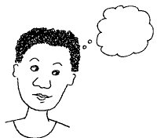

No!

yes…

**Passive Communication**

**When we use passive communication we:**

* don’t express our opinions, needs or feelings
* don’t respond to things that make us feel hurt or angry
* let others deliberately or accidentally infringe our rights

**Why might we do this?**

* we believe what we say isn’t important
* we think other people know better
* we’re scared of causing a scene, or upsetting people
* we don’t want to feel embarrassed

**Short term effects**

We may feel relief that we’ve avoided a scene, but often this doesn’t last long. Very quickly we feel regret and wish we’d said something when we had the chance.

**Long term effects**

* loss of self-esteem and confidence
* others may lose respect for us
* people may stop consulting us or asking our views

**and we can feel:**

* anxious
* out of control
* stuck
* resentful
* confused
* angry with ourselves



When we use passive communication our voices aren’t heard, we don’t get what we want and need and other people don’t get the benefit of our skills, ideas and knowledge.

**Aggressive Communication**



**When we use aggressive communication we:**

* express our emotions and demand what we need without taking the other person’s rights or feelings into account
* criticise, blame or attack
* say ‘you’, rather than ‘I’
* don’t listen well, and interrupt

**Why might we do this?**

* we think it’s the alternative to being passive
* we feel threatened by people or situations
* we overreact because of things that have happened in the past
* we think other people will respect us if we’re ‘strong’
* we believe it’s the only way to get something to happen

**Short term effects**

We may feel proud that we have got our own way, or made people listen to us.

**Long term effects**

* we may get threats, sarcasm or nastiness from other people
* people may not say what they think to avoid a scene
* people may avoid us or ignore us

**and we can feel:**

* lonely
* out of control
* hurt
* confused
* misunderstood
* angry with others



When we use aggressive communication our voices may be heard initially and we may get what we want and need in the short term, but in the long term we may not be invited to take part in things. Again, other people don’t get the benefit of our skills, ideas and knowledge.



I’d like …

**Assertive Communication**

**When we use assertive communication we:**

* state our needs and wants clearly and firmly, while respecting other people’s rights
* express our feelings appropriately and respectfully
* say ‘I’, rather than ‘you’
* listen well and don’t interrupt

**Short and long term effects**

* we address issues and problems as they arise
* 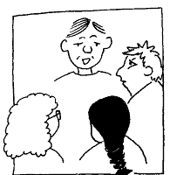we have influence and choice
* increased confidence and self-esteem
* we build good trusting relationships with people
* people invite us to take part in things or consult us

**and we feel:**

* good about ourselves
* competent and in control
* proud of our behaviour
* accepted, valued and purposeful
* calm

When we use assertive communication our voices are much more likely to be heard, other people can get the benefit of our skills, knowledge and ideas and we’re much more likely to be able to create lasting change.

**Assertive Communication**

**Four steps to assertive communication**

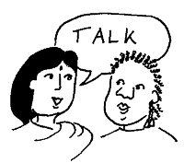

1. **Say clearly what you want**
2. **Explain what effect the behaviour, attitude or issue has on you or others**
3. **Give specific examples**
4. **Ask for change**

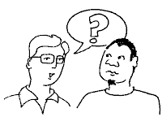**Before – questions to ask yourself**

* What do you want out of this situation – what would be a success?
* What do you want the other person/people to do?
* What’s the worst that can happen?
* What’s the best that can happen?
* What’s most likely?
* What is the risk of saying nothing?

Plan what you want to say in each of the four steps – gather examples

**During – what to do**

* Stay calm and try not to ramble
* Check that the other person has understood what you’ve said
* Ask if they need more information

**Afterwards – questions to reflect on**

* How did you feel?
* How did the other person react?
* 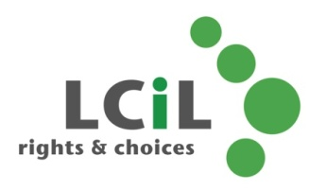Did you get the outcome you wanted?

**Lothian Centre for Inclusive Living**

0131 475 2350

[LCIL@lothiancil.org.uk](mailto:LCIL@lothiancil.org.uk)

* What could you do differently next time?

**Lothian Centre for Inclusive Living**

0131 475 2350

[LCIL@lothiancil.org.uk](mailto:LCIL@lothiancil.org.uk)