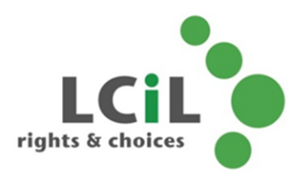
What is a support plan?
A support plan is an agreed arrangement in place to deliver support to a person with support needs. It usually takes the form of a document but this can be as simple or as detailed as you wish.

Support plans have the following purposes:
- To provide day to day care and support to keep someone safe and healthy
- To maintain health and wellbeing
- To manage risk and prevent crisis
- To ensure support needs are clear
- To ensure support is delivered in a consistent way
- To ensure support is person-centred
- To have a reference point when support is not as expected

Support plans should be:
- Created with the supported person at the centre
- Shared with the person who is being supported
- Designed around what’s needed, not what’s available
- In an accessible format
- Clear and measurable
- Regularly reviewed

A support plan can be done in whatever way works for you, although often local authorities or provider organisations have a standard format that they may use. This is usually the case when they are directly providing the support.
At it’s very simplest, a support plan might be a post it note stuck on the fridge which says “if I am unwell, call my son”
A plan may be quite formal, especially if it forms part of a Social Work plan and you receive a support package (Self-Directed Support).
You can also develop your own support plan which may be less formal, but can be useful in letting friends, family or any carers know your wishes and how you would like things to be done. It can help everyone be clear about the help you need and save you explaining several times.
What types of support plan are there?

There are many support plans available and these are just some examples

Time and Task  Daily Care Plan | - Often used by nursing and care agencies  - Based on what task needs to be provided and when  - Tasks are day to day care  - Can be quite detailed about how and when things are to be done  - Good when there may be new or multiple carers involved  - Risk that it may be done too quickly, often ticking boxes
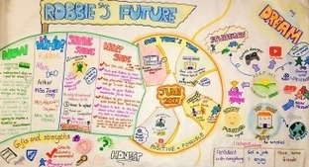  Person Centred Plan | - Person Centred planning is a process  - Process is facilitated by a trained person  - Supported person chooses who contributes  - The plan is a visual representation  - It is a life plan  - Includes long term goals, dreams and aspirations  - Doesn’t include finer, day to day details
WRAP  Wellness  Recovery  Action  Plan | Primarily used in Mental Health  Includes  - What does wellness look like?  - Early warning signs and triggers  - General day to day coping skills  - Pre-crisis intervention  - Crisis intervention
Anticipatory  Care plan | - Primarily for people with a long term health condition  - Created with a health care professional  - Involves conversations about the care you want to receive in future  - Highlights what’s important to you, concerns and choices
Child Support Plan | - For children with additional support needs  - Used within an educational setting  - Usually developed at a multi-agency meeting  - Relates to day to day activities
Adult Carers Support  Plan | - What is needed for you to fulfil your caring role  - May include things like emotional support and respite  - What do you need to prevent a crisis?  - Who looks after you?

These are just some examples of different types of support plan but the important thing it to have one that works for you. Don’t be afraid to change it or ask for something different if it’s not working.

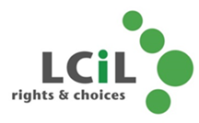
Developed for “Outcomes and Support Planning” workshop
SDS Team
Lothian Centre for Inclusive Living

