The

Social Model

of

Disability

By Grant Carson

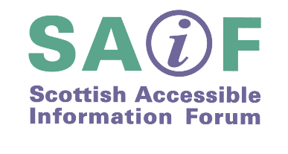
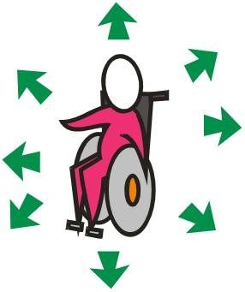
ISBN 9780114973490

© Scottish Accessible Information Forum

(SAIF) 2009

You may copy all or part of this publication but please acknowledge the source.

Feedback

SAIF is very keen to get your views on this publication.

- Email any comments you have to info@saifscotland.org.uk

- Use the feedback form on our website www.saifscotland.org.uk

- Write to us at the address at the back of this publication

Grant Carson

Grant Carson is currently Manager of Housing and Employment Services in the Glasgow Centre for Inclusive Living (GCIL) and has worked there since 1995.

Accessible Housing Solutions is a service which provides information, advice and advocacy to disabled people. Employment Solutions helps disabled people find work.

Grant joined the Scottish Accessible Information Forum (SAIF) in 1997 and has contributed to a number of committees and publications.

He is a non-executive director of Greater Glasgow and Clyde Health Board and also Chair of Margaret Blackwood Housing Association.

Grant has been a disabled person since early childhood, and has extensive experience of disability equality training.

The Scottish Accessible Information Forum (SAIF) is funded by the Scottish Government to promote and provide guidance about making information accessible to disabled people.

SAIF is made up of 21 people from disability-led organisations and information providers. It employs two part-time staff and is based in Consumer Focus Scotland.

SAIF has produced the Standards for Disability Information and Advice Provision in Scotland.

Acknowledgements

Many thanks to:

John Dever, of the Glasgow Centre for Inclusive Living, for his invaluable suggestions and helpful advice.

Circles Network for the social and medical model graphics.

Maggie Cameron of the Lothian Centre for Integrated Living for more social and medical model graphics.

Mary Evans of Dyslexia Scotland and SAIF for proof reading, design and layout advice.

The membership of the SAIF Standards Working Group which guided the development of the publication.

What is Disability?

There are two distinct models of disability, the medical model and the social model. A model is a framework for understanding information.

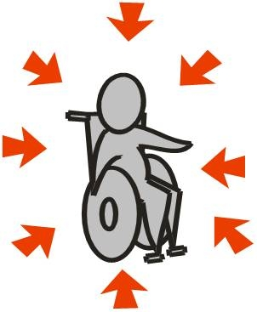

The Medical Model of Disability

Through the medical model, disability is understood as an individual problem. If somebody has an impairment - a visual, mobility or hearing impairment, for example - their inability to see, walk or hear is understood as their disability.
The medical model is also sometimes known as the ‘personal tragedy model’ because it regards the difficulties that people with impairments experience as being caused by the way in which their bodies are shaped and experienced.

Typical definitions based on this restricted perception are those historically offered by the World Health Organisation (WHO) (1):-

Impairment: any loss or abnormality of psychological, physiological or anatomical structure or function.

Disability: any restriction or lack, resulting from an impairment, of ability to perform any activity in the manner or within the range considered normal for a human being.

- World Health Organisation (1980), A manual relating to the consequences of disease. Geneva, World Health Organisation

Handicap: a disadvantage for a given individual, resulting from an impairment or disability, that prevents the fulfilment of a role that is normal depending on age, sex, social and cultural factors for that individual.

This kind of definition is so seriously at odds with the daily experiences of disabled people that it was inevitable that change had to come. It was clear to disabled people that, in the absence of any cure for their physical condition, the impairment must be regarded as given: a constant factor in the relationship between themselves and the society with which they attempt to interact.

It follows from this that any failure in the interaction must be overcome through a restructuring of the social and physical environment. What was required were definitions which took account of the many individuals with their particular impairments and dealt with the effect on such individuals of their social and physical environment.

When people such as policy-makers and managers think about disability in this individual way they tend to concentrate their efforts on ‘compensating’ people with impairments for what is ‘wrong’ with their bodies. Examples of this are the targeting of ‘special’ welfare benefits at them and providing segregated ‘special’ services for them.

The medical model of disability also affects the way disabled people think about themselves. Many disabled people internalise the negative message that all disabled people’s problems stem from not having ‘normal’ bodies.

Disabled people can also be led to believe that their impairments automatically prevent them from taking part in social activities.

This internalised oppression can make disabled people less likely to challenge their exclusion from mainstream society.

The Social Model of Disability

The social model was created by disabled people themselves. It was primarily a result of society’s response to them but also of their experience of the health and welfare system which made them feel socially isolated and oppressed.

The denial of opportunities, the restriction of choice and self-determination and the lack of control over the support systems in their lives led them to question the assumptions underlying the traditional dominance of the medical model.

Through the social model, disability is understood as an unequal relationship within a society in which the needs of people with impairments are often given little or no consideration.

People with impairments are disabled by the fact that they are excluded from participation within the mainstream of society as a result of physical, organisational and attitudinal barriers.

These barriers prevent them from gaining equal access to information, education, employment, public transport, housing and social/recreational opportunities.

However, recent developments promote inclusion. Anti-discrimination legislation, equal-opportunity policies and programmes of positive action have arisen because it is now more widely recognised that disabled people are unnecessarily and unjustly restricted in or prevented from taking part in a whole range of social activities which non-disabled people access and take for granted.

In the United Kingdom, as a developed country with the fifth largest economy in the world, we have the knowledge, experience, technology and the wealth to remove the barriers which continue to exclude disabled people from equality of opportunity.

Most people will experience disability at some point in their lives through illness, accident or aging. For example, the lack of information in large print can be a disabling barrier to many older people as their eyesight changes over time and they are no longer able to read standard-size print.

Social Model definitions were first proposed by the Union of the Physically Impaired against Segregation (2) as follows:-

Impairment: lacking part or all of a limb, or having a defective limb, organ or mechanism of the body.

Disability: the disadvantage or restriction of activity caused by a contemporary social organisation which takes little or no account of people who have physical impairments and thus excludes them from participation in the mainstream of social activities.

- UPIAS Fundamental Principles of Disability 1976

From this socially-focused definition disabled people developed a sense of themselves as being a distinct social group.

This empowering new view of disability allowed disabled people to develop their own user-led and user-controlled organisations.

These new organisations, for example Centres for Independent Living (CILs), became the springboard for promoting confidence amongst disabled people, enabling them to lobby and campaign for changes to social policy.

However, disabling barriers experienced in the past can continue to have an adverse effect. For example, those disabled people who attended segregated schools may have gained lower academic qualifications than their non-disabled peers, simply because their ‘special’ school failed to provide a proper mainstream curriculum.

These barriers have nothing to do with individual disabled people’s bodies: they are created by people so it is possible to remove them.

Disabled people, irrespective of the nature of their impairment, all too often still share a commonality of exclusion. As Ken Davis (3) highlights:

“A person who is hearing-impaired may have no difficulty boarding public transport, whilst a paralysed wheelchair-user would most likely be prevented from sharing the same journey. By contrast, the paralysed person may have no difficulty in making her or his intentions known at a booking office, whilst the deaf person might be totally unable to carry out the same activity”.

- The Social Model of Disability – Setting the terms of a new debate – by Ken Davis. Published by the Derbyshire Coalition of Disabled People (September 1996, revised)

The employment rate for disabled people in Scotland is 47% compared with 82% for non-disabled people (4). The inability to earn a living can arise because of a range of real but surmountable barriers like lack of access to public transport or the negative attitudes of some employers.

It follows that if disabled people are to be able to join in mainstream society, which is their human right, the way society is organised must be changed.

- The Disability Rights Commission – Disability Briefing. March 2004

The Scottish Accessible Information Forum (SAIF) rejects the medical model of disability and accepts the following:

- that disabled people have historically been excluded from mainstream society and can continue to face discrimination and prejudice leading to disadvantage and exclusion

- that disability is a result of the barriers faced by people with impairments

- that while many individuals have physical or sensory impairments or learning difficulties or are living with mental health needs, it is not the individual’s impairment which creates disability but the way in which society responds to these impairments

- that disabilism is a form of oppression in the same way as is racism, sexism and homophobia.

The Social Model of Disability and its implications for information provision

The social model is about the barriers that disabled people face. For example, if a wheelchair-user cannot climb stairs, then a ramp or a stair lift should be fitted. If a blind person cannot read written information then the solution is to provide it in an alternative format such as audio or braille.

By providing satisfactory ‘reasonable adjustments’, barriers can be overcome and this can have a positive impact on people’s lives. This offers the hope that we can eliminate discrimination by eradicating these barriers with support from our non-disabled allies.

It is important to recognise the important role that language has had in reinforcing society’s assumptions about groups of people.

In the same way that women and people from different cultural backgrounds have identified the power of language in the promotion of sexism and racism, disabled people have become more sensitive to the way words perpetuate discriminatory behaviour and language.

Language use is not really difficult. There are a few simple rules which help you to understand what to say and why.

In terms of disabled people as a group, irrespective of impairment, use disabled people. If you are referring to someone’s medical condition or health problem then the term impairment is generally accepted as the appropriate phrase. For example ‘people with a visual impairment’, or ‘hearing impairment’, or ‘physical impairment’.

The United Kingdom Disabled People’s Council (UKDPC) and other user-controlled organisations use disability to mean ‘The disadvantage or restriction of activity caused by a contemporary social organisation which takes little or no account of people who have impairments and thus excludes them from the mainstream of social activities’.

Disability is therefore a particular form of social oppression and focuses on the barriers (attitudinal, environmental and organisational) which prevent disabled people from having equality of opportunity in education, employment, housing, transport, leisure and so on.

Given the above definition, it does not make sense to say ‘people with disabilities’, just as you would not say ‘people with black skin’ or ‘people with female gender’, for example. ‘People with disabilities’ is really used to link people with their medical conditions and implies that the difficulties experienced by disabled people are a result of these impairments.

The phrase ‘people with learning disabilities’ is still commonly used. However, organisations like People First and Values Into Action (VIA) use ‘people with learning difficulties’ to describe impairment. This is because they have asked people with this type of impairment what they prefer to be called. The term ‘disability’ should therefore be reserved for the mechanisms of social oppression that all disabled people face.

User-controlled organisations like the term ‘non-disabled’ to describe people who are not disabled. There is a certain elitist arrogance based on biological superiority in the concept of ‘able-bodied’. In addition, the term ‘non-disabled’ implies a continuum between all people and indicates that disability affects everyone in time.
Language –
A Good Practice Checklist

Avoid/Offensive | Preferred
Victim of… | Person who has…  Person with…  Person who experiences…
Crippled by… | Person who has…  Person with…
Suffering from… | Person who has…  Person with…
Afflicted by… | Person who has…  Person with…
Wheelchair bound | Person who uses a wheelchair or  wheelchair user
Invalid (= not valid) | Disabled person
Mental | Disabled person
Handicapped | Disabled person
The disabled | Disabled people
The handicapped | Disabled people
Spastic | Cerebral Palsy
Deaf and dumb | Deaf or hearing impaired person

Avoid/Offensive | Preferred
Cripple or crippled | Disabled person or mobility impaired person
The blind | Blind or visually impaired people
The deaf | Deaf people
Mentally handicapped, backward, dull | Learning difficulty
Retarded, idiot, imbecile, feeble-minded | Developmentally impaired person
Mute, dummy | Speech impaired person
Mentally ill, mental patient, insane | Person with mental health impairment or survivor/user of mental health system
Abnormal | Different/disabled person
Patient | Person
Special needs | Individual needs
Special | Everyone is special!

Practical steps you can take to meet the information needs of most disabled people

- Produce all information in plain language and a minimum type size of 12 point, preferably 14 point.

- Use a clear, easily recognisable, sans serif font. Use a matt paper of contrasting colour. Justify type on the left. Don’t print sentences in block capitals.

- On request, provide information in alternative formats such as large print, audio, braille, and an easy-to-understand version.

- Use interpreters for people who need to communicate in a sign language or other community language.

- If you have a website, get it designed and developed in a way which makes it accessible for disabled people.

- Provide any service in a flexible way using, where appropriate, home visits, telephones, the internet or different opening hours.

- Ensure that your premises are fully accessible to people with mobility or sensory impairments.

- Provide publicity materials which tell disabled people what you can and cannot do.

- Have good working relationships with other service-providers who can help, and good referral arrangements.

- Provide your staff with disability-equality training. A key barrier for disabled people is negative attitudes towards them.

- Get regular and organised feedback from disabled people about the accessibility of your service.

- Involve disabled people in service planning and training delivery.

There are 2 Models of Disability

Medical
This model thinks that the person is the problem

Social
This model thinks that society is the problem
The Medical Model of Disability

The two main groups to think about are:
Impairment – your problem!

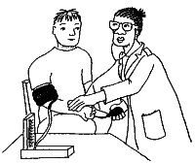

Disability – your problem!

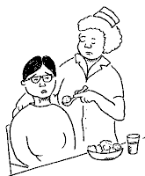
The Social Model of Disability

There are two main groups to think about in this model too.
Impairment – is part of me.

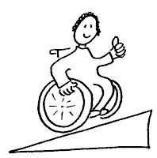

Disability – is society’s problem.
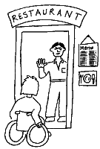
Using the Social Model all disabled people have a right to be a part of society.

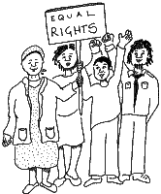

Society needs to change, not disabled people
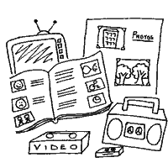

Further information about the social model

Disabling Barriers – Enabling Environments, edited by John Swain, Sally French, Colin Barnes and Carol Thomas (2004)

The Politics of Disablement by Professor Michael Oliver (1990)

Centre for Disability Studies –
University of Leeds
www.leeds.ac.uk/disability-studies

Inclusion Scotland www.inclusionscotland.org

National Centre for Independent Living
www.ncil.org.uk

United Kingdom Disabled People’s Council
www.bcodp.org.uk

Some other SAIF publications

- Standards for Disability Information and Advice Provision in Scotland

- Making E-communication Accessible

- Guide to User-Led Reviews

- Scottish Formats Resource – CD Rom

- Information and Advice Services – what disabled people should expect and receive

- A3 poster:
Making Information Accessible

- A4 posters:
Making Websites Accessible
Making Word Documents Accessible
Making Email Accessible
This publication is available on request in the following formats:

- braille
- large print
- audio
- electronic format
It can also be downloaded in PDF and Microsoft Word from the SAIF website.

Scottish Accessible Information Forum
Consumer Focus Scotland
100 Queen Street
Glasgow
G1 3DN

Tel: 0141 226 5261
Fax: 0141 221 0731
Text phone: 0141 226 8459

Email: info@saifscotland.org.uk
Website: www.saifscotland.org.uk

Published by TSO (The Stationery Office) and available from:

Online
www.tsoshop.co.uk

Mail, Telephone, Fax & Email
TSO, PO Box 29, Norwich, NR3 1GN
Telephone orders/General enquiries:
0870 600 5522
Fax orders: 0870 600 5533
Email: customer.services@tso.co.uk
Textphone: 0870 240 3701

TSO@Blackwell and other Accredited Agents

Customers in Ireland can order publications from:
TSO Ireland
16 Arthur Street, Belfast BT1 4GD
Tel: 028 9023 8451 Fax: 028 9023 5401
£2.00

