Coronavirus (COVID-19): guidance for festive period – Easy Read
What is this easy read about?
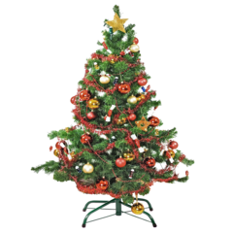 | This is an easy read version of Scottish Government guidance about what people can do for Christmas.
 | People can do things for Christmas between 23 and 27 December.
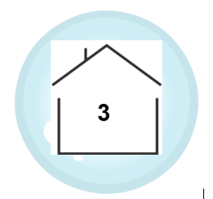 | People can form a Christmas bubble of up to 3 households.
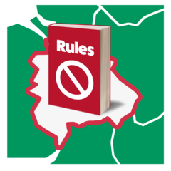 | A lot of the rules depend on what you can do in the local area where the Christmas bubble will be.
You can find out the local rules in the place where you will be here.
https://www.gov.scot/check-local-covid-level/

Staying safe at Christmas

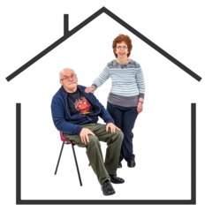 | The safest way to spend Christmas is to stay with the people you live with in your house.
 | We know people can get lonely at Christmas so there will be a change to the rules about what we can do.
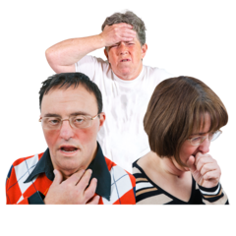 | The virus will still be able to make you unwell during Christmas.
 | You do not have to see family and friends by having a Christmas bubble. You can choose not to.
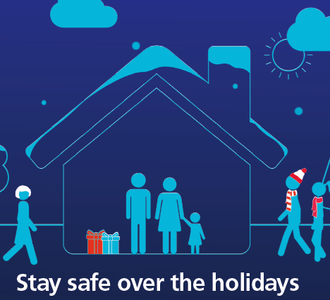 | If you do see family and friends at Christmas this is information to help keep you safe.
What you can and cannot do in a Christmas bubble
 | You can form a Christmas bubble between 23rd December and 27th December.
The Christmas bubble can include no more than 3 households including 1 extended household.

It would be better and safer if it only had 2 households.
 | You can meet people in your bubble in homes and gardens.
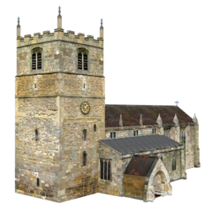 | You can meet in a place of worship like a church.
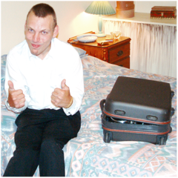 | You can stay overnight at the house of your bubble. But you should only do this if you have to.
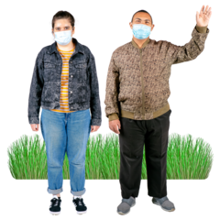 | You can meet them in outdoor public spaces.
 | You should not be in more than one bubble.
 | You cannot change who is in your bubble after it starts. The same people have to stay in your Christmas bubble during the days it is allowed.
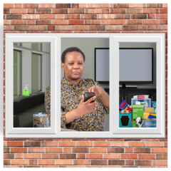 | Try not to see people on the days before you start your bubble.
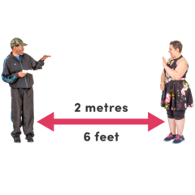 | Stay 2 metres away from people in the Christmas you do not usually live with.
 | The 2 metres rule does not apply to children under 12.
 | Try not to meet the other people in your bubble too much if you can.
 | You should not meet people who are not in your bubble either indoors or outside
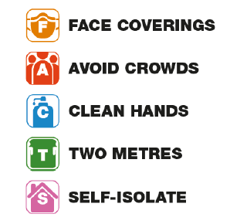 | Remember to follow the FACTS guidance.
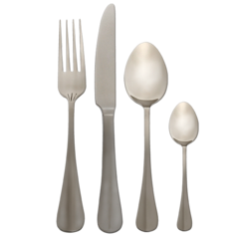 | Do not share plates or cutlery.
Christmas bubbles and extended households
Sometimes an extended household is called a bubble.

An extended household and a Christmas Bubble are not the same.
1 | A Christmas Bubble should only include 1 extended household.
 | Different types of people can be an extended household.
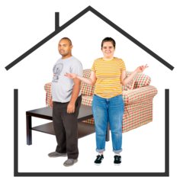 | If you are in a couple or relationship but do not live together
 | If you live alone
 | The only people you live with are under 18 years of age
Children whose parents live apart
 | Some children have parents who do not live in the same house.
 | If their parents have two different Christmas bubbles then children can move between them.
Older and vulnerable people
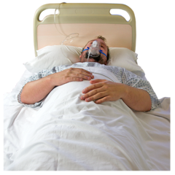 | Some people have a higher chance of becoming very ill from coronavirus.
 | These people should be very careful about having a Christmas bubble.
Travel
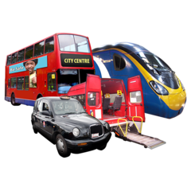 | If you have to travel to see people in your Christmas bubble you should do so between 23rd and 27th December.
 | You should travel home no later than the 27th December.
 | You should try not to leave a level 4 area in Scotland
 | You should try not to go to a tier 3 are in England.
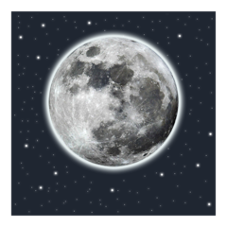 | If you have an overnight journey you must start it on the 27th
 | You do not have to travel if someone from your group gets symptoms of the coronavirus.
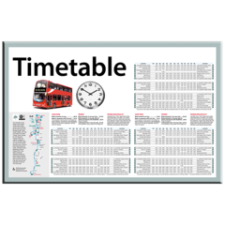 | Plan and book ahead if you need to use public transport.
 | If you travel to be in a Christmas bubble you must follow the travel rules for the area you go to.
 | When you are in that area you should not leave to go to a different level.
You can find more information about travel rules here
https://www.gov.scot/publications/coronavirus-covid-19-protection-levels/

You can find out more about travelling safely here

https://www.transport.gov.scot/coronavirus-covid-19/transport-transition-plan/advice-on-how-to-travel-safely/

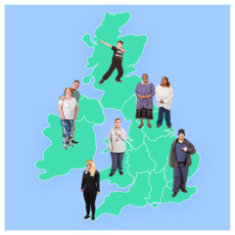 | If you travel to a different country than Scotland you should find out the rules for that area.
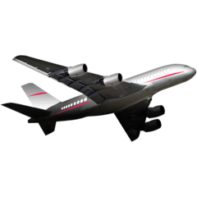 | You should not travel to a country that is not in the UK and Ireland unless you have to for a very important reason.
Going to pubs and restaurant
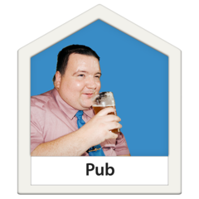 | You should not visit a pub or restaurant with people in your Christmas bubble you do not live with.
 | If you do not have a Christmas bubble then you should follow your local rules.
Staying in tourist accommodation
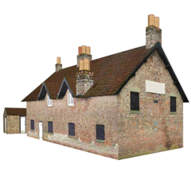 | Your Christmas bubble can meet or stay in self-catering accommodation. You should only do if you have to.
 | Your Christmas bubble should try not to stay in the same holiday house.
 | Someone in your Christmas bubble has to live in the council area where the self-catering accommodation is.
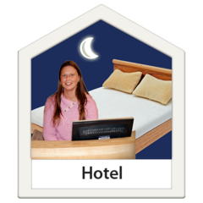 | Not everyone in your Christmas bubble can stay in the same hotel.
 | You can stay in the same hotel if you go from there to visit your Christmas bubble in another place.
Visiting and caring for others
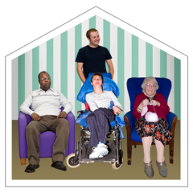  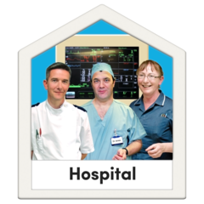 | Some people will want to visit people in a:  Hospital or hospice  Care home
 | The safest thing to do if you want to keep visiting these places is not to have a Christmas bubble.
You can read more information about visiting care homes during Christmas here.

https://www.gov.scot/publications/coronavirus-covid-19-adult-care-homes-visiting-guidance/
 | You can still go into another house to care for a relative.
 | You should be very careful to follow the rules on physical distancing and hygiene when you do this.
You can find more easy read information on this here:

https://www.nhsinform.scot/translations/formats/easy-read/coronavirus-covid-19
 | If you are part of a Christmas bubble you can still visit someone in prison.
Students
 | If a student goes to a family home for Christmas then they become part of the household at their family home.
Shared accommodation
 | Some people live together in a shared flat or house. These people are not family members or students.
 | The rules are different for these people who live in a shared flat or house.
 | These people should try not to join a Christmas bubble with people not in their shared flat or house.
 | If they do join a Christmas bubble they should isolate from the people in their shared flat or house for 7 days.
 | This means they should stay as far away from the people they live with inside before going to a Christmas bubble and they when they come back.
Places of worship
 | You can go to a church or other place of worship with members of your Christmas bubble.
 | Maximum numbers at individual places of worship will depend on where the church is and how many people can fit inside.
For more information about going to places of worship here

https://www.gov.scot/publications/coronavirus-covid-19-protection-levels/pages/protection-level-4/

Self isolation
 | Some people will be staying at home because of coronavirus symptoms.
 | These people must not join a Christmas bubble.
Shopping
 | You should not go shopping with people in your Christmas bubble.
Santa and Christmas experiences
 | Whether you can go and see Santa depends on where you live.
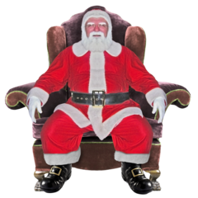 | You cannot go to see Santa or another type of Christmas experience if you live in a level 4 area.
 | You should not travel to another council area to see Santa if you live in a level 4 area.
 | There should be a booking system so that people do not have to queue.
 | Only 1 household should visit Santa at a time and only 1 adult is allowed to go.
 | Children must pick their own present instead of being given one by Santa.
 | Children over 5 years old should wear a face covering.
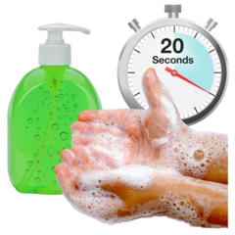 | People should remember to wash their hands.
 | People should physically distance and stay 2 metres apart from each other.
Carol singing and music
 | Carol singing and musical performances can take place only in Level 0 and 1 council areas.
 | Professional singers and musicians can have performances.
 | Professionals and non -professional singers and musicians can have performances outside.
 | Carol singers should not go to houses and knock on the door.
 | You cannot travel from a Level 3 or 4 area to watch a performance in another area.

