

**Spring 2018**

**Action required by all readers of Lothian Disability News**

***In this edition:***

Opt-in to receive future news from LCiL: Page 2

LCiL staff update: page 3

*Grapevine news*

Cold weather payments: page 5

PIP update pape 6

Devolved benefits page 7

LCiL workshops pages 8-10

If you want to continue receiving future editions of Lothian Disability News and/or information from LCiL about our news, events and activities, we need to gain your consent and require you to **opt-in** to receive these. This is a result of new data protection legislation coming into force from May 2018.

A consent form and Freepost envelop is enclosed for all our readers along with a link should you prefer to do this online.

See page 2 for more details.

Lothian Disability News is produced by Grapevine Disability Information service on behalf of Lothian Centre for Inclusive Living (LCiL).

This publication is available in a range of formats, including large print, audio and braille.

For more information please contact LCiL on 0131 475 2350 or email: [grapevine@lothiancil.org.uk](mailto:grapevine@lothiancil.org.uk)

Lothian Centre for Inclusive Living (LCiL) is a Company Limited by Guarantee. Registered in Scotland 129392. Accepted by the HMRC as a Charity SC/017954

Postal address for main office: LCiL, Norton Park, 57 Albion Road, Edinburgh, EH7 5QY

**Action required for all readers of Lothian Disability News**

If you wish to continue receiving Lothian Disability News, please send the consent form below back to us at our Freepost address: **Lothian Centre for Inclusive Living, FREEPOST SCO2157, Norton Park, 57 Albion Road, Edinburgh, EH7 0BR.** You can also email us at:[**admin@lothiancil.org.uk**](mailto:admin@lothiancil.org.uk) **For email recipients you can follow this link to get in touch:** [**https://www.surveymonkey.co.uk/r/WTRTBWZ**](https://www.surveymonkey.co.uk/r/WTRTBWZ)

We have included an option if you would like to receive other information in relation to LCiL, news, events and activities.

If we do not receive your consent unfortunately, we will have to remove your contact details from our database. **Deadline for responses is 11th of May 2018**

Please complete details and tear off the slip below:

✂……………………………………………………………………………………………………

Do you give consent that LCIL may use your name and contact details to send you **our newsletter?**

Please circle: Yes or No

Do you give consent that LCIL may use your name and contact details to contact you about **other information that may be useful to you**?

Please circle: Yes or No

Name:

Address:

Telephone number

Email address:

Signed: Date:

**LCiL staff changes:**

We want to give a warm welcome to some new faces at LCiL:

#### **New faces at LCiL…**



LCiL services are based out of our main office in Norton Park, Edinburgh.

**Name:** Kirsten Kerr

**Job Title:** HR & Office Coordinator

**Brief info about what your job involves:** The Human Resources & Office Management of LCiL.

**If a film was made about your life what would it be called?** Pink Sparkly & Prosecco

#### F:\Photos LCIL\Staff Pics\Kirsten L for newsletter.jpg

#### **Name:** Kirsten Logan

#### **Job Title:** Payroll Officer

#### **Brief info about what your job involves:** Processing payroll, submitting all relevant figures to HMRC on the service user’s behalf as well as administering pension data. Liaising with service users and LCiL.

#### **If a film was made about your life what would it be called**? ‘Joke’ I am forever being laughed at as I am always the last person to understand jokes.

#### **Name:** Lindsay Richards

#### **Job Title:** Pensions/Payroll Administrator (maternity cover)

#### **Brief info about what your job involves:** My job is to assist service users gain a basic understanding of how pensions work and help make their duties run smoothly as an employer.

#### **If a film was made about your life what would it be called**?

#### ‘Hakuna Matata’ – a problem-free philosophy approach to life.

**Name:** Gillian Buchan

**Job Title:** Payroll Administrator

**Job description:** Processing client payroll, including inputting data/hours of work for clients so that they know how much to pay their Personal Assistants (PAs), generating PAYE for tax and national insurance purposes, liaising with client and inland revenue, and issuing relevant forms i.e. P45’s and P60’s.

**If a film was made about your life what would it be called**? “It Doesn’t Always Work…But it’s good to Try”

#### **LCiL also said goodbye to some familiar faces recently…**

#### **Sandra Main**

#### cid:438add28-937e-477b-a8b1-0d43cf43adfc@eurprd09.prod.outlook.comAfter 27 years, Sandra Main, Operations Coordinator retired from her role with LCiL. From the early days working with Grapevine Disability Information, through to seeing the introduction of Direct Payments until now, Sandra has always been at the root of LCiL’s work. Sandra, for her fellow LCiL workers, LCiL board members and many of our established service users, is not just a colleague; she is a close friend and great source of support. We will miss Sandra dearly and wish her all the very best in her retirement!

#### **Debbie Bayne**

#### F:\Photos LCIL\SDS launch event 010414\20140401_121038.jpgAfter 5 and a half years, Debbie Bayne, LCiL’s Self-Directed Support (SDS) Coordinator, has gone onto pursue pastors new. She has developed many innovative projects including; training for social workers, LCiL Champions, Peer Support and Capacity Building programme. We wish Debbie well with her exciting and new adventures!

#### **Emma McKendrick**

#### We wish Emma McKendrick all the best in her new role as Peer Support Worker, and thank her for dedication and professionalism as LCiL’s Volunteer Administrator through the years, which she is leaving at the start of April. Emma will be continuing her role as an LCiL Champion.



#### **Lorraine Prince** We also gave a fond farewell to Lorraine Prince, Training Administrator, after 6 months with LCiL, and thank her for her contribution.

#### **Grapevine Disability Information news:**

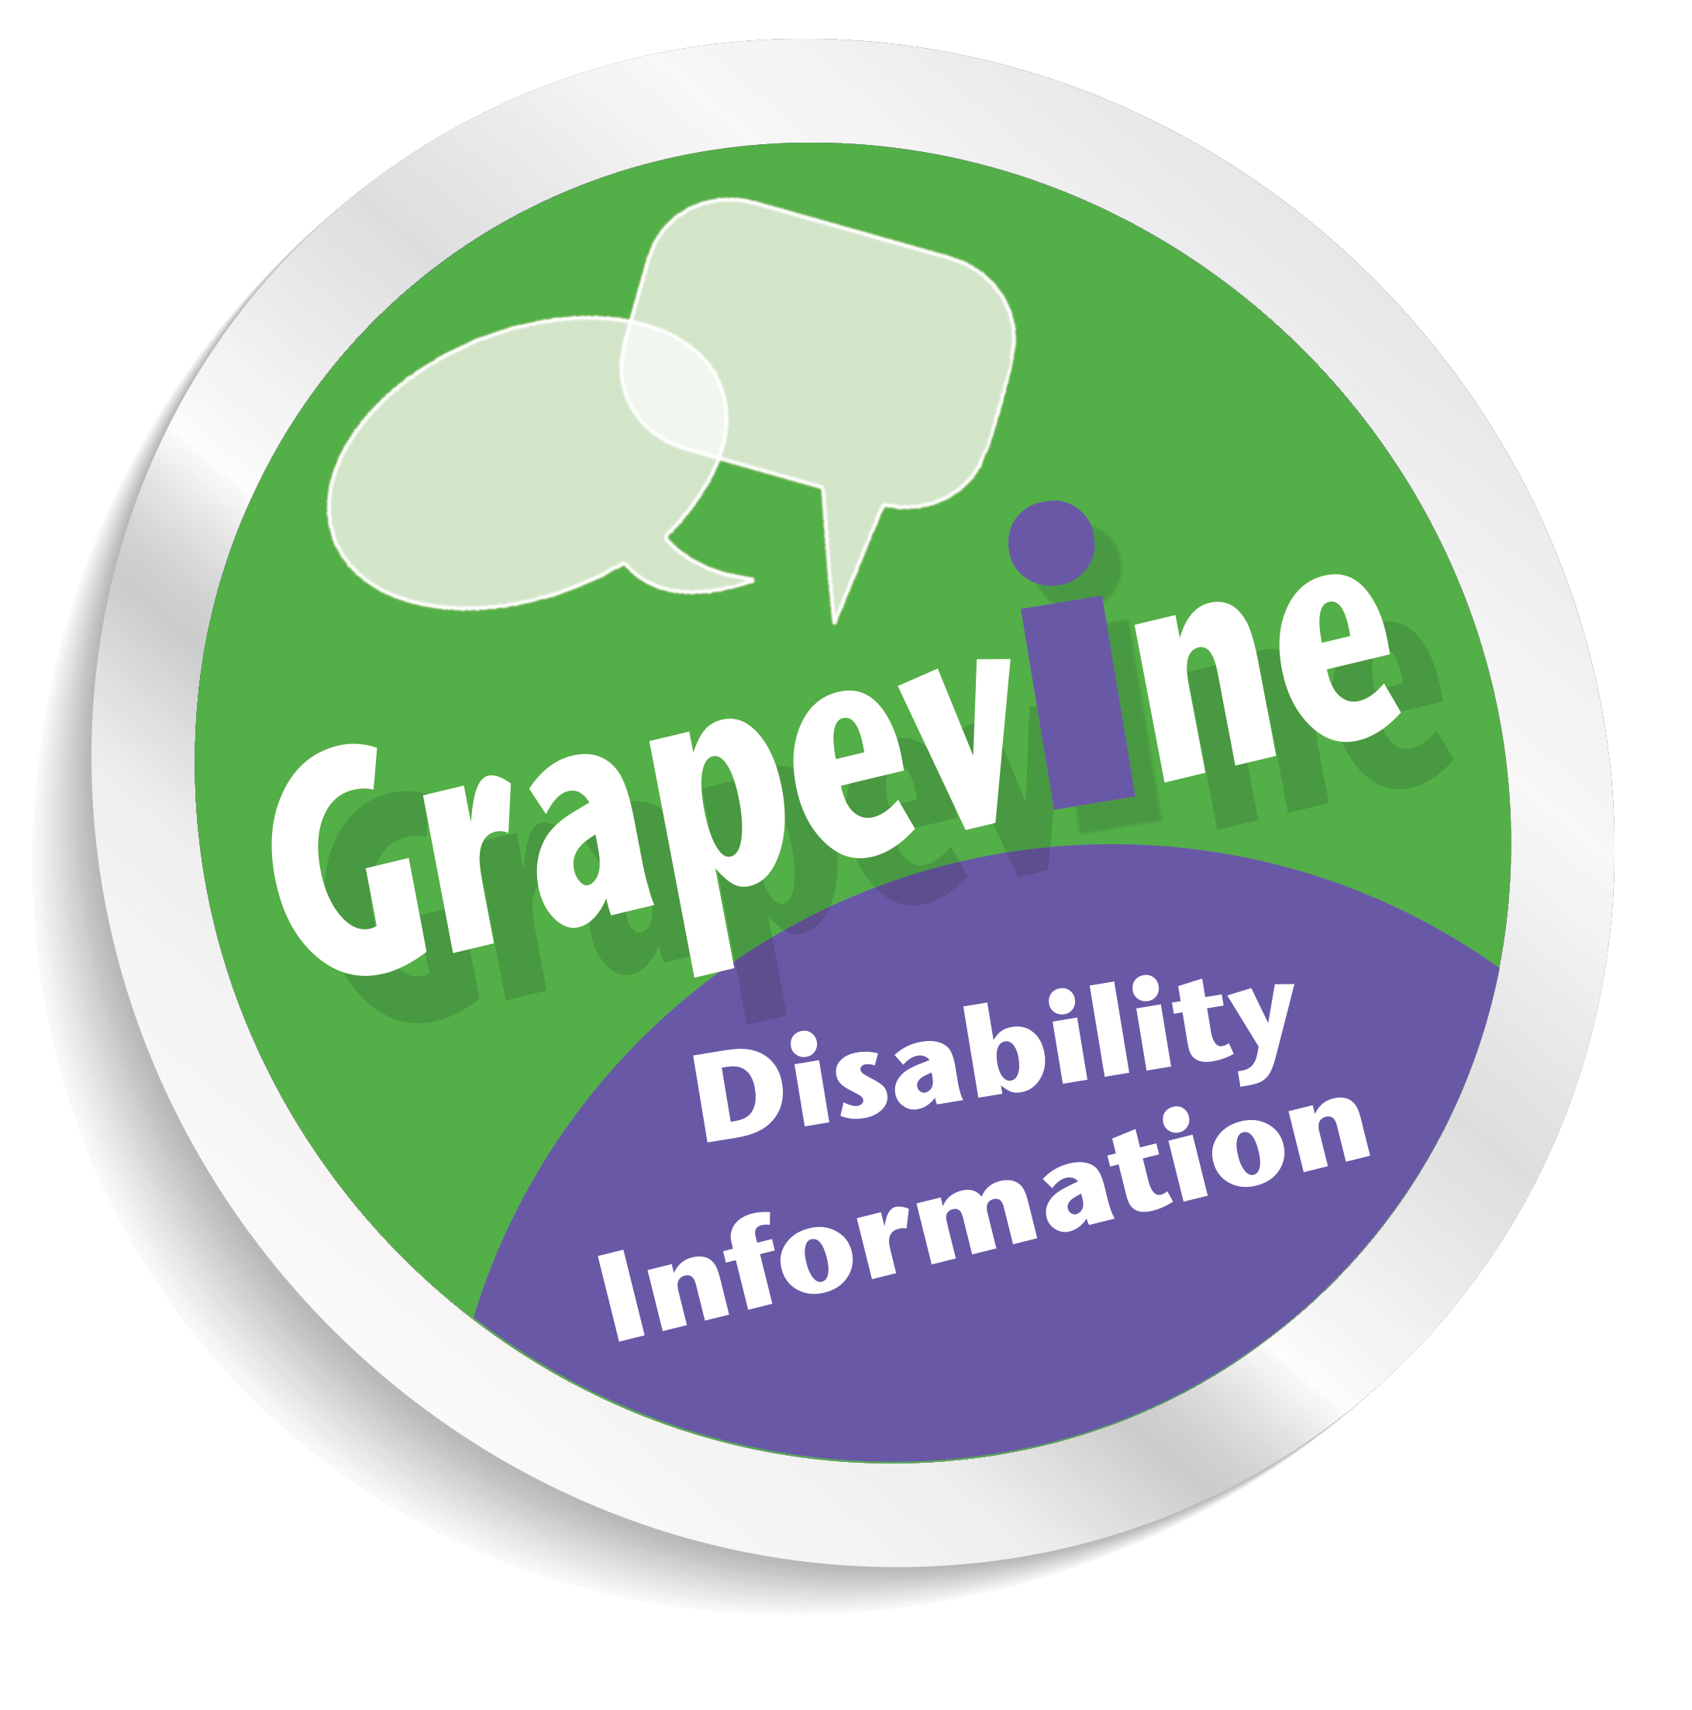

#### Grapevine, part of LCiL, provides free and confidential disability information and advice to anyone in Edinburgh.

#### Our advice line is available Mon-Fri, 10am-4pm on 0131 475 2370.

#### Email enquiries: [grapevine@lothiancil.org.uk](mailto:grapevine@lothiancil.org.uk).

#### We also provide face-to-face appointments for people aged 16 and above in Edinburgh who require assistance with disability benefit forms.

#### Below is a summary of some news items:

**Cold Weather Payments**

The cold weather, which gripped parts of the country, has left some people asking if they will receive Cold Weather Payment/s. Cold Weather Payments are payable to those receiving certain means tested benefits when the weather drops below zero degrees Celsius for more than seven consecutive days in your area. Cold Weather Payments should be automatic for those eligible already. However, there are some circumstances e.g. people who have children under five and in receipt of means-tested benefits, where you may have to inform the agencies below.

**Area checker for Cold Weather Payments:** [**https://www.gov.uk/cold-weather-payment/eligibility**](https://www.gov.uk/cold-weather-payment/eligibility)

If you do not receive your Cold Weather Payment inform the Pension Service on 0800 731 0469 or Job Centre Plus 0800 169 0310. If you are getting Universal Credit, contact the helpline instead on 0800 328 9344

**Personal Independence Payment (PIP update)**

At the end of January, the Department for Work and Pensions (DWP)

decided not to challenge a court ruling that said changes to Personal Independence Payment (PIP) were unfair to people affected by mental health problems.

Last year, the DWP went ahead, despite widespread criticism, and changed the descriptors for the mobility component of PIP. Specifically in relation to Planning and Following a journey*,* removing grounds for people to receive the enhanced rate of the mobility component if they were unable to travel independently on the grounds of psychological distress, as opposed to other conditions.

Estimates now suggest that around 220,000, could have lost out because of this change, and may be entitled to more money under PIP. The DWP are now conducting a review of existing information they hold and have stated they will contact the claimant and/or their doctor if they require more information about a claimants award for PIP.

Meantime the Minister for Disabled People, Health and Work (Sarah Newton) stated in the UK Parliament: “the individuals affected, and all payments will be back-dated to the effective date in each individual claim…and there will be no face-to-face reassessments of awards.”

(See source: <https://hansard.parliament.uk/Commons/2018-01-30/debates/F35E85CB-FF67-467E-AD63-1C13EB1EC32B/PIPBackPayments>)

Grapevine can assist people living in Edinburgh with their PIP forms based on our available appointments. We strongly suggest anyone going through the PIP process attempt to gather recent and consistent evidence to support their claim form, as this tends to help at assessment stage. Examples may include:

* Letter of diagnosis
* Letters summarising condition(s) from doctor/nurse.
* Prescription list
* Pictures of conditions
* Current Occupational Therapy (OT) reports
* Current OT letter indicating use of aids
* Evidence from support workers
* Special Needs report
* Current Psychiatric reports
* Current Carer’s assessments

If you or someone you know lives in Edinburgh and requires further information and advice in relation to their PIP claim please contact Grapevine on 0131 475 2370 (Mon-Fri, 10am-4pm) or email: [grapevine@lothiancil.org.uk](mailto:grapevine@lothiancil.org.uk)

**Devolved benefits for Scotland**

Control of certain disability and carer benefits, including Personal Independence Payment (PIP), Disability Living Allowance (DLA), Attendance Allowance and carers allowance, will eventually be devolved Holyrood for Scottish claimants.

At present, the Scottish Social Security Bill is making its way through The Scottish Parliament. Estimates suggest Scotland’s social security system will be in place, delivering and administering these benefits by 2021.

A recent Scottish Government publication, ‘About Your Benefits and You’, reported on the experience of benefit claimants and found:

* More than half (60 per cent) of respondents rated their experience of the current benefits system as ‘poor’ or ‘very poor’.
* 18 per cent rated their experience as ‘good’ or ‘very good’.
* Majority of respondents (71 per cent) listed ‘advice and support about claiming’ as a priority for Scottish Government to improve in the new social security system.

As the Bill progressing through the Scottish Parliament Grapevine will be sure to keep our readers posted on developments **(please see pages 1 and 2 to make sure you continue to receive our newsletter).**

**News from elsewhere in LCiL…**

**Peer Support for Parents and Carers**

Lothian Centre for Inclusive Living (LCiL) hosts a peer support group for parents and carers of disabled children and children with additional support needs. The parent and carer peer support group gives parents and carers the opportunity to:

* ****Meet other parents and carers
* Explore ideas and opportunities around support
* Find out practical information, resources and information on who to ask
* Develop skills and build confidence
* Hear from guest speakers and organisations on a range of topics

**When:** Once a month, alternating Monday and Thursdays, 10.30am -1.30pm with Lunch from 12:30pm.

**Where:** The group will meet at Norton Park Conference Centre, 57 Albion Road, Edinburgh, EH7 5QY

**Lunch and refreshments provided**

**To let us know you would like to attend or find out more information about the peer support group, contact Lisa Milburn at LCiL on 0131 475 2350 or email** [**lisa.milburn@lothiancil.org.uk**](mailto:lisa.milburn@lothiancil.org.uk)

**Personal Assistant (PA) Employer Peer Support Group**

LCiL has recently re-launched a Peer Support Group for all PA Employers and those managing PAs on behalf of someone else in Edinburgh and the Lothians. The aim of the group is to provide an informal and supportive setting to support PA employers with:

* Sharing ideas.
* Hearing from others what does/doesn’t work.
* Breaking down isolation.
* Getting the best out of your PA support arrangements.
* Build your knowledge, skills and confidence making it easier for yourself as an employer.
* Get information from speakers and discuss things in an information supportive setting.

The next session is due to take place on **Wednesday 2nd of May 2018 from 12noon-3pm.**

Lunch and refreshments will be provided and if needed we can organise and pay for transport if you live in Edinburgh or the Lothians.   
  
To find out more and to book, Lisa Milburn at LCiL on 0131 475 2350 or email [lisa.milburn@lothiancil.org.uk](mailto:lisa.milburn@lothiancil.org.uk)



**Know your rights workshop**

**Are you a disabled person, or someone with a long-term condition?**

**Do you want to:**

* Improve your knowledge of your rights
* Increase your ability to self-advocate?
* Learn how to make a complaint if your rights aren’t met?



**…and would you like to:**

* meet new people?
* Increase your confidence?

**In a relaxed and friendly atmosphere…**

**…then come along to our workshop!**

**Where and When?**

10.30am – 2.00pm, **Wednesday 9 May 2018**

Training Suite

Norton Park Conference Centre, Albion Road, Edinburgh EH7 5QY



At this workshop, we will cover:

* the social model of disability
* where, when and how to get support
* where to go for support/advocacy with accessing benefits and services

[](http://www.bing.com/images/search?q=taxi&view=detailv2&qft=+filterui:color2-bw+filterui:photo-clipart&id=E1653047A1FEAB78DE3E323A0D28BA48F56073BA&selectedIndex=137&ccid=A3l1gD5A&simid=608049146515689387&thid=OIP.M037975803e4043f1511e554c3fb12c73o0)[](http://www.bing.com/images/search?q=lunch&view=detailv2&qft=+filterui:color2-bw+filterui:photo-clipart&id=45817BA4D28BD00055453C3C56BFDF1859F0315B&selectedIndex=4&ccid=xBonofcg&simid=607988419973155748&thid=OIP.Mc41a27a1f720605fd8ddfebd8a04adfdH0)

Lunch and refreshments will be provided,

and if needed we can organise and pay for transport if you live in Edinburgh or the Lothians.

****

To find out more and to book, contact:

Lisa Milburn at LCiL on 0131 475 2350 or email [lisa.milburn@lothiancil.org.uk](mailto:lisa.milburn@lothiancil.org.uk)

**Are you a disabled person, or someone with a long-term condition?**

**Assertive communication workshops**

**Do you want to learn how to:**

* be more assertive?
* Give yourself the best chance of getting what you need

by preparing well for meetings or assessments?

* Challenge decisions?

**…and would you like to:**

* Meet new people?



I’d like …

* Increase your confidence?

**In a relaxed and friendly atmosphere…**

**…then come along to our workshops!**

**There will be two sessions:**

**Assertiveness 1**

10.30am – 2.30pm, **Wednesday 16 May 2018**

Training Suite, Norton Park Conference Centre, Albion Road, Edinburgh EH7 5QY

At this workshop, we will cover different ways of communicating and their effects, and you will have a chance to think about and plan how to make a case for something you need.

**Assertiveness 2**

10.30 – 2.30pm, **Wednesday 30 May 2018**

Training Suite, Norton Park Conference Centre, Albion Road, Edinburgh EH7 5QY

This workshop will give you the chance to discuss how you used what you learned in Assertiveness 1 and to take your skills further.

**Please note:** you **must** do Assertiveness 1 before you do this workshop.

[](http://www.bing.com/images/search?q=taxi&view=detailv2&qft=+filterui:color2-bw+filterui:photo-clipart&id=E1653047A1FEAB78DE3E323A0D28BA48F56073BA&selectedIndex=137&ccid=A3l1gD5A&simid=608049146515689387&thid=OIP.M037975803e4043f1511e554c3fb12c73o0)It is great if you can come to both, but you are welcome just to do Assertiveness 1 on its own.

Lunch and refreshments will be provided, in addition, if needed we can organise and pay for transport if you live in Edinburgh or the Lothians.

To find out more and to book, contact Lisa Milburn at LCiL on 0131 475 2350 or email [lisa.milburn@lothiancil.org.uk](mailto:lisa.milburn@lothiancil.org.uk)