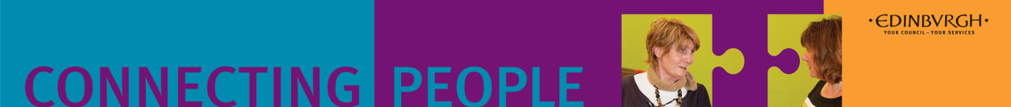
Lifestyle Management Course 2018

Is this course for you?
Would you like to improve your sleep pattern, increase your energy levels?
Would you like to reduce your stress levels and become a bit more active?
Get better at pacing so you get more out of your day?
Improve your confidence and get your needs or hopes met?
This course would be suitable for you if you have a diagnosed physical disability or long term health condition. It would suit you if you are keen to explore ways of building your confidence, self worth and knowledge and skills that will help you to cope better and move on in life despite any difficult life situations that you may be dealing with.
What would this course offer?
This 10 week course is an opportunity for you to share your experiences and coping strategies with other group members.
Together you can explore ways of small changes which can enable powerful progression in your life. The course covers the following topics:
- Incorporate Effective Communication into your life
- Stress and anxiety management and the benefits of relaxation
- Understanding pain and other symptoms
- Pacing and energy management and sustaining a balanced lifestyle
- Getting active and motivated
- Planning and prioritising for a better lifestyle
- Mindfulness and Mind-body connection
- Managing change and preventing and minimising relapse
- Reflection and forward planning your next steps ahead
Venue and facilities
The course is being run at a variety of venues across Edinburgh throughout 2018. The first two courses of 2018 are detailed below: Drumbrae Library Hub and Cameron House Education Centre. They are accessible for disabled people. There will be tea and coffee provided along with fruit and biscuits. Please let us know if you have any dietary requirements or particular allergies.
The course itself is free.
How do I find out more?
If you are interested in attending this course then contact a course facilitator directly or speak to a key worker if you have one and they can refer you. You need to book yourself into an initial meeting (see above) with a course facilitator prior to the course starting to discuss the course in more detail.
Drumbrae Library Hub  81 Drum Brae Dr, Edinburgh EH4 7FE | Cameron House Education Centre  34 Prestonfield Ave, Edinburgh EH16 5EU
25th January – 29th March | 19th April – 21st June
Please book an Initial session to discuss the course & your hopes:  8th January & 11th January  10am-11am  11am-12noon  12.30-1.30pm  1.30-2.30pm  2.30-3.30pm  3.30-4.30pm  Contact course facilitator:  Lorna Todd; 0752 325 8211  Lorna.todd@edinburgh.gov.uk | Please book an initial session to discuss the course & your hopes:  9th April & 12th April  10am-11am  11am-12noon  12.30-1.30pm  1.30-2.30pm  2.30-3.30pm  3.30-4.30pm  Contact course facilitator:  Susan Dalgliesh; 07795 121 702 Susan.dalgliesh@edinburgh.gov.uk

