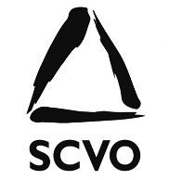
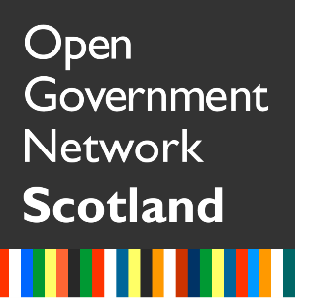
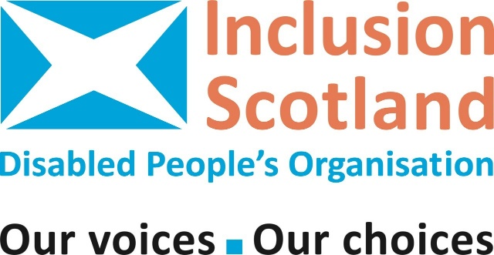
Open Government or Closed Doors?
What does Community Empowerment mean for disabled people?
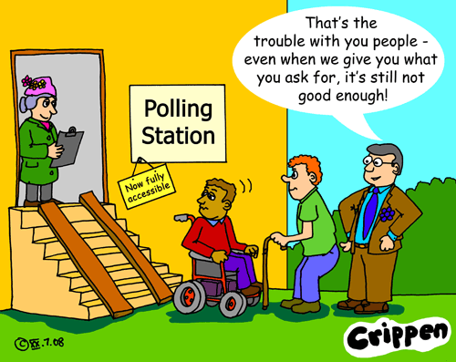
The Scottish Government is committed to our communities being supported to do things for themselves and to people having their voices heard in the planning and delivery of services.
Public
Meeting
But what does this mean for disabled people? Will we have a real say in decisions that affect us, or will we just be left further behind?
Inclusion Scotland in partnership with the Scottish Council for Voluntary Services (SCVO) invite you to a free event to look at how disabled people can take advantage of open government, community empowerment and participatory budgeting, and find out what we have learned from Inclusion Scotland’s Local Policy and Engagement Project in the Highlands.
Thursday 29 June 2017
10.30 – 3.30
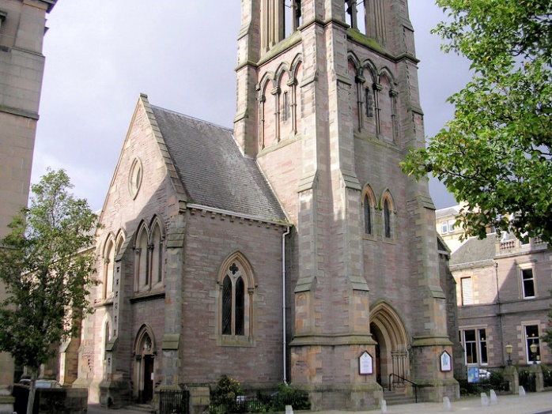
St Matthew’s Church, Tay Street, Perth
Lunch provided.
Reasonable travel and other support costs will be met.
Register for free on Eventbrite:
https://open-government-closed-doors.eventbrite.co.uk
Or e-mail events@inclusionscotland.org or phone Rhona on 0131 281 086
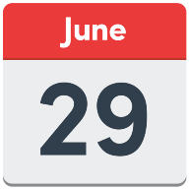
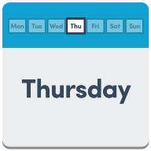
Open Government or closed doors?
Thursday 29 June 2017
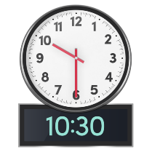
Registration,
Tea, coffee and biscuits
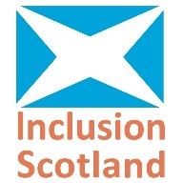
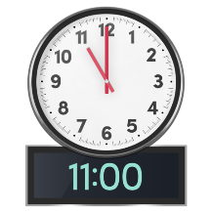
Welcome and Introduction
Iain Smith (Inclusion Scotland)
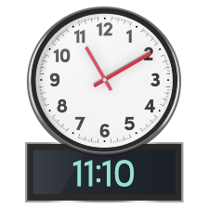
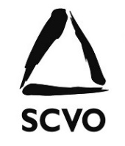
Introduction to Open Government Network
Allan Young (SCVO)
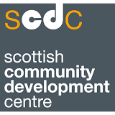
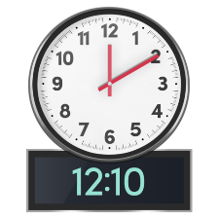
followed by Workshop 1
Participatory Budgeting – what is it?
David Reilly (Development Manager SCDC)
followed by Workshop 2
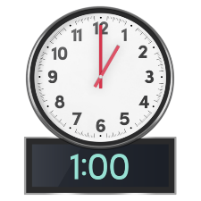
Lunch

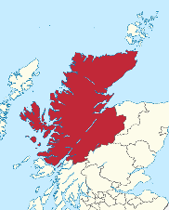
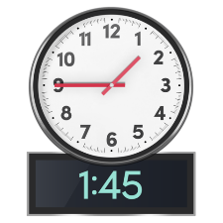
Learning from the Highlands
John Beaton (Inclusion Scotland Highlands)
Followed by Workshop 3

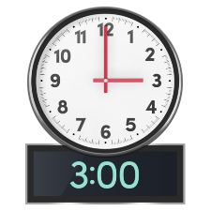
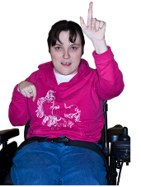
Feedback and Questions

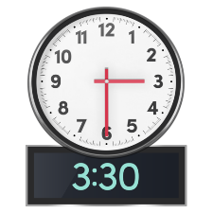

Close of event

