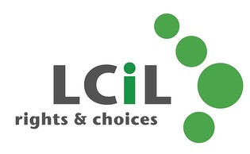

Are you thinking about becoming a PA, or

would you like to brush up on your PA skills?

Introducing the 2-day Training for Personal Assistants course, it could enhance your prospects of employment as a PA or, if you are already a PA, help you to be more effective in your role.

Topics covered include:
• Disability and Equality - cultural representations of disabled people and barriers faced by disabled people
• Social Model of Disability – and how to apply the principles in your PA role
• Understanding the importance of appropriate language
• Exploring roles and relationships
• Knowing the Relationship Boundaries
• Exploring potential dilemmas
• Responding to Your Employer’s Needs

Dates: TBC, (looking at late August 17) Time: 10.30am to 4.00pm
(Lunch provided)
Venue: Norton Park, 57 Albion Road, Edinburgh. EH7 5QY

For more info email: amanda.beech@lothiancil.org.uk or visit www.lothiancil.org.uk
Or call, Amanda Beech on 0131 475 2510

