

www.mhfestival.com

Scottish Mental Health Arts & Film Festival
International Writing Competition
Guidelines and Entry Form 2015

GUIDELINES

The Festival:

The ninth Scottish Mental Health Arts & Film Festival (SMHAFF) will take place at venues across Scotland from the 10th – 31st October 2015. Led by the Mental Health Foundation, the Festival aims to support the arts and challenge preconceived ideas about mental health, through genres ranging from film, music and visual art to theatre, dance and literature. By engaging artists, connecting with communities and forming collaborations, the Festival celebrates art and mental health, explores the relationship between creativity and the mind, and promotes positive mental health and wellbeing.

The Competition:

The SMHAFF writing competition is managed in partnership with Bipolar Scotland.

This year's theme for all categories is "Passion". This can be interpreted in any way you choose - the limit is your imagination.

There will be five categories:

- Poems
- Short stories
- Newspaper articles
- Diary/Blog entries
- Letters

The closing date for the competition is 5pm UK time on Friday 31st July 2015. We cannot accept any entries received after this date.

Submission details:

- Entry to the competition is free.

- Entrants must be over 16 years of age.

- Entries must be typed and in English.

- Entries must be on the theme of “Passion”.

- Entries must be the entrant’s own original work.

- We will accept entries written at any time as long as they have not previously been submitted to Bipolar Scotland’s poetry and short story competitions.

- Poems must not exceed 40 lines. Short stories must be between 500 and 2000 words.
Newspaper articles must not exceed 750 words. The article may be aimed at any type of newspaper audience: eg. tabloid, broadsheet or Sunday supplement. The article does not have to have been published. Diary/Blog entries must not exceed 500 words. This may be one or sequence of diary entries for the same diary up to the word limit. Letters must not exceed 750 words. Letters may be addressed to anyone: real or fictional; alive or dead; famous or not famous. However, the letter must be from and signed by the entrant himself or herself.

- Only one entry per entrant can be considered in each category.

- Entries must be received by Friday 31st July 2015. Please submit your work as soon as you possibly can before this date.

- We can only accept entry by email. Entrants should send a single email to writecomp2015@bipolarscotland.org.uk.
The email should include an attached file for the entry form and a file for each entry. Please do not attach folders. Attachments should be compatible word files only.
Please include the entrant’s full name in the subject bar.

Please name each file with the title of the entry. Do not put name, initials or anything that may identify you on any file except the entry form and in the subject bar.

If you cannot access email please phone Aileen or Alison on 0141 560 2050.

- By entering you are agreeing to be published in any media or subsequent anthologies associated with the competition as approved by the SMHAFF.

- Copyright of any work submitted remains with the author.

- Staff and Board Members of Bipolar Scotland and SMHAFF are not eligible to enter.

- Successful entrants will be notified by Wednesday 30th September 2015. If you have not heard by that date then you have not been successful.

- The judges’ decision is final and we are not able to provide feedback on unsuccessful submissions.

- For further information, and to answer any queries, please contact:

Aileen Bell, Development Officer, Bipolar Scotland, Studio 1015, Mile End Mill, Abbeymill Business Centre, Seedhill Road, Paisley PA1 2SN, writecomp2015@bipolarscotland.org.uk or 0141 560 2050

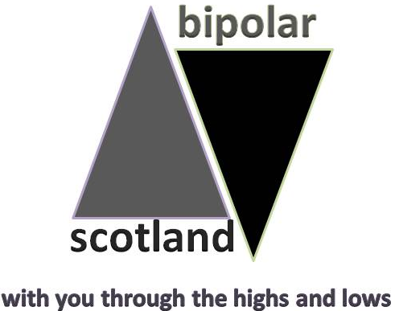

ENTRY FORM (make sure you have read the guidelines before completing this form)

Entrant details:
Name:

Address (inc. postcode and country):

Phone: | Email:
How did you hear about the competition:

About your submission:
(Please fill out for each submission; you can only submit one entry for each category)
Title:
Category (Please tick):
Poem | Short Story | Newspaper | Diary/Blog | Letter

Title:
Category (Please tick):
Poem | Short Story | Newspaper | Diary/Blog | Letter

Title:
Category (Please tick):
Poem | Short Story | Newspaper | Diary/Blog | Letter

Title:
Category (Please tick):
Poem | Short Story | Newspaper | Diary/Blog | Letter

Title:
Category (Please tick):
Poem | Short Story | Newspaper | Diary/Blog | Letter

I HAVE READ, UNDERSTOOD AND AGREE WITH THE CONDITIONS OF SUBMISSION AS LAID OUT IN THE ABOVE SUBMISSION GUIDELINES.

Name: | Date:

By submitting this completed form you confirm that the entry is your own work and does not include any plagiarised material

PLEASE SEND ENTRIES TO:
writecomp2015@bipolarscotland.org.uk

