
Lothian Disability News
Autumn 2014

#Care Charge Petition

Over Scotland there’s a mixed picture when it comes to charging people for aspects of their care and support. Scotland Against the Care Tax (SACT) Campaign believes that by abolishing all care charges this will create a level playing field for all disabled people no matter what local authority area they live in. The campaign group also believes that by making care and support free at the point of delivery this will reduce financial hardship, emotional stress, and open up the life opportunities of disabled people and their right to live independently in their community.

In the meantime it is very important that local authorities understand the associated additional daily living costs of living with an illness or a disability if they are to avoid charging disabled people more than they can afford for social care services.

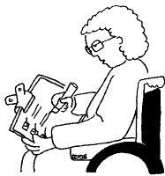
Scotland Against the Care Tax (SACT) is encouraging everyone to sign their petition calling for the Scottish Government to use its existing powers to abolish care charges for non-residential care. The petition has been lodged in the Scottish Parliament and supported by a number of user led organisations and other groups supporting disabled people already however the race is on to gather more signatures in the campaign so there is a better chance this will lead to a full and open debate in the Scottish Parliament, no matter what the outcome is of the Independence Referendum on the 18th of September. It is hoped by using the hashtag on #Care Charge on social media sites this will generate more interest over the coming weeks. You can access the online petition by following this link: https://www.change.org/p/scottish-parliament-end-non-residential-social-care-charges-for-older-and-disabled-people
In this edition:
- LCiL training updates, page 3 onwards.
- Information for PA employers – Auto-enrolment for pensions page 7
- Free hearing aid batteries – page 11.
If you don’t have access to the internet you can request a hard copy of the petition from The Learning Disability Alliance Scotland on 079 201 418 23 or email: office@ldascotland.org

Read on to find out how you can have a say about this newsletter…
Lothian Disability News is written and produced by Grapevine, Disability Information Service, which is run by the Lothian Centre for Inclusive Living (LCiL).
Grapevine, LCiL, Norton Park, 57 Albion Road, Edinburgh, EH7 5QY Tel 0131 475 2370
Email grapevine@lothiancil.org.uk Website: www.lothiancil.org.uk

Grapevine, LCiL, Norton Park, 57 Albion Road, Edinburgh, EH7 5QY Tel 0131 475 2370
Email grapevine@lothiancil.org.uk Website: www.lothiancil.org.uk

Your chance to have a say about this newsletter:
It’s been a while since we last asked our readers what they think about the content of Lothian Disability News so we’d like to give you this opportunity to complete an anonymous short survey enclosed with hard copies of this newsletter with freepost envelop. An online survey is also available here: https://www.surveymonkey.com/s/SQ3G3B5
so you can tell us what you think about the newsletter, including what’s good, not so good and how it could be improved. This will help inform future articles and make sure we are still reflecting the views and interests of disabled people living in Edinburgh and the Lothians.


Lothian Centre for Inclusive Centre (LCiL)
News and events:


Independent review of Personal Independence Payment:

Last month Grapevine in partnership with the Inclusion Scotland hosted a consultation on Personal Indepedence Payment (PIP). PIP started to replace Disability Living Allowance (DLA) in April 2013. For many people affected it has been a stressful and worrying time.
The first Independent Review of PIP was launched by the Department of Work and Pensions (DWP) in June 2014 and it’s been set up to gather evidence from people who have been affected by PIP.
People who Grapevine had assisted with PIP claims came along to the event to share their experiences and views. Some key improvements suggested at the event that would help improve the experience for disabled people include:
- Making it easier to get a claim form, without having to phone up for one.
- Ensuring that all DWP and assessment staff dealing with PIP claims are fully trained in disability equality and disability equalities.
- Including the descriptors and criteria for awarding points on the application form or accompanying information booklet.
- Only requiring a face to face assessment where this cannot be done using the information form, the application form and additional information provided by the applicant or at the request of the DWP.
- Conducting more face to face assessments in the applicants own home.
- Ensuring that those carrying out assessments have knowledge of the condition the claimant has.
- Reducing the delays between application and assessment, and assessment and decision.
The full report has now been submitted to the Independent Review which Paul Gray, Chair of the Social Security Advisory Committee (SSAC), is conducting on behalf of the Department for Work and Pensions (DWP) and will be required to feedback to the UK Government at the end of the year. The report can be read in full in the Consultation Response sub-section of the E-library at: http://www.lothiancil.org.uk/docs-library-consultations-and-responses/
We will keep you posted on developments with this including efforts to influence the Scottish Parliament Welfare Reform Committee.

TRAINING UPDATES:

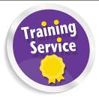
Training for Personal Assistants is back!!!
Thinking about becoming a PA?
Or
Want to brush up on your PA skills?

This 2 day Training for Personal Assistants course, which has proved so successful since coming back, is being run again on 18th and 19th Nov 2014. It could enhance your prospects of employment as a PA or, if you are already a PA, help you to be more effective in your role.

Topics covered include:
- Disability and Equality - cultural representations of disabled people and barriers faced by disabled people
- Social Model of Disability – and how to apply the principles in your PA role
What are you waiting for?
Learn today!

- Understanding the importance of appropriate
language
- Exploring roles and relationships
- Knowing the Relationship Boundaries
- Exploring potential dilemmas
- Responding to Your Employer’s Needs

Dates: 18th and 19th Nov 2014. Time: 10.00am to 4.00pm (Lunch provided)
Venue: Norton Park, 57 Albion Road, Edinburgh. EH7 5QY
Are you eligible for ILA funding? If so, you can use it to pay for this course. To find out more, visit www.ilascotland.org.uk or visit our website now!
www.lothiancil.org.uk for ILA Eligibility Criteria. For non-ILA holders, the cost will be £195 for the two days
Book your place now!
For more information contact Amanda Beech on 0131 475 2350 or email: amanda.beech@lothiancil.org.uk. Find out more about the course here: http://www.lothiancil.org.uk/our-services/training-service/services-traini

ng-training-for-pas/


FREE
Essential PA Employer Skills Course!

Are you a disabled person or a person with long-term condition?

Thinking about employing Personal Assistant(s) to support you?

Or, if you are already a PA employer, want to refresh your employer skills?

The Essential Employer Skills is a 3 day course that provides disabled employers of Personal Assistants with an understanding of the essential responsibilities and roles required of a good employer.
Gain more confidence in managing your PA!
When: 1st, 6th & 8th October 2014! 10.30am - 3.30pm

Lunch provided transport can be arranged if required

Where: Norton Park, 57 Albion Road, Edinburgh.
The course will enable participants:
- to gain an overall understanding of the key responsibilities of an employer
- to better understand what is involved in recruitment of a Personal Assistant (optional for existing PA employers)
Course will be delivered by a disabled PA employer
- to gain skills in effective PA management
- to determine boundaries to promote good employer/employee relationships
- gain more independence and control
- to increase self confidence
To register your interest or for an informal chat to find out more about the course, please contact LCiL on 0131 475 2350 or email either elspeth.ferguson@lothiancil.org.uk or kelly.jack@lothiancil.org.uk

Independent Living and Work Choices Service

Are you a disabled person or a person with long term conditions living in the Lothian area and interested in?:

- Living a more independent life?
- Accessing Employment/Further Education or Training?
- Developing your own action plan and achieving your goals with one to one support?
- Then this is for you…….!!
Don’t delay, book today!
Lothian Centre for Inclusive Living is running a five year BIG lottery project which aims to support disabled people and people with long term conditions to maximise their potential and participation in community life.



How does it work?

- You contact us.

- One of our project staff will arrange to meet with you to welcome you.
- You attend our FREE four day course covering Confidence, Disability Equality, Self Directed Support and a Working Life (Lunch is provided & Transport can be arranged if required)

- Our project staff will offer you one to one follow up support to help you to achieve your goals
The next course……
- 30^{th,} Oct, 4th, 6th& 11th Nov 2014!
- 10.30am – 3.30pm
- Norton Park, 57 Albion Road, Edinburgh

To register your interest or for an informal chat to find out more about the course, contact LCiL on 0131 475 2350 or email
Elspeth.ferguson@lothiancil.org.uk or kelly.jack@lothiancil.org.uk
Website: www.lothiancil.org.uk



‘Let’s tell it like it is’ – Debbie Bayne talks about her role as the LCiL Champions co-ordinator

Co-ordinating the Champions Programme is the best bit of my job by far. I’ve been working on the project for nearly two years, and have seen the nine Champions all the way through from their initial training to now. I’ve watched them all grow in skills and confidence and find out what they’re most interested in.

We always hoped that the Champions project would be good for everyone – for LCiL, for the groups or organisations that the Champions went to speak to and for the Champions as individuals. We’ve had fun, faced challenges and learned lots – so far it’s been very good for all of us!

I really enjoy promoting what the Champions do, working out who should go to which event and helping people to prepare. It was also great fun being involved in making the video, and getting such positive feedback about the finished product – if you haven’t already seen it you can watch it here:
https://www.youtube.com/watch?v=lBOgiFS25qE
(it has subtitles which can be turned on and off using the ‘captions’ button on the bottom bar)

But the very best thing is when we meet up every eight weeks or so – it’s always noisy and lively with lots of jokes and laughter, but it’s also taken very, very seriously by the Champions – they’re talking and reflecting about how it feels to go out and try to influence attitudes to disability and how disabled people are supported through self-directed support – that can be tough, as well as being worthwhile. Lots of insight and learning comes out of these sessions, and this helps us decide what to do next, where to put our effort and what issues need to be worked on. This is all made possible by the commitment and determination of the Champions and by how strong their relationships with each other are. It’s a real privilege to work with them.

What’s next? As well as getting involved in self-directed support training for council staff, Champions are now starting to train other service users to talk about their own lived experience – if we can get to do more of this it will ripple out to more and more people.

We’re also thinking about and planning the next stage of the project – hopefully something bigger with more Champions so they can reach even further. Watch this space!

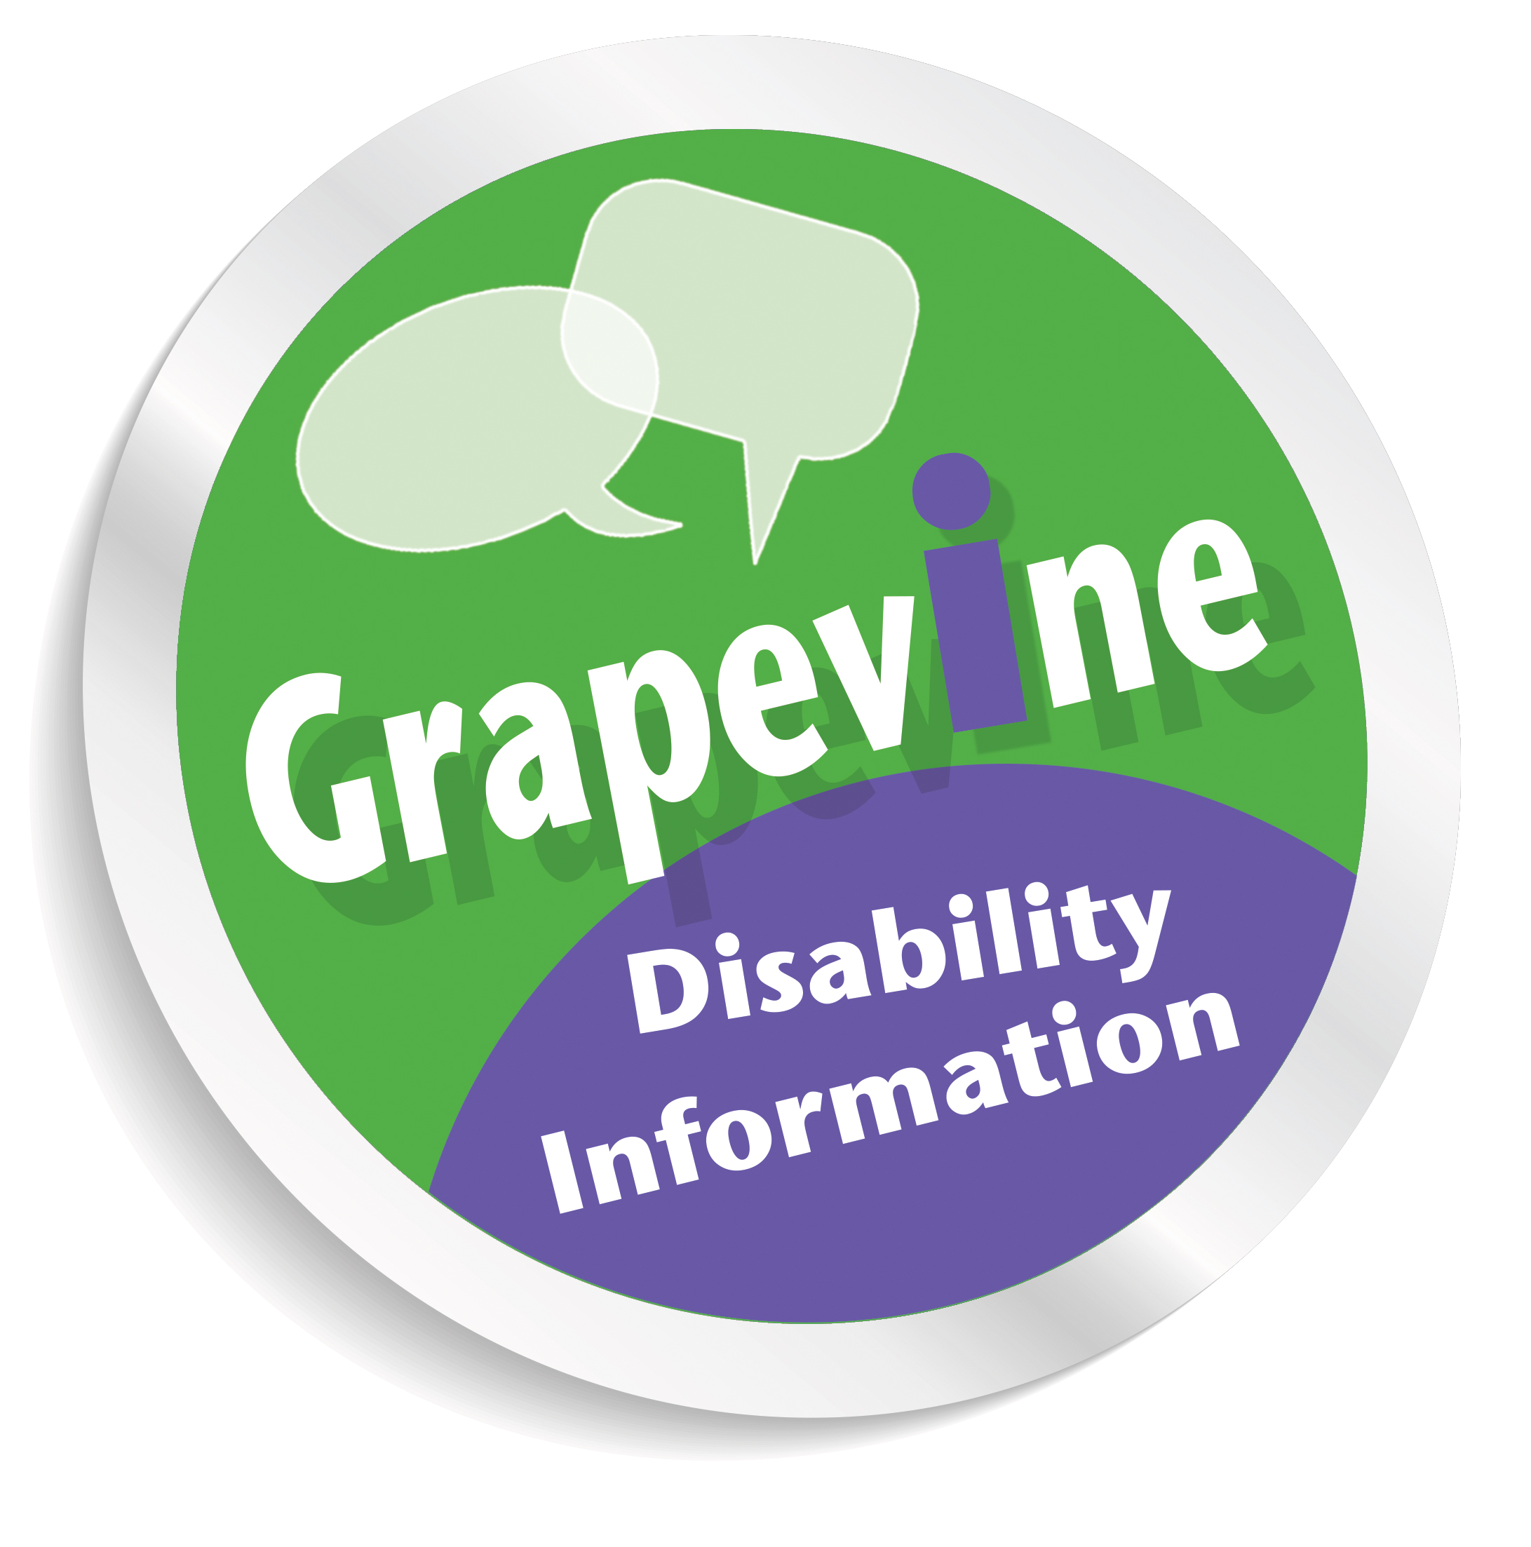
Grapevine new publication
- Private Care Agencies in Edinburgh and the Lothians – produced jointly with LCiL’s Independent Living Team this has a comprehensive list of most agencies and what they can offer for those looking to arrange care and support services.

Call us on 0131 475 2370 or email: graepvine@lothiancil.org.uk to receive a copy.

SAVE THE DATE: Food Safety and Quality in the Workplace Time:

Tuesday 2nd of December, 11.30am—3pm

Venue: Greggs Bakery, Greggs Bakery, 36, Dryden Rd, Bilston Glen Industrial Estate, Midlothian EH20 9LZ. For more details call Amanda on 0131 475 2350 or email: amanda.beech@lothiancil.org.uk

Important information for PA Employers
Workplace Pensions - Automatic Enrolment

The UK Government is keen for most workers to have an opportunity to contribute to a pension. For this reason between now and 2018, every employer with at least one worker will need to have a workplace pension scheme in place and start enrolling workers – many workers will eligible for automatic enrolment or auto enrolment. Some other workers must be enrolled if they ask to join.

Not every employer will have to start this at the same time but each employer will need to know their own individual “staging” date which is linked to their registration with HMRC. The “staging” date sets out when the employer must have a pension scheme in place.

If you employ PAs what does this mean for you?
The Pensions Regulator will communicate directly with you to
- advise your staging date (12 months in advance);
- request two contact names for any communication;
- give you a registration code;
- impose fixed penalty of £400 and further daily penalties if you do not set up a pension scheme for your eligible workers.

To be ready for auto enrolment you need to:
- choose and set up a pension scheme before your staging date
- check details of your PAs to see who needs to be auto enrolled
- tell your PAs:
  - about the scheme you have chosen;
  - how much they will have to pay into the pension scheme;
  - how much you as the employer will pay into the pension scheme;
  - about their rights to opt out or in;
  - changes made to Terms & Conditions regarding their rights under auto enrolment.

You will also have ongoing responsibilities to
- forward all contributions (employer & employee) to the pension provider within a set timescale
- keep records of:
  - payments sent to pension provider;
  - requests from workers to opt out of scheme.
- check every pay day to see if any workers now qualify for auto enrolment (e.g. reached aged 22)
- auto enrol your PAs again every 3 years on the anniversary of your staging date or every 18 months if you as the employer choose to pay higher contributions

If you use LCIL’s payroll service, we will help you with all this. We will also be offering information sessions/workshops on this topic and will send out booking forms very soon. We strongly encourage you to work with us on this so that you have everything in place, on time and with as little stress as possible. In the meantime if you receive any correspondence from The Pensions Regulator please keep it safe, or send in a copy to LCIL so we can support you to comply with this new legislation.

LCIL is currently talking to the four Lothian local authorities about auto enrolment so that they are ready too and able to tell employers how these new pension costs will be funded. These changes will also involve a lot more work for LCIL’s payroll service so LCIL will also be discussing with local authorities how they will fund this increased level of support.

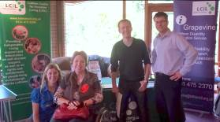
Grapevine in the Gateway service (led City of Edinburgh Council (CEC))

Last month Grapevine in partnership with the City of Edinburgh hosted a launch event for the Gateway service. This service provides information and advice to support adults living in Edinburgh with the neurological progressive conditions Multiple Sclerosis, Motor Neuron Disease, Huntington’s disease and Parkinson’s. It has been developed as a result of consultation with service users who said the most important thing is face to face contact with information that is up to date and accurate.
The Gateway Launch event on 20th August 2014

For the last two years, working with CEC, Grapevine developed the service at Craighall and Firhill resource centres in Edinburgh to ensure that people who are diagnosed with these conditions get information and advice at the right point in time to avoid them having to jump through hoops and get what they need to stay well and connect with support they require. Grapevine being part of Gateway and LCiL means that users of the service have instant access to a one stop shop.

Now there is a Gateway Project Officer in post to help promote the service more widely to carers, family members and workers it’s hoped many more can benefit from accessing support such as claiming benefits they are entitled to, funding which is available, help to get out and about or getting some help at work, making plans for the future and much more.

Here’s what Neil Lucas, LCiL Champion said about his involvement with the Gateway service:

“It just so happened that when my personal circumstances changed I met Andy from Grapevine as part of Gateway service who informed me of my rights and told me about help and benefits I could claim. He helped me to understand what I was entitled to and get back on the right path in life. Having someone to see face to face who believed in me and gave me encouragement to claim what I was entitled to has made a huge difference. I’m now supporting other people in my role as a Champion for the Lothian Centre for Inclusive Living, so that they too are aware of the help that is out there and would urge others who are diagnosed with progressive neurological conditions in Edinburgh to get in touch with the Gateway service.”

How can you access the service?
You can call Roisin McVie, Gateway Project Officer on 07702 918 951 or email: hsc.gateway@edinburgh.gov.uk

Alternatively can contact Grapevine on 0131 475 2370 (Mon-Thu, 10am-4pm, or email: grapevine@lothiancil.org.uk


Other News and Events:

We Can Work website
Inclusion Scotland has developed a new website called We Can Work with advice and support for disabled people to develop their employability. This includes information about paid Internship programmes targeting disabled people just now as well as resources such as how to write a good job application & preparing for an interview. You can find out more at: http://www.wecanwork.org.uk/. Alternatively you can call Phyl Meyer at Inclusion Scotland about these opportunities on 0131 281 0864 or email: phyl@inclusionscot.org

Firrhill Technology Hub

Firrhill resource centre in Edinburgh has recently received additional funding to set up a Technology Hub. This is aimed at young people with learning difficulties, people with physical impairments or people with neurological conditions. It can support people directly involved in Firrhill Centre as well as to those based in the community.

The aim of the project is to enable disabled people to try out and to practice with new technologies. Julie King is the assistive technology occupational therapist and she will advise if an initial assessment and further support would be helpful for an individual. For further details you can contact Julie on: 0131 441 7176.

The Sestran Thistle Card Scheme
The SEStran Thistle Assistance Card is designed to make using public transport easier for disabled people, people with long term conditions, and older people. The card, which is supported by a wide variety of voluntary organisation in South East Scotland and by most bus operators, is credit-card sized and comes with a supply of peel-off stickers, which advise the driver of your disability and the help you need in
an easy-to-read format. It’s free and is available at all Travelshops and Park & Ride sites as well as a range of outlets across South East Scotland, including; local authorities, bus operators, GP surgeries and health centres. You can also request a card be sent to you free of charge by calling SEStran on 0131 524 5150.

Free advice on cutting your fuel bills

Home Energy Scotland offers free, impartial energy efficiency advice. They have Community Liaison Officers who can offer home visits to householders who might have difficulties using their helpline, 0808 808 2282. Home Energy Scotland advisors are available on the phone Monday - Friday from 8am to 8pm, and on Saturday from 9am to 5pm.

Anyone worried about their bills, struggling to heat their home or interested in becoming more energy efficient can benefit from their service. Contact Home Energy Scotland free on 0808 808 2282 or visit their website http://www.greenerscotland.org/warm-homes/
Hearing aid batteries

If you have hearing aids from the NHS Lothian Audiology Department, you can now collect new free batteries from Edinburgh libraries. If you have purchased your hearing aid battery privately you will need to return to the original supplier.

You can collect your hearing aid battery supplies from all libraries in the city and recycle NHS hearing aid batteries. Please bring your yellow audiology battery book with you to the library to collect your new batteries. This will tell the library staff what kind of battery you need. Individuals will get 2 packs of batteries for each hearing aid every 4 months. If you have any queries regarding increased battery use please phone the Audiology office: 0131 536 4160

Deaf Action on Albany Street will also have hearing aid battery supplies for NHS hearing aids. Call them on 0131 556 3128 Staff at Deaf Action will fit new hearing aid batteries for you. Library staff will not fit new batteries.

Recycling points - Libraries will also have recycling points for your old batteries. Most large supermarkets and local rubbish tips have bins to recycle batteries.


Befriending project ECAS

- Would you like someone to visit you on a one to one basis in a regular safe and supported way?
- Would you like someone to read to you, talk to you, listen to you or get out and about?
- Would you like help to visit other disabled friends in Edinburgh?

If you are 18+, live in Edinburgh, and would like to become a befriender or would like to be befriended or know someone who would benefit contact Ally Irvine, Befriending Project Manager on 0131 475 2344 or email: ally.irvine.browning@ecas-edinburgh.org


Your Passport to a smooth journey:

This new publication from the Equality Advisory Service provides disabled people with information on their rights and what to do to make sure you have the best chance of a smooth course when you fly to and from the UK and Europe, including on domestic flights. If you live in Edinburgh, Midlothian and East Lothian you can request a copy from Grapevine on 0131 475 2370 or download a copy from our website at: http://www.lothiancil.org.uk/docs-library-disability-resources/. We also give advice on a whole range of travel related topics, including accessible holiday accommodation and what to prepare for.

Grapevine Disability Information Service

Providing up to date, reliable and accessible information to disabled people and their supporters in Edinburgh, East Lothian and Midlothian. We cover all disability related matters and our service is completely free and confidential.

You can contact us on:

Disability Information line 0131 475 2370 (Monday – Thursday, 10am-4pm)

(If you can’t get through to speak to someone please leave a message on the answer machine and someone will call you back as soon as possible).

Alternatively you can email your enquiry to: grapevine@lothiancil.org.uk

Or use our Online enquiry form at: http://www.lothiancil.org.uk/

Appointments can be offered to disabled people living in Edinburgh, who require assistance on their Personal Independence (DLA) and Attendance Allowance (AA) forms.

Check out the latest news on our website at: www.lothiancil.org.uk
or write to Grapevine, LCiL, Norton Park, 57 Albion Road, Edinburgh, EH7 5QY.
To contact the Lothian Centre for Inclusive Living (LCiL) please call our main switchboard number on 0131 475 2350 (available Mon-Fri, 10am-4pm or email: lothian@lothiancil.org.uk)

Other helpful phone numbers:
Breathing Space - 0800 83 85 87(Mon to Thurs 6pm - 2am) (Fri to Mon 6pm - 6am)
Samaritans - 08457 90 90 90 (24 hours)
Emergency Social Work Service - 0800 731 6969 (out of hours only)
NHS 24 Helpline (111)
NHS Inform Helpline – 0800 22 44 88 (8am to 10pm, 7 days) - can give you details of all pharmacies, GP practices and dental practices in Scotland.

This publication is available on request in a range of alternative formats, including Large Print,  Audio Tape  and Braille. 
Audio

The Lothian Centre for Inclusive Living (LCiL) is a Company Limited by Guarantee Registered in Scotland 129392. Scottish Charity No SC017954. Copyright © 2014 LCiL. All Rights reserved.

