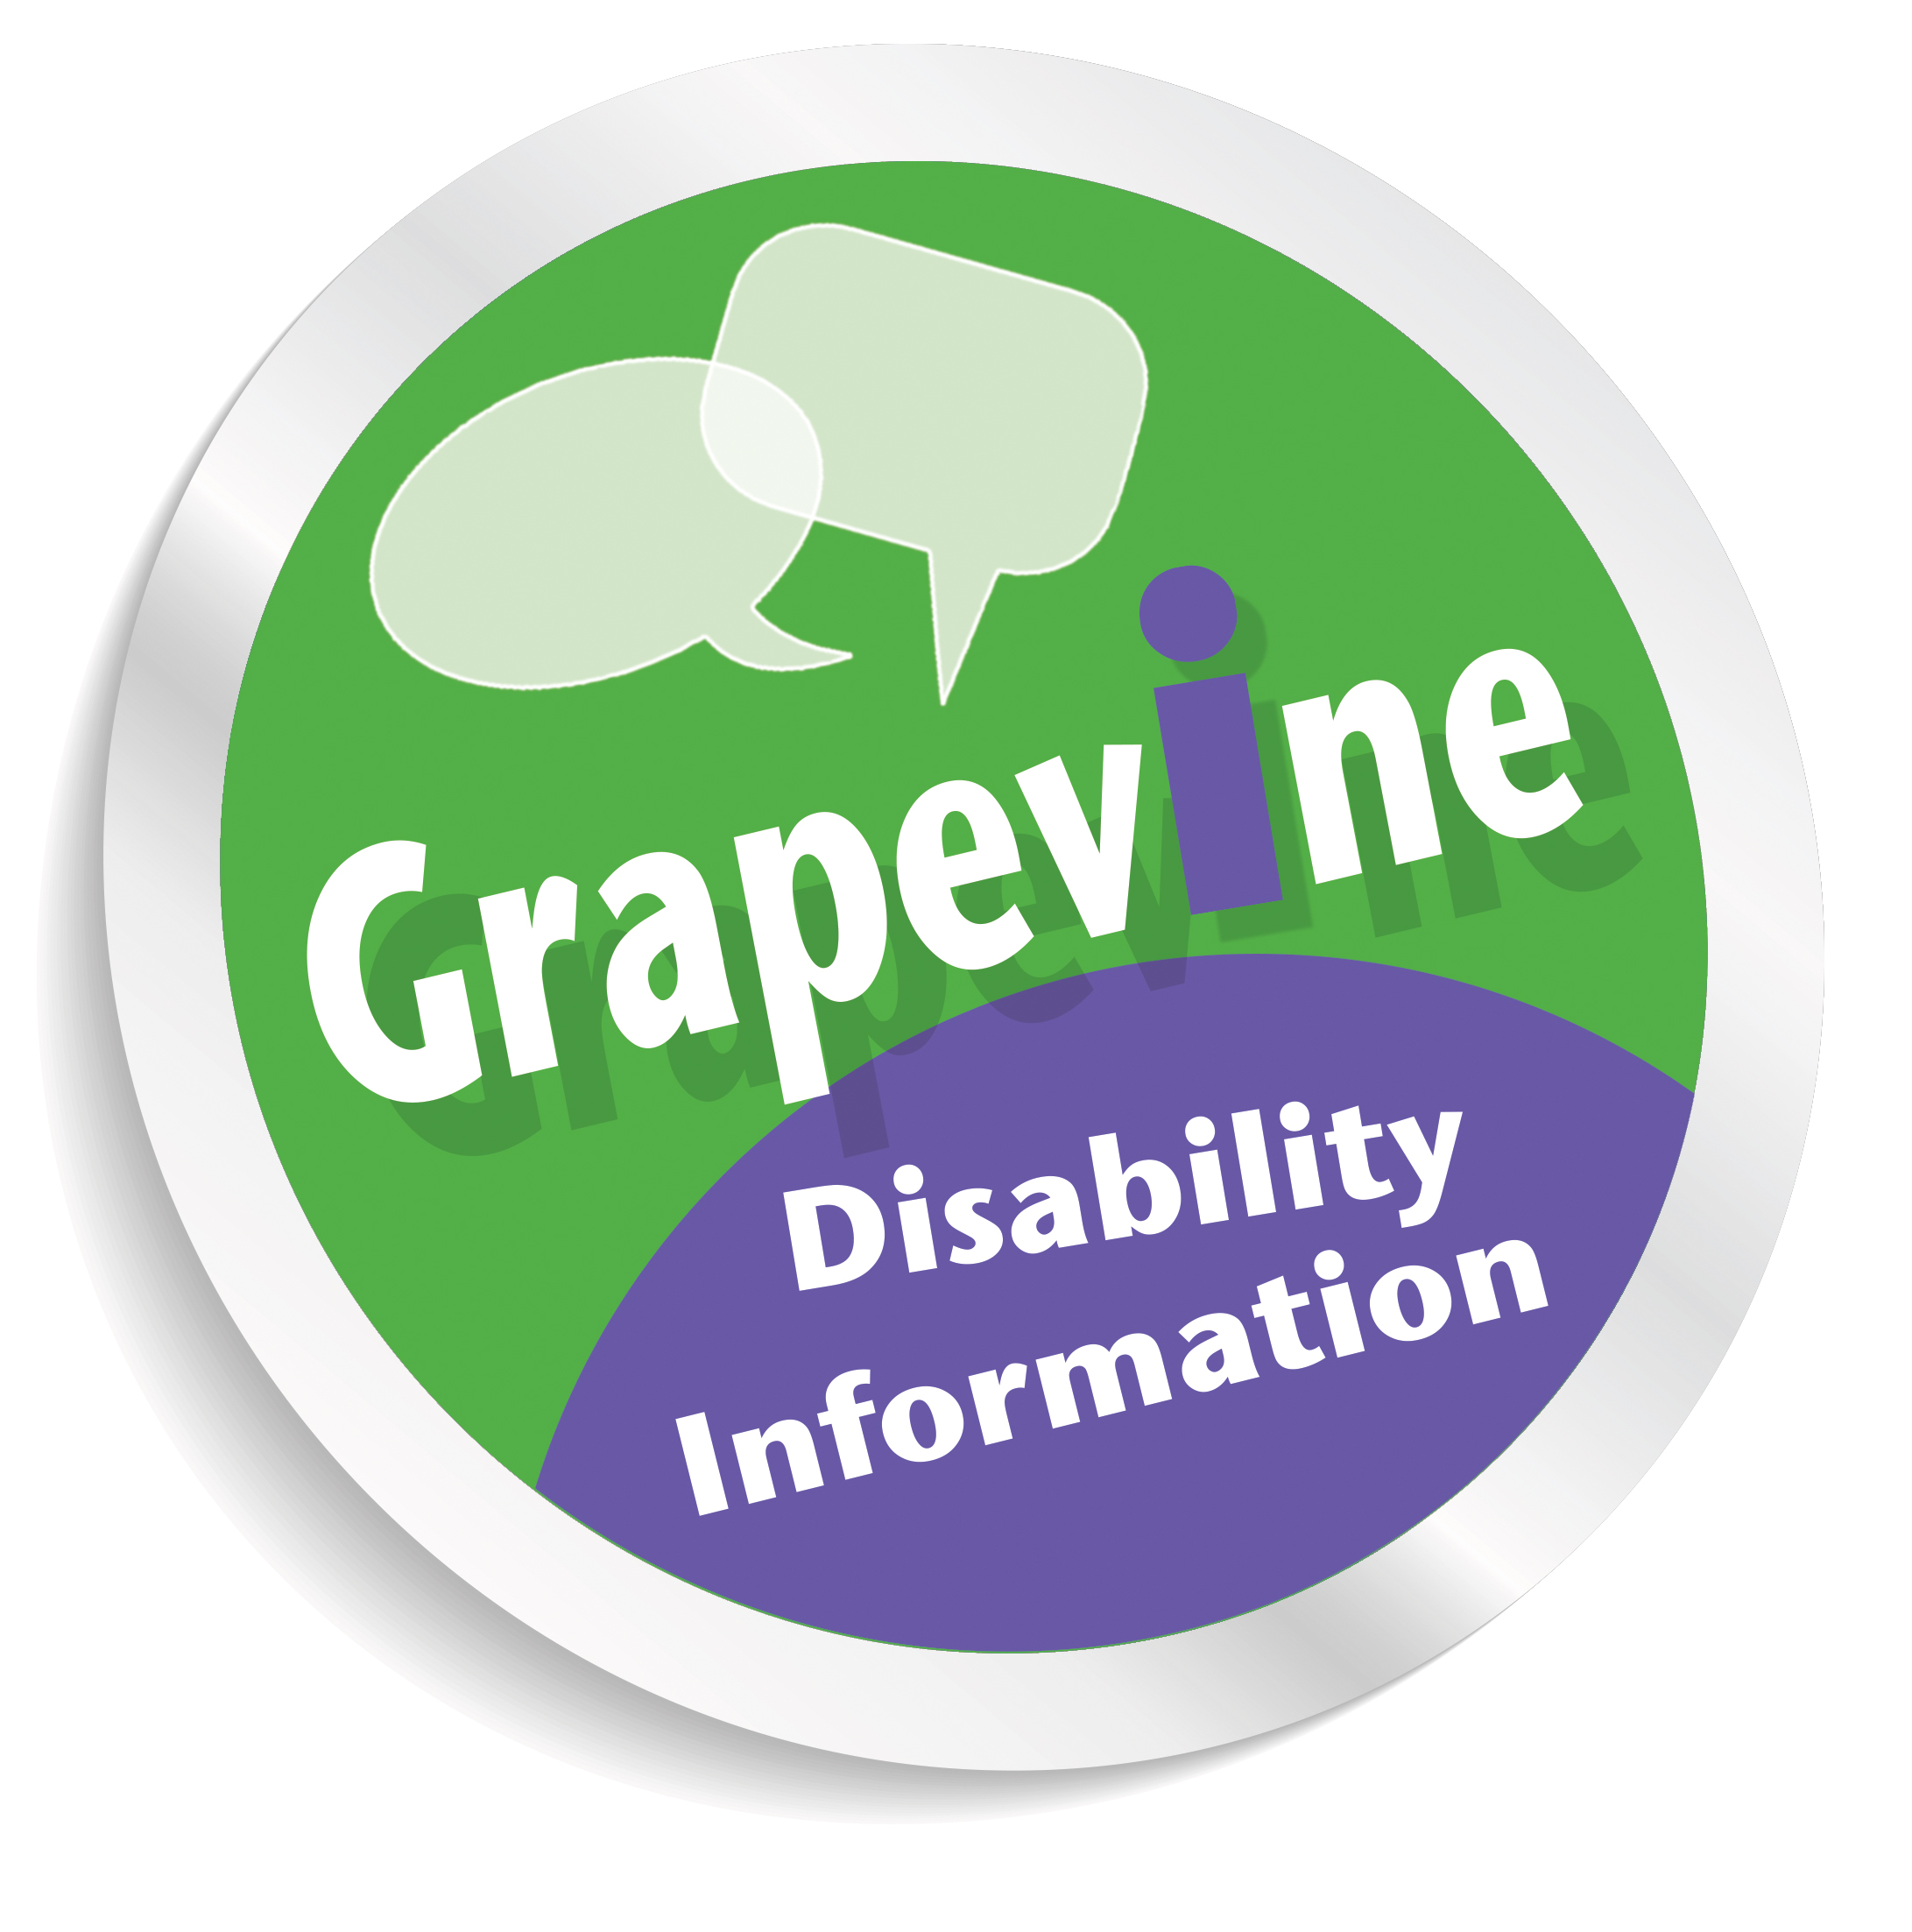
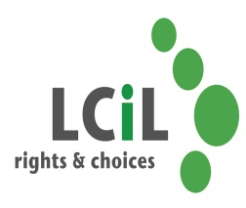

Personal Independence Payment
A consultation event
Are you disabled or have a long term condition and have experience of making a claim for the benefit Personal Independence Payment (PIP)?
PIP started to replace Disability Living Allowance (DLA) in April 2013. For many people affected it has been a stressful and worrying time.
The first Independent Review of PIP has now been launched by the Department of Work and Pensions (DWP). The first stage of the review is to gather evidence from people who have been affected by PIP.
Grapevine, part of the Lothian Centre for Inclusive Living (LCiL) in partnership with the National Disabled Peoples network Inclusion Scotland want to give people who have been affected by PIP the opportunity to feed their views and experiences into this process at a consultation event (date/time and location below).
The evidence gathered during this consultation will be presented to Parliament and will affect the national roll out of PIP which is due to take place next year for everyone living in the UK who currently receiving Disability Living Allowance.
The event will be held in an informal and confidential setting.
Tuesday 19th of August 2014
10.30am – 3.00pm
(lunch included)
Conference Hall, Norton Park Centre, 57 Albion Road, Edinburgh,
EH7 5QY
Spaces are limited so please get in touch with Kirstie at LCiL on
0131 475 2370 / email: Kirstie.henderson@lothiancil.org.uk or Ian Sneddon at Inclusion Scotland on 0131 281 0867 / email: ian@inclusionscotland.org to book your place.

Please specify if you have any access or dietary requirements.
Travel expenses can be covered if arranged in advance.
Location fully accessible for wheelchair users.

