A
WOULD YOU LIKE TO HELP GIVE
people more choice and control in social care services?

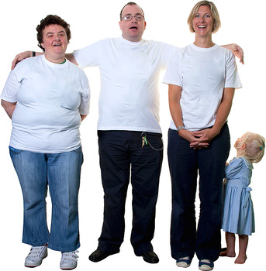

The Self Directed Support Programme Board will meet every month, which members will be expected to attend:
In addition there will be time required to read papers for meetings.

For more information on self directed support visit www.selfdirectedsupportscotland.org.uk

Closing Date for applications
17 December 2013

The new Self Directed Support Programme Board is looking for two members to join them – a member of the Public and Unpaid Carer.
This is an exciting opportunity to help shape how self directed support is delivered in Midlothian.

The new Self Directed Support Programme Board will oversee the implementation of the new Social Care (Self-directed Support) (Scotland) Act 2013, which is anticipated to come into force in April 2014. The Act requires councils to offer people a range of options for how their social care is delivered, beyond just direct payments, empowering people to decide how much ongoing control and responsibility they want over their own support arrangements.

The Programme Board will develop new arrangements to help empower people using social care services (adults, children and unpaid carers) to have as much choice and control as they want over the support they receive.

Applicants should possess:
- Effective verbal communication skills
- The ability to challenge and raise issues of concern
- Listening skills
- Ability to read and understand complex documents
- Ability to be sensitive to other people’s opinions
- Reliable and committed to attending Programme Board meetings and carrying out agreed tasks
- Ability to bring their own knowledge and expertise to inform how self directed support is delivered in Midlothian.

It would be desirable if applicants had a broad understanding of self directed support or direct payments and the principles around which they are based. This is a voluntary role, but reasonable expenses will be reimbursed.
For an application pack and/or more information on the Self Directed Support Programme Board please contact Rebecca Squirrell, Midlothian Council Fairfield House, 8 Lothian Road, Dalkeith, EH22 3ZH telephone 0131 271 3800 or email Rebecca.Squirrell @midlothian.gov.uk

