More Dates coming up for LCiL’s

Access to Work Project’s series of

Information

Workshops for

Disabled People and Parents/Carers

Have now been confirmed!

Venue: Norton Park in the Training Suite

contact

Amanda

On 0131 475 2350/2510

To Book a Place!

Access to Work

Officers will be

contributing to the

programme at each event!
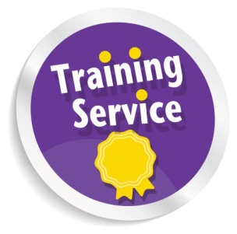
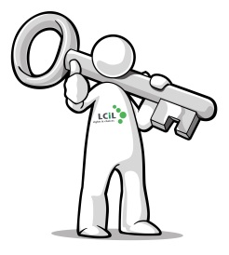

Access to Work Information
Workshops are coming your way!

Email: Amanda.beech@lothiancil.org.uk
Phone: 0131 475 2350/2510
57 Albion Road Edinburgh
EH7 5QY
Rights & Choices for
Disabled people, people with long term conditions and older people in
Edinburgh and Lothian
Light refreshments such as: teas; coffees; juices and cakes will be available, a great chance to find out more, in a comfortable small group setting.
All you need to do is to sign up now, and I will do the rest!
As part of our Access to Work project, LCiL are holding further workshops in December for parents/carers of Disabled People who want to find out more about AtW and what it actually means for disabled people in real terms.
The dates are:
4th December Time 10-12.30pm (these two workshops would be for parents/carers of 14-25yrs) then again at 6-8.30pm for those who cannot make in the day because of work commitments
10th December
Time: 6-8.30pm (this one would be for parents/carers of adults 26 years and above)
Venue would be the training suite at Norton Park
Then 14th January 2014
Workshop for young people with additional support needs (16 - 25)
Time: 6-8.30pm
At these workshops:
You can find out what is Access to Work, and get up to date with all the changes that are happening within the service.
It will be useful for those who may be thinking of going into new employment or are already in employment and require additional support to remain in their work!
Travel costs can be met on request!
Employers/Support Organisations can find out how they can assist their employees to remain in their work when they find out they have been diagnosed with a long term condition
All ages and all impairments are covered by A2W, so why not come and spend a couple of hours at a workshop or information session and see how we can help give you the information you need and help you to understand how A2W could help you!
Dates: 4th September Time: 1-3pm
10th October Time: 1-3pm

