[](https://www.google.co.uk/url?sa=i&rct=j&q=&esrc=s&source=images&cd=&cad=rja&uact=8&ved=2ahUKEwjEjYiE98LhAhXQTxUIHXoVDT4QjRx6BAgBEAU&url=https://twitter.com/hashtag/crossreach&psig=AOvVaw33PX2gl8jnLTgxagQCQbVH&ust=1554896466691169)[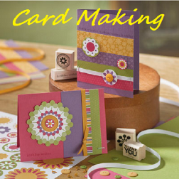](https://www.google.co.uk/url?sa=i&rct=j&q=&esrc=s&source=images&cd=&ved=2ahUKEwj5g_Lq0sLhAhWjzYUKHWy1CL8QjRx6BAgBEAU&url=https://www.amazon.co.uk/Bliss-Apps-Card-Making/dp/B00A23VY6Y&psig=AOvVaw0UQKhWeP1xoWOP2XlT9QmG&ust=1554886794737511)[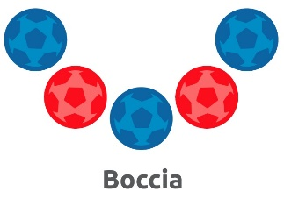](https://www.google.co.uk/url?sa=i&rct=j&q=&esrc=s&source=images&cd=&cad=rja&uact=8&ved=2ahUKEwjE66Xd08LhAhWjx4UKHdmgDm8QjRx6BAgBEAU&url=https://ablemagazine.co.uk/special-olympics-boccia-the-knowledge/&psig=AOvVaw1aCBmhXuGaariNFKfg32gE&ust=1554886913939640)[](https://www.google.co.uk/url?sa=i&rct=j&q=&esrc=s&source=images&cd=&cad=rja&uact=8&ved=2ahUKEwjXs4W41sLhAhUIzIUKHf7WC20QjRx6BAgBEAU&url=https://www.youtube.com/watch?v%3DNUHSpeUj-NQ&psig=AOvVaw2HFdP0D-svtD8Z817Ja2Iy&ust=1554887712099407)[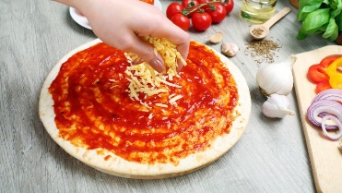](https://www.google.co.uk/url?sa=i&rct=j&q=&esrc=s&source=images&cd=&cad=rja&uact=8&ved=2ahUKEwiH_cfR1sLhAhXIx4UKHa2_CkAQjRx6BAgBEAU&url=https://www.mashed.com/36697/mistakes-everyone-makes-making-pizza/&psig=AOvVaw1KBURASHwymt_7NXUfkoRL&ust=1554887805585152)[](http://www.google.co.uk/url?sa=i&rct=j&q=&esrc=s&source=images&cd=&cad=rja&uact=8&ved=2ahUKEwjX3-ra0sLhAhWJxIUKHePdCtoQjRx6BAgBEAU&url=http://www.memorymattersglynn.com/event/gentle-seated-yoga-2pm-brunswick/&psig=AOvVaw11o3eO82a36ff7_xf8qk_N&ust=1554886755270705)[](http://www.google.co.uk/url?sa=i&rct=j&q=&esrc=s&source=images&cd=&cad=rja&uact=8&ved=2ahUKEwj0372U08LhAhWhyIUKHQpKBUQQjRx6BAgBEAU&url=http://standrewscofe.org.uk/uncategorized/cofton-hackett-and-barnt-green-bake-off/&psig=AOvVaw2WQuGK9uxnOZQMooO3mLTZ&ust=1554886867018515)[](https://www.google.co.uk/url?sa=i&rct=j&q=&esrc=s&source=images&cd=&cad=rja&uact=8&ved=2ahUKEwiun6zr0cLhAhUECRoKHSffBnEQjRx6BAgBEAU&url=https://www.hyglossproducts.com/rainbow-people-border-poster.html&psig=AOvVaw1uZQedx7t4JOO_PKM4w_xH&ust=1554886524922672)[](https://www.google.co.uk/url?sa=i&rct=j&q=&esrc=s&source=images&cd=&cad=rja&uact=8&ved=2ahUKEwjgtZ7w-sLhAhX0SxUIHQjZCDQQjRx6BAgBEAU&url=https://twitter.com/thebandpm&psig=AOvVaw0v2U2kcDNqdfPiEr06qYf4&ust=1554897535450696)[](http://www.google.co.uk/url?sa=i&rct=j&q=&esrc=s&source=images&cd=&cad=rja&uact=8&ved=2ahUKEwiiq-3L-sLhAhVNQRUIHWBADwcQjRx6BAgBEAU&url=http://www.gerbschmidt.com/2017/12/12/vikings-fall-10-3-still-lead-nfc-north/&psig=AOvVaw03JUq4NRW-Ip8bXYVnqXl9&ust=1554897461433136)[](http://www.google.co.uk/url?sa=i&rct=j&q=&esrc=s&source=images&cd=&cad=rja&uact=8&ved=2ahUKEwiYhuf4-MLhAhXqQxUIHXAmBdAQjRx6BAgBEAU&url=http://hprepair.com.au/product-category/events-calendar/&psig=AOvVaw3smpB1u6l13-3vY2hbTToS&ust=1554897015383905)[](https://www.google.co.uk/url?sa=i&rct=j&q=&esrc=s&source=images&cd=&cad=rja&uact=8&ved=2ahUKEwiN8-_W-MLhAhUdQhUIHX7OCbsQjRx6BAgBEAU&url=https://pixabay.com/illustrations/monday-day-week-calendar-date-706919/&psig=AOvVaw2X6G4wTpgvwdS1W2TozxMU&ust=1554896932736869)[](https://www.google.co.uk/url?sa=i&rct=j&q=&esrc=s&source=images&cd=&cad=rja&uact=8&ved=2ahUKEwjVysCB-MLhAhXESBUIHTWeDAoQjRx6BAgBEAU&url=https://9energies.com/create-your-own-custom-community-gathering/&psig=AOvVaw3TmZqu7-VUesrW-gcNEUqD&ust=1554896772242720)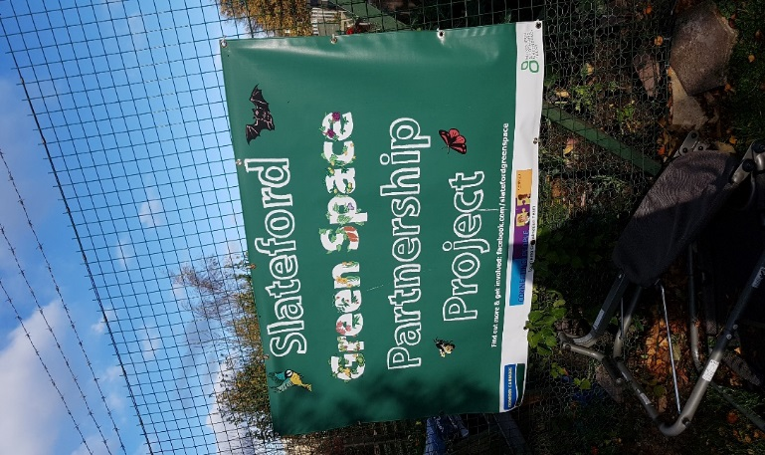[](https://www.google.co.uk/url?sa=i&rct=j&q=&esrc=s&source=images&cd=&cad=rja&uact=8&ved=2ahUKEwiM1OTO98LhAhUgVBUIHT1QDaUQjRx6BAgBEAU&url=https://www.westdalejuniors.co.uk/news/2017-11-23-bingo-night-23rd-november-2017-5-30-7pm&psig=AOvVaw0PmPk4rdBIDA3yYKYTr9t8&ust=1554896641117869)

**Held in Slateford community Centre**

**Activities on offer throughout the day**