Save money on your energy bills this winter.
Come to one of our free energy efficiency advice sessions, in partnership with Utilita and Hibernian Football Club
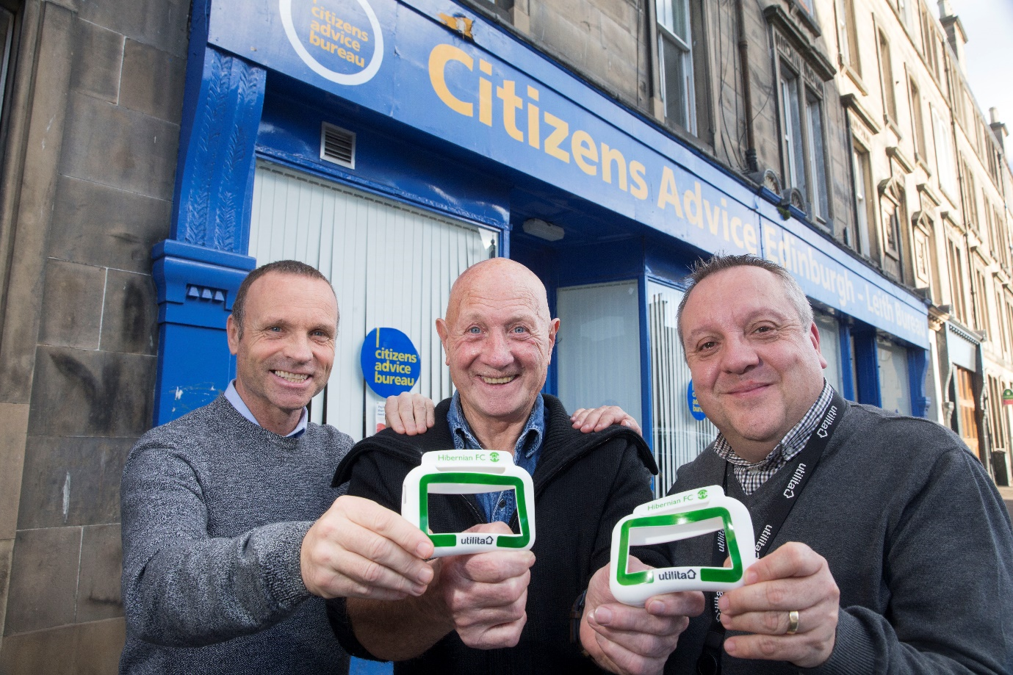
Sessions are free to attend, just drop by Bureau at 23 Dalmeny Street between 09:30 – 12:30 on Thursday 29 November or Thursday 13 December

