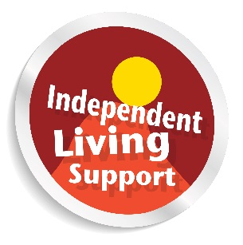

Social Care Assessment:
Being Prepared

August 2016

Lothian Centre for Inclusive Living (LCiL) is a Company Limited by Guarantee. Registered in Scotland 129392. Accepted by HMRC as a Charity SC/017954
Postal address for main office: LCiL, Norton Park, 57 Albion Road, Edinburgh, EH7 5QY

Copyright © 2018 LCiL. All Rights reserved.

Social Care Assessment: Being Prepared

Lothian Centre for Inclusive Living (LCiL) is a user-led disabled people’s organisation funded by local authorities in Edinburgh and the Lothians. LCIL also gets support from the Scottish Government and various trusts and foundations. We support disabled people and their families by offering advice and practical support towards independent living. This booklet was produced by LCiL to help guide you through the assessment stage of Self Directed Support (SDS).
This document is a guide to getting prepared for a social care assessment in Scotland. The assessment is only one part of the journey from realisation of needing support to actually getting a SDS package of care. To access information on other stages of the pathway, see appendix C on SDS stages/support pathway.

Who is this guide for?

This guide is for anyone who has identified that they need some care and support and are either starting the process of accessing support, are getting a review of their support by the social work department or feel that the support they currently receive isn’t adequate. The impairment could be physical, mental, sensory or a learning difficulty. This guide may be useful to you if you have the impairment yourself or because you live with or care for someone with an impairment.

Why do I need to prepare?

Some people don’t find it easy to talk about what support they need, especially if the support is of an intimate nature. It can be hard to admit that you need help or that the person you love needs help. By preparing for an assessment you are better able to discuss all aspects of your daily support needs.
The assessment should be carried out by a practitioner such as a social worker or an occupational therapist or even a health practitioner. The practitioner who carries out the assessment with you should have a conversation with you to figure out if you have support needs that the local authority is willing to fund. The practitioner should collaborate with the assessed person to co-produce the assessment. It is part of the role of the practitioner to support you to make informed choices. However, if you prepare, it may result in a better outcome of the assessment as you will have given the practitioner all the information they require. Getting prepared will also help you to evidence your support needs.

Before you start preparing

Not everyone is eligible for care/support. It is worth mentioning that local authorities have the power to decide their eligibility criteria. There are four identified levels of support for social care services: critical, substantial, moderate and low. In Scotland, some local authorities will only fund critical need, whereas others might also fund substantial need. It is vital that you find out before the assessment what your local authority is willing to fund. According to the Self Directed Support (SDS) statutory guidance produced by the Scottish government, definitions for adult services are:

* Critical Risk: Indicates that there are major risks to an individual's independent living or health and wellbeing likely to require immediate or imminent provision of social care services (high priority).
* Substantial Risk: Indicates that there are significant risks to an individual's independence or health and wellbeing likely to require immediate or imminent provision of social care services (high priority).

If the result of the assessment is that the person does not fit funding criteria, the practitioner should signpost and/or provide information on other support that may be available.

Starting to prepare: Outcomes

It is necessary to evidence to the practitioner what it is you can’t do and what support you need. However, if you just focus on this, it is easy to miss the big picture. It is worthwhile taking some time to try and figure out what your goals in life are and what it is you would like to achieve. Another name for these goals are Outcomes. By identifying your outcomes, it is easier for you to demonstrate your needs, or the support you require, to reach these outcomes.
Another way to think about outcomes is that an outcome is the consequence of an action or series of actions. For example, you get support to get out of bed, dressed, supported to travel to the gym safely, supported to change at the gym, helped to do exercise then showered and supported to get safely back home. The consequences of this series of actions are that you feel healthier. You might also feel happier and socialise with friends. Feeling happier and healthier are all outcomes. A support plan outlines the steps needed to help to achieve identified outcomes. Once the assessment is complete, you should have a list of outcomes that will be used in planning your support.
However, support planning is for a different stage of the process. Identifying outcomes will help later but will also help you now to figure out all the support you need to do the things you want to do.

Preparing for the assessment

One way you can prepare for an assessment is to keep a diary of the support you needed each day. Also list the things you would have done if support had been available. There is a form in appendix D to help you keep track of things.
It is also useful to identify what risks there are to the supported person if the support is not put in place. This can help justify obtaining support from the local authority.
For example, if John doesn’t get help to take his heart medication twice per day then the risk would be that John could suffer a heart attack and end up in hospital.
Many people have better days than others. It is important not to under estimate the support you need on your bad days. If you only talk about the support you need on your good days, this will inevitably lead to you having inadequate support when you are having a bad day.
If you have had a previous assessment and/or you have a package of care in place, it would be a good idea to get a copy of the previous assessment and/or SDS support plan. You might have a care plan instead of a SDS support plan, if the support was put in place before SDS was introduced. You might find that having these older documents is a good starting point to look again at your support needs. If you don’t have copies of these documents, then you may be able to get a copy of them from the practitioner who is doing the SDS assessment.
The practitioner should support you to be involved as much as you choose in a way that maximises your participation and protects your dignity. The practitioner should structure any meetings to suit you, for example if you get tired easily, then perhaps you might want any meetings to last no more than 30 minutes. The practitioner should take account of any communication support needs you might have, for example have a British Sign Language interpreter at the meetings. The practitioner should also help if you require independent advocacy support.

Unpaid Carers

Some people have family members or friends who deliver regular, substantial care for them and do not get financial remuneration for doing so. These people are called carers. When preparing for the assessment both parties need to think about whether or not this arrangement should continue. If you are not explicit during the assessment about what a carer is willing to do, you might find that the support offered is much less than it could otherwise be. If your carer provides you with support but they no longer wish to continue to do so, then this should be detailed and it should be made clear that the you or the carer does not want this to continue and the reasons why. One of the main reasons for the carer not providing the support anymore is so that they can concentrate on having a more ordinary relationship with the supported person.

Things you might need support for

What follows is a list of tasks you might need support for. You should identify what tasks you need support with, how you would like this support to be carried out and how long it would take to carry out each task. It is also worth noting what the risks are if the support does not happen. It is not an exhaustive list. Also, please bear in mind that although you might need support to do these tasks, a local authority might not fund support to carry out the task. Finally, it is worthwhile to try and figure out your goals in life (see earlier). If you just concentrate on what you can’t do, or what you need support to do, you might miss other things that are equally as important.
Waking up.
Getting in and out of bed.
Brushing hair and teeth.
Showering/bathing.
Dressing or undressing.
Wearing environmentally appropriate clothing.
Shaving.
Applying make-up.
Toileting.
Eating.
Drinking.
Avoiding choking.
Taking medicines.
Applying creams.
Pain management.
Fatigue management.
Exercising.
Sleeping.
Adjusting your position.
Moving safely, both inside and outside your home.
Deciding what to have to eat or drink.
Preparing food and drink.
Doing the dishes.
Cleaning and tidying your home.
Managing your money.
Shopping.
Maintaining a tenancy.
Socialising.
Planning your day.
Going places.
Maintaining family relationships.
Managing specific medical conditions, e.g. epilepsy, diabetes.
Being a parent.

Please note that the support you might need could include prompting you to carry out the task, ensuring your safety whilst carrying out the task or ensuring the task is completed to a satisfactory standard.

What happens next?

Once the practitioner has completed the assessment you should be provided with a copy to allow you to comment and/or agree with what has been said. The assessment will be processed by the local authority, which may take a few weeks. If the local authority decides you have needs that they are willing to fund, then you will start the support planning process. If the local authority does not feel you have needs they can fund, the practitioner should make suggestions regarding where you could go to get support.

What happens if you do not agree with the results of the assessment?

You should talk to the practitioner who carried out the assessment if you do not agree with the result. There is no appeal process, however, you can use the local authority complaints procedure if you are not satisfied. Once you exhaust the complaints procedure you could use the Scottish local authority ombudsman.
You also have three to four local councillors who have been elected to represent you. You could approach them for support with any issue you may have with your local authority.

Appendix A: types of assessment

Currently there are three basic types of assessment: an adult assessment, a child assessment and a carers assessment. The carers assessment is actually split between carers of adults and carers of children. Quite often it is clear which type of assessment needs to be carried out but sometimes it can be more complicated. The advice provided in this booklet is relevant for any type of assessment. Why you might want to ask for different types of assessments, from different departments of a local authority, is that different charging criteria operates (see appendix B.)

A children’s assessment is for disabled children or a child affected by disability, i.e. their parent is disabled. The parent who is a disabled person would be entitled to an adult assessment. The partner or spouse of the disabled person would also be entitled to a carer’s assessment.

Appendix B: council’s charging for care

The law allows local authorities to ask for a financial contribution towards the support package. This charge is not dependent on how the care is delivered but only on the financial circumstances of the supported person.
In Scotland, anyone aged over 65 is entitled to free personal and nursing care. What this means for anyone aged 65 or over is that they will not be asked to make a financial contribution towards personal care but may be financially assessed and asked to make a contribution if part of their support Package involves non-personal care.
Local authorities do not normally financially assess children and families for support.
Carers should not be financially assessed on any support they receive however, if the support also affects a disabled adult, then it is likely that the disabled person will be financially assessed.

Appendix C: SDS stages/SDS support pathway

The following diagram has been reproduced from the Scottish Government’s SDS Guidance:

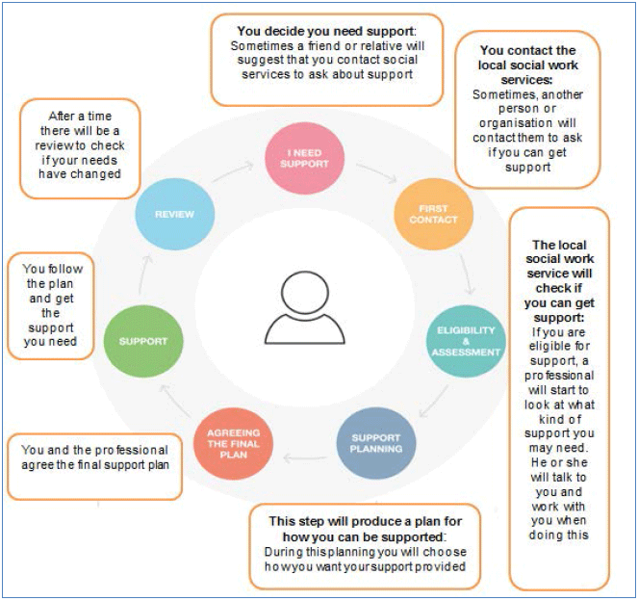

Organisations in Edinburgh and the Lothians who might be able to offer support:

Lothian Centre for Inclusive Living (LCIL)
Web: www.lothiancil.org.uk
Tel: 0131 475 2350
Email: lcil@lothiancil.org.uk

Carers of East Lothian
Web: www.coel.org.uk
Tel: 0131 665 0135
Email: centre@coel.org.uk

Vocal carers centre (Edinburgh)
Web: www.vocal.org.uk
Email: centre@vocal.org.uk
Tel: 0131 622 6666

Vocal carers centre (Midlothian)
Web: www.vocal.org.uk
Email: midlothian@vocal.org.uk
Tel: 0131 663 6869

Carers of West Lothian
Web: www.carers-westlothian.com
Tel: 01506 448 000
Email: office@carers-westlothian.com
For additional information on SDS including a list of support organisations in Scotland please visit the Scottish Government’s one stop shop for SDS at;
www.selfdirectedsupportscotland.org.uk

Contact information for Social Work:
City of Edinburgh Council
0131 200 2324

East Lothian
0845 603 1576

Midlothian
Adults 0131 271 3900
Children 0131 271 3860

West Lothian
Bathgate 01506 776 700
Broxburn 01506 775 666
Livingston 01506 282 252

Appendix D: Form to keep track of support need

Support needed | Time support needed | How long support needed | Support carried out by whom? | What would happen if support not carried out?

