Meet the Employer

Are you an employer of Personal Assistants (PAs) living in Edinburgh and the Lothians? Would you like to meet people interested in becoming your next great PA?

These sessions will be an opportunity for you to meet people interested in becoming a PA in an informal setting which will allow you to promote your own PA opportunities while also assisting in raising the profile of PA work as a career opportunity.

Supported by the Independent Living Team, we will be inviting people interested in working as a PA to come along and find out more but to make it a success we need you, the employer, too.

Where and When, 2018 dates
1pm – 3pm (with tea/coffee provided),
Wednesday 17th October
Wednesday 7th November
Norton Park, Albion Road, Edinburgh, EH7 5QY

Whether you have a current vacancy to fill or you’d just like to help in raising the profile of PA work as a career opportunity, we’d like to hear from you. You can book to attend either or both of the sessions and will be supported by a member of the independent living Team and other PA employers.

For disabled people who require it, we can organise and pay for transport if you live in Edinburgh or the Lothians. The group is open to all PA employers, both disabled people and those managing PAs on behalf of someone else.
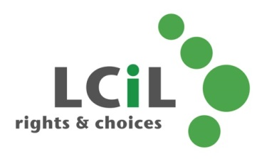
To find out more and to register interest, contact: Lisa Milburn at LCiL on 0131 475 2554 or email lisa.milburn@lothiancil.org.uk

