Know your rights workshop

Are you a disabled person, or someone with a long-term condition?
Do you live in Edinburgh or the Lothians?

Do you want to:
- Improve your knowledge of your rights
- Increase your ability to self-advocate?
- Learn how to make a complaint if your rights aren’t met?
…and would you like to:
- meet new people?
- increase your confidence?

in a relaxed and friendly atmosphere…
…then come along to our workshop!

Where and When?

10.30am – 2.00pm, Tuesday 30th October 2018
Training Suite, Norton Park Conference Centre, Albion Road, Edinburgh EH7 5QY
At this workshop we’ll cover:
- the social model of disability
- where, when and how to get support
- where to go for support/advocacy with accessing benefits and services

Lunch and refreshments will be provided,
and if needed we can organise and pay for transport if you live in Edinburgh or the Lothians.

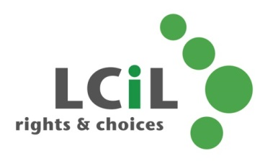

To find out more and to book, contact:
Lisa Milburn at LCiL on 0131 475 2554
or email lisa.milburn@lothiancil.org.uk

