‘Have you tried God, or snake venom?’
…are you tired of getting asked questions like this?

Are you a disabled person, or someone with a long-term condition?
Do you live in Edinburgh or the Lothians?

Do you want to:
- have increased skills in having ‘difficult’ conversations?
- gain a better understanding of your own and others’ motivations?
- learn how to turn the conversation around to educate/change attitudes?
What about..?
You should….

…and would you like to:
- meet new people?
- increase your confidence?

in a relaxed and friendly atmosphere…
…then come along to our workshop!
Where and When?

Have you tried God, or snake venom?
10.30am – 1.30pm, Tuesday 4th December 2018
Training Suite, Norton Park Conference Centre, 57 Albion Road, Edinburgh, EH7 5QY
At this workshop we’ll cover:
- the social model of disability
- dealing with own responses to people trying to be ‘helpful’

Lunch and refreshments will be provided,
and if needed we can organise and pay for transport, if you live in Edinburgh or the Lothians.

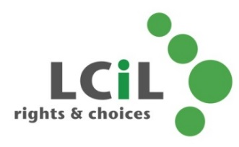
To find out more and to book, contact:
Lisa Milburn at LCiL on 0131 475 2510
or email lisa.milburn@lothiancil.ac.uk

