Assertive communication workshops

Are you a disabled person, or someone with a long-term condition?
Do you live in Edinburgh or the Lothians?
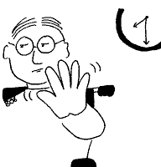
Do you want to learn how to:
- be more assertive?
- give yourself the best chance of getting what you need
by preparing well for meetings or assessments?
- challenge decisions?
…and would you like to:
I’d like …
- meet new people?
- increase your confidence?

in a relaxed and friendly atmosphere…
…then come along to our workshops!
There will be two sessions:

Assertiveness 1
10.30am – 2.30pm, Tuesday 13th November 2018
Training Suite, Norton Park Conference Centre, Albion Road, Edinburgh EH7 5QY

At this workshop we’ll cover different ways of communicating and their effects, and you’ll have a chance to think about and plan how to make a case for something you need.

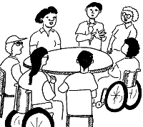
Assertiveness 2
10.30 – 2.30pm, Wednesday 28th November 2018
Training Suite, Norton Park Conference Centre, Albion Road, Edinburgh EH7 5QY

This workshop will give you the chance to discuss how you used what you learned in Assertiveness 1 and to take your skills further.

Please note: you must do Assertiveness 1 before you do this workshop.

It’s great if you can come to both, but you’re welcome just to do Assertiveness 1 on its own.
Lunch and refreshments will be provided,
and if needed we can organise and pay for transport if you live in Edinburgh or the Lothians .

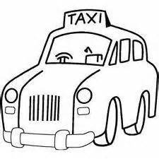

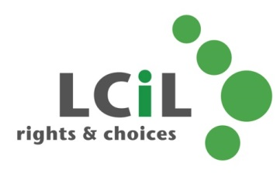
To find out more and to book, contact:
Lisa Milburn at LCiL on 0131 475 2554
or email lisa.milburn@lothiancil.org.uk

