PA employer peer support group

Are you an employer of Personal Assistants (PAs) living in Edinburgh and the Lothians?

Do you want to:
- Meet other PA employers?
- Share learning & experiences?
- Get the best out of your PA support arrangements?
- Build your knowledge, skills and confidence making it easier for yourself as an employer?

Then come along to the second meeting of our new PA employer peer support group!

The group is open to all PA employers, both disabled people and those managing PAs on behalf of someone else.

Where and When

12 noon – 3pm (with lunch provided)
Wed 3rd October 2018
Wed 7th November 2018
Wed 5th December 2018

Simpson Room, Norton Park, 57 Albion Road, Edinburgh, EH7 5QY
Lunch and refreshments are provided by us, and if needed we can organise and pay for transport if you live in Edinburgh or the Lothians.
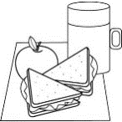

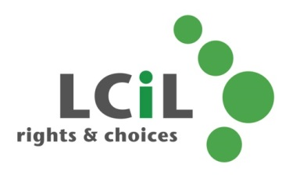
To find out more and to book, contact:
Lisa Milburn at LCiL on 0131 475 2510
or email lisa.milburn@lothiancil.org.uk

