PA employer drop-in sessions

Are you an employer of Personal Assistants (PAs) living in Edinburgh and the Lothians? Do you want to meet other PA employers or chat to an Independent Living Officer?

This drop-in group is a welcoming space to share ideas, learning and experiences; get the best out of your PA support and build your knowledge, skills and confidence.

Come along to our new PA employer drop in session!

Each session lasts two hours and while you’re welcome to stay for the duration you can also just pop in for as long as is convenient for you.

Where and When, 2018 dates
1pm – 3pm (with tea/coffee provided),
Wednesday 3rd October
Wednesday 31st October
Wednesday 5th December
Norton Park, Albion Road, Edinburgh, EH7 5QY

For disabled people who require it, we can organise and pay for transport if you live in Edinburgh or the Lothians. The group is open to all PA employers, both disabled people and those managing PAs on behalf of someone else.
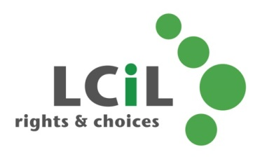
To find out more and to register interest, contact: Lisa Milburn at LCiL on 0131 475 2554 or email lisa.milburn@lothiancil.org.uk

