Getting it Right for your Child

Are you a parent or carer of a disabled child or young person, or a child with additional support needs?

Do you want to:
- Meet other parents and carers?
- Explore opportunities around support?
- Improve your knowledge of your rights?
- Increase your confidence to ask for the support you need?
- Find out about practical information, resources and who to ask for more help?
In a relaxed and friendly atmosphere…
…then come along to our workshops!

Where and When

Session 1
10.30am – 2.15pm, Tuesday 23rd October 2018. Norton Park Conference Centre, Albion Road, Edinburgh EH7 5QY.
We’ll look at yours’ and your child’s rights, and where to go for information, support or advocacy

Session 2
10.30am – 2.15pm, Wednesday 31st October 2018. Norton Park Conference Centre, Albion Road, Edinburgh EH7 5QY.
We’ll look at what support you need for your child, and how to prepare for an assessment or important meeting

*You can come to both or either session*

The workshops are free and lunch and refreshments are provided

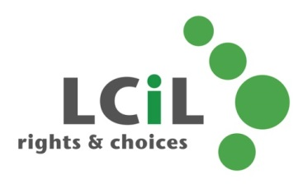
To find out more and to book, contact:
Lisa Milburn at LCiL on 0131 475 2510
or email Lisa.Milburn@lothiancil.org.uk

