BE A MODEL FOR VISITSCOTLAND
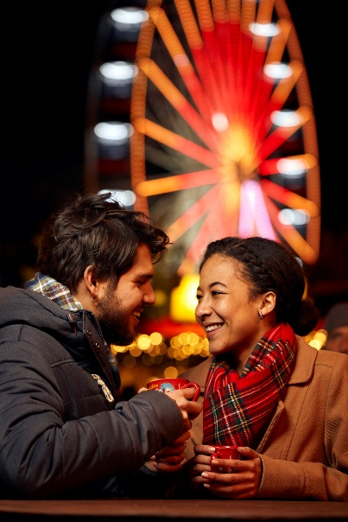

- Where: St Andrew’s
- When: 17th April
- What: Outdoor city walks and sightseeing
(e.g. castle, cathedral, beach walks)
- Application deadline: 31st March

This shoot fits within a series of shoots that aim at promoting diversity. We aim to celebrate people from the disabled, LGBT+, elderly BME and Minority faith communities in shoots spanning throughout the year and across Scotland.
In this shoot, we will be focusing on couples from all the above categories.

- Volunteer Models criteria:
- For you to be able to attend with your partner for most of the day
- To be visibly part of an under-represented group (e.g. for disabled people, we need the disability to be visible, or made visible by an aid such as a walking stick – this is purely due to the fact that the aim of the project is to increase visual representations of diversity in promotional materials)
- To be comfortable in front of a camera (we want you to have fun during the shoot, and it will show on the pictures too!)

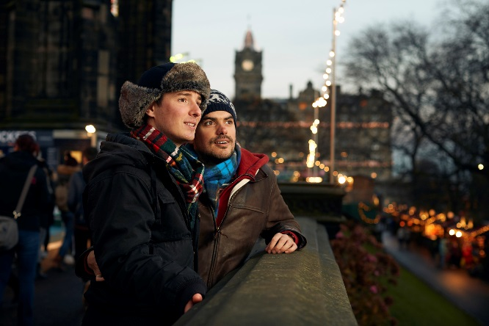
- HOW TO APPLY:
Send the following to Gabrielle,
at gabrielle.blackburn@visitscotland.com
- Name
- Pictures of yourself and your partner
(both portrait and full body if possible)
- Contact details for both participants
- Access requirements

- What’s covered:
Food and travel will be covered, as well as any activities planned as part of the shoot (depending on the shoot, you might get a nice dinner or access to an exciting attraction out of it!).
You will also have full access to any photos you model for (which means beautiful professional pictures of you and your loved one enjoying a nice day out).

If you have any questions, don’t hesitate to get in touch.
If you are interested but cannot attend those specific dates, do get in touch and we will keep you in mind for future shoots.

Gabrielle Blackburn  Communications Executive – Inclusive Tourism | 0131 4722 260  Gabrielle.blackburn@visitscotland.com

