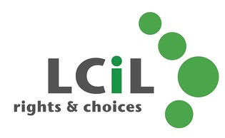

Are you thinking about becoming a PA, or

would you like to brush up on your PA skills?

Introducing the 2-day Training for Personal Assistants course, it could enhance your prospects of employment as a PA or, if you are already a PA, help you to be more effective in your role.

Topics covered include:
• Disability and Equality - cultural representations of disabled people and barriers faced by disabled people
• Social Model of Disability – and how to apply the principles in your PA role
• Understanding the importance of appropriate language
• Exploring roles and relationships
• Knowing the Relationship Boundaries
• Exploring potential dilemmas
• Responding to Your Employer’s Needs

Dates: 28th April & 2nd May 2017, Time:10.30am to 4.00pm
(Lunch provided)
Venue: Norton Park, 57 Albion Road, Edinburgh. EH7 5QY

The course is free to participants, as The Personal Assistant Network Scotland has jointly funded the course with LCiL.

For more info email: amanda.beech@lothiancil.org.uk or visit www.lothiancil.org.uk
Or call, Amanda Beech on 0131 475 2510

