Disabled People’s Human Rights: How are we doing in Scotland?

An Easy Read report about our rights under the United Nation’s Disabled People’s Convention (UNCRPD)

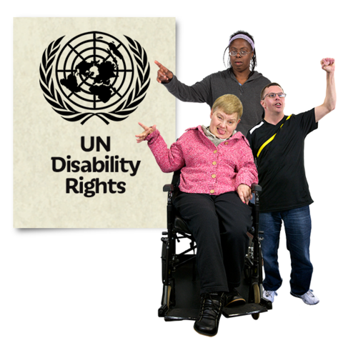

|  |  |
| --- | --- |
| http://cdn.shopify.com/s/files/1/0606/1553/products/Report-Easy-Read_compact.png?v=1418571579 | **About this report** |
| http://cdn.shopify.com/s/files/1/0606/1553/products/Law-UN-Disability-Rights_f259fc8c-7673-4d15-8389-841784e5deaf_large.png?v=1426518809  Image result for saltire crosshttp://cdn.shopify.com/s/files/1/0606/1553/products/Checklist_Tick_large.png?v=1417852448 | This report is about disabled people in Scotland getting or not getting their human rights.  Disabled people’s human rights are explained in the United Nations Convention on the Rights of Persons with Disabilities. The Convention gives a list of rules that governments have to follow to make sure that disabled people get their human rights.  The Convention was written by the United Nations or UN for short. The UN is an organisation that helps different countries to work together. The countries agree rules about how they should treat people living in their countries. |
| https://assets.publishing.service.gov.uk/static/opengraph-image-a1f7d89ffd0782738b1aeb0da37842d8bd0addbd724b8e58c3edbc7287cc11de.pnghttp://www.communityscot.org.uk/media/resources/images/logos/Scottish%20Government.JPG  http://cdn.shopify.com/s/files/1/0606/1553/products/Report_compact.png?v=1418572132 | Every four years the UN gets a report from government and one from disabled people.  The government report says how it thinks disabled people are getting their rights. The report from disabled people says whether they are getting or not getting their rights. |
| http://cdn.shopify.com/s/files/1/0606/1553/products/Rights-Disabled_compact.png?v=1427296461http://cdn.shopify.com/s/files/1/0606/1553/products/Report_compact.png?v=1418572132 | This report is from disabled people. It gives a list of what disabled people say government should do to make sure disabled people get their human rights. It mentions the Scottish Government and the UK Government. |
| http://cdn.shopify.com/s/files/1/0606/1553/products/Women2_compact.png?v=1417855164    http://cdn.shopify.com/s/files/1/0606/1553/products/Abuse-Grab_compact.png?v=1418211876 | **Disabled women**  Benefits should be paid to women and men equally.  Women experience domestic violence more than men. Disabled women experience domestic violence even more often. Paying less benefits to women would make this worse. |
| http://cdn.shopify.com/s/files/1/0606/1553/products/Adaptive-Switch-1_297d30af-50cf-4002-8398-7c4b6a260376_compact.png?v=1468338987  http://ccibhp.com/wp-content/uploads/2014/06/depressed-teen-and-therapist-794x518.jpghttp://www.communityscot.org.uk/media/resources/images/logos/Scottish%20Government.JPG | **Disabled children**  Children and young people should wait less time to get mental health care in Scotland.  Deaf and Deafblind children and young people should have better mental health services. |
| http://cdn.shopify.com/s/files/1/0606/1553/products/No-3_compact.png?v=1417847988 | **Awareness Raising**  Everyone should know that being disabled does not mean that people can say abusive things about you or assault you. |
| http://cdn.shopify.com/s/files/1/0606/1553/products/Vote-2_compact.png?v=1417851929 http://cdn.shopify.com/s/files/1/0606/1553/products/Transport_compact.png?v=1417858573 | **Accessibility**  Transport needs to be more accessible. We would like announcements on trains and buses, enough space for wheelchairs, and helpful staff.  If the council wants to make changes in a public place they should speak to disabled people about what will work. |
| http://cdn.shopify.com/s/files/1/0606/1553/products/Benefits_compact.png?v=1417852071http://cdn.shopify.com/s/files/1/0606/1553/products/Upset6_large.png?v=1417848039 | **Right to Life**  Problems with benefits might have led some disabled people to commit suicide.  The rules for getting benefits should not be too difficult to follow. |
| http://cdn.shopify.com/s/files/1/0606/1553/products/Law-Mental-Health_compact.png?v=1463660633  http://www.communityscot.org.uk/media/resources/images/logos/Scottish%20Government.JPG | **Equal recognition before the law**  There should be good support for people with learning disabilities to make decisions.  The Scottish government must review laws that call Learning Disability a mental disorder. |
| http://cdn.shopify.com/s/files/1/0606/1553/products/Barrister-1_compact.png?v=1417850812 | **Access to Justice**  Scotland needs more lawyers who are specially trained to support disabled people. |
| Related image | **Liberty and Security of Person**  The Scottish Government should make sure that all its policies about mental health respect the human rights of disabled people. |
| http://cdn.shopify.com/s/files/1/0606/1553/products/Winterbourne-View-Building_large.png?v=1417846965 | **Freedom from torture or cruel, inhuman or degrading treatment or punishment**  Some disabled people have been abused when they are meant to be getting care. The Government needs to find ways to stop this happening. |
| http://www.communityscot.org.uk/media/resources/images/logos/Scottish%20Government.JPGhttp://cdn.shopify.com/s/files/1/0606/1553/products/Homophopia_compact.png?v=1417846785C:\Users\People First Lenovo\Downloads\Two police officers talking to three people rreporting crime or incident to tree people.JPG | **Freedom from exploitation, violence and abuse**  The police should take all reports of hate crime seriously.  The Scottish Government should find out more about who is experiencing hate crime. A person might be targeted because they are disabled and also gay or from a minority ethnic group. |
| https://image.freepik.com/free-icon/question-mark_318-52837.jpghttp://cdn.shopify.com/s/files/1/0606/1553/products/Bus_pass_compact.png?v=1417858440http://www.communityscot.org.uk/media/resources/images/logos/Scottish%20Government.JPGhttp://cdn.shopify.com/s/files/1/0606/1553/products/Centre_for_Independent_Living_compact.png?v=1417856854 | **Living independently and being included in the community**  The Government should make sure that people get the right support to live at home and be involved in the community. They should get good support wherever they live.  Some people getting a benefit like Disability Living Allowance or Personal Independence Payment also get other benefits like a free bus pass. When the Scottish Government makes rules about benefits it should make sure this stays the same. |
| http://www.communityscot.org.uk/media/resources/images/logos/Scottish%20Government.JPGhttps://pbs.twimg.com/profile_images/725410127646461952/i2CJYtz-.jpghttp://cdn.shopify.com/s/files/1/0606/1553/products/Easy-Read-Logo_9bc0fe2d-c766-4778-887f-40c86d4734f3_compact.png?v=1454440456http://cdn.shopify.com/s/files/1/0606/1553/products/BSL-Information_compact.png?v=1425235160 | **Freedom of expression and opinion, and access to information**  When the Scottish Government sends out important information it should give Easy Read and BSL versions at the same time.  The Scottish Government should tell everyone about the new BSL (Scotland) Act 2015. The Act will help Deaf people to access interpreters. |
| http://cdn.shopify.com/s/files/1/0606/1553/products/Mother-Child-3_compact.png?v=1457533032 | **Respect for home and the family**  Parents with learning disabilities should get better support to look after their children. |
| http://cdn.shopify.com/s/files/1/0606/1553/products/Lesson-Help-4_compact.png?v=1466635012 | **Education**  Disabled children should go to the same schools as non-disabled children. This means that there needs to be good support for disabled children at school. |
| http://cdn.shopify.com/s/files/1/0606/1553/products/Money_Broke-2_compact.png?v=1417852236http://cdn.shopify.com/s/files/1/0606/1553/products/Feel_Sick_compact.png?v=1417849051 | **Health**  Problems with benefits mean that some disabled people do not have enough money to live on. This can affect their health.  The Government needs to make sure that disabled people have enough money to stay healthy. |
| http://cdn.shopify.com/s/files/1/0606/1553/products/Care-After-Hospital_compact.png?v=1426967386http://cdn.shopify.com/s/files/1/0606/1553/products/College-1_compact.png?v=1421924575 | **Services to help stay well and live in your community**  Young disabled people need the right care and support when they leave school.  Disabled people need the right support to go home after staying in hospital for a long time.  The Government should make sure that local services which help people cope with illness have enough money to run. |
| http://cdn.shopify.com/s/files/1/0606/1553/products/Desk_Work-4_compact.png?v=1417858642 | **Work and employment**  The Government needs to do more to support disabled people to get and keep work.  This means giving employers enough money to make changes which will help a disabled person do their job. |
| http://cdn.shopify.com/s/files/1/0606/1553/products/Choose_Home_compact.png?v=1417847382http://www.communityscot.org.uk/media/resources/images/logos/Scottish%20Government.JPGhttps://assets.publishing.service.gov.uk/static/opengraph-image-a1f7d89ffd0782738b1aeb0da37842d8bd0addbd724b8e58c3edbc7287cc11de.pnghttp://cdn.shopify.com/s/files/1/0606/1553/products/Work_Capability_Assessment_compact.png?v=1417852279 | **Adequate standard of living and social protection**  The UK Government should make sure that people are treated fairly at benefits assessments. It should make sure that people do not have their money stopped.  The Scottish Government should make sure that all disabled people in Scotland are able to live in homes that are accessible to them. |
| http://cdn.shopify.com/s/files/1/0606/1553/products/Year-2017_4399dd9e-547d-456d-a361-b7a31afb8aae_compact.png?v=1455550862http://cdn.shopify.com/s/files/1/0606/1553/products/Cal-Month-January_compact.png?v=1417857747 | This report was written in January 2017. A list of those who wrote it is on the next page. |

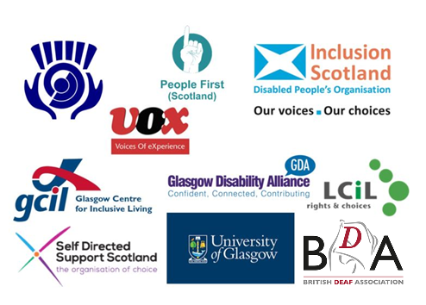

Inclusion Scotland

People First Scotland

Self-Directed Support Scotland

Glasgow Disability Alliance

Lothian Centre for Inclusive Living

Glasgow Centre for Inclusive Living

Voices of Experience

British Deaf Association

Scottish Council on Deafness

Professor Nicholas Watson, University of Glasgow**.**