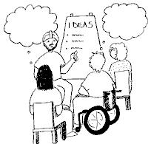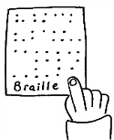MC900351591[1]

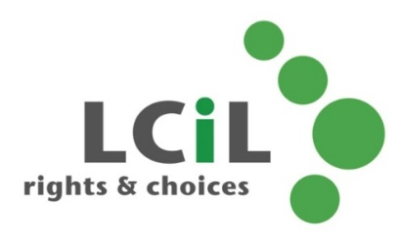

**Lothian Centre for Inclusive Living**

Every workshop includes a talk from one of the LCiL Champions – disabled people who share their own experience of the topic

Workshops run from 10.30am to 12.30 or 1pm,

with lunch afterwards

Refreshments and lunch are provided, and we

can organise and pay for transport if you live in Edinburgh or the Lothians.

**Are you a disabled person or someone with a long-term condition?**

**Do you want to:**

* learn new skills?
* increase your knowledge?
* meet new people?
* increase your confidence?

**in a relaxed and friendly atmosphere…**

**…then come along to a workshop or peer support group!**

**For more information and dates of the next LCiL workshops and peer support groups**, contact Emma Wynack:

**0131 475 2554**

[emma.wynack@lothiancil.org.uk](mailto:emma.wynack@lothiancil.org.uk)

Information is available on request in a range of formats:

**Audio Braille Easy words Large Print**

For more information about LCiL services, contact:

0131 475 2350

[lcil@lothiancil.org.uk](mailto:lcil@lothiancil.org.uk)

[www.lothiancil.org.uk](http://www.lothiancil.org.uk)

Lothian Centre for Inclusive Living

Norton Park, 57 Albion Road

Edinburgh, EH7 5QY

(our offices are fully accessible, with parking available)

**Getting in touch**

**Workshops and**

**peer support groups**

LCiL is a registered charity number SC017954

Pictures from CHANGE Picture Bank & London People First

**‘Have you tried God,**

**or snake venom?’**

…are you tired of getting asked questions like this?

**Assertive communication**

**What will I learn about?**

* aggressive and passive communication and their effects
* assertive communication and how to use it – and you’ll get the chance to try it out
* how to make a case to get something changed, and to communicate this assertively
* feelings and their effect on confidence
* how to reflect on a situation that didn’t go so well and have another go at it

**Note:** this workshop is in two parts, about a fortnight apart. You’re welcome to come to part 1 only, or both parts.

**What will I learn about?**

* the social model of disability, explained by a disabled person
* dealing with your own response to people trying to be ‘helpful’
* how to turn the conversation around to educate or change attitudes – you’ll get the chance to replay a situation from your own life, if you want to

**Know your rights**

**What will I learn about?**

* the social model of disability and how it relates to human rights, explained by a disabled person
* what your rights are around benefits and social care support
* where and how to get support
* when to ‘do it yourself’ and when to get support
* where to go for support/advocacy with accessing benefits and services
* when and how to complain

**Peer support groups**

Groups are organised and facilitated by LCiL staff, but owned by the group members, who meet to:

* discuss issues and share information
* find out practical information, resources and information on who to ask
* develop skills and build confidence
* hear from guest speakers and organisations on a range of topics, picked by the group

There are two groups, which both meet once a month:

* **Edinburgh** – for people who live in Edinburgh, Midlothian or East Lothian
* **West Lothian** – for people who live in West Lothian