*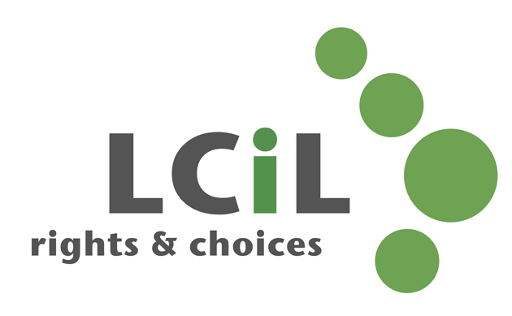MC900351591[1]*

**Grapevine**

**0131 475 2370**

(Mon-Thur, 10–4)

[grapevine@lothiancil.org.uk](mailto:grapevine@lothiancil.org.uk)

**0131 475 2350** (10am – 4pm)

18001 0131475 2383 (text direct)

[lcil@lothiancil.org.uk](mailto:lcil@lothiancil.org.uk)

or visit our website:

[**www.lothiancil.org.uk**](http://www.lothiancil.org.uk)

 Find us on Facebook  
 Follow us on Twitter

Information is available on request in a range of formats:

**Audio Braille Easy words Large Print**

**Getting in touch**

LCiL is a registered charity number SC017954

Pictures from CHANGE Picture Bank & London People First

**What we do and our services**

To find out more, contact us at:

**Lothian Centre for Inclusive Living**

Norton Park, 57Albion Road

Edinburgh, EH7 5QY

(our offices are fully accessible, with parking available)

LCiL works with disabled people, people with long-term conditions and older people, parents and carers in Edinburgh and the Lothian’s.

We support people to:

* live more independently
* be more in control
* use self-directed support

**Lothian Centre for Inclusive Living**

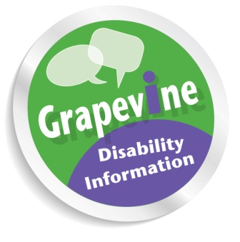

Free, confidential disability information and advice to people in Edinburgh and East Lothian.

**About us**

We are a user-led disabled people’s organisation, and a registered charity.

We’re part of the Independent Living Movement and we work with disabled people to take control of their own lives, support their choice to take up their rights and enable their full participation in society.

Our services are designed and delivered by disabled people.

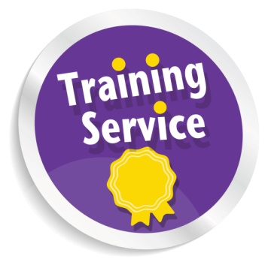

For individuals or organisations, on topics such as Disability Equality and self-directed support.

Skills training for disabled employers and PAs.

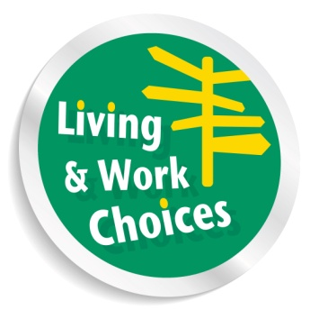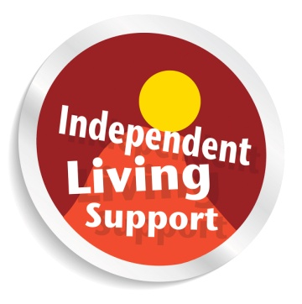

A group of service users who’re trained and supported to share their lived experience of independent living, self-directed support, LCiL services and peer support.

Free courses to help you explore options for the future, and gain practical skills for independent living if you’re a disabled adult in the Lothian’s.

**Wages processing** and administration if you employ your own personal assistants (PAs).

**Financial Management Service** to help you budget and plan, make payments and manage paperwork.

Information and advice to individuals and employers on **Access to Work** – a UK Government programme providing practical and financial support to enable people to start or remain at work.

Providing you with information and one-to-one support to manage your own self-directed package.