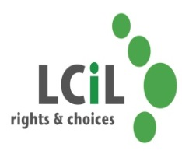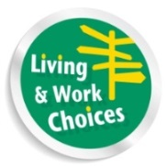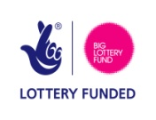

**Are you a disabled person or have a long term health condition & live in the Lothian area?**

**Do you want to become more confident and positive about your future?**

**Then book a place on our Living & Work Choices Course**

**On**

**22nd, 25th, 29th August & 1 Sept 2016**

Lothian Centre for Inclusive Living is running a series of four day courses covering a range of topics aimed at supporting disabled people and people with long term conditions to maximise their potential and participation in community life. Course topics include Session one: Personal Development (Confidence Building etc.), Session two: Equality, Session three: Self Directed Support & Planning for the Future, Session Four: A Working Life.

**C:\Users\elspeth.ferguson\AppData\Local\Microsoft\Windows\Temporary Internet Files\Content.IE5\3GIR52RI\MC900320976[1].wmfC:\Users\elspeth.ferguson\AppData\Local\Microsoft\Windows\Temporary Internet Files\Content.IE5\3GIR52RI\MC900320976[1].wmf**LCIL invite you to our next FREE Living & Work Choices course at Norton Park Centre on 22nd, 25th, 29th August & 1 Sept 2016 10.30-3.30pm (lunch included)

To find out more & to register your interest please:

Telephone Kelly or Eleanor at LCIL on 0131 475 2350

Email either [kelly.jack@lothiancil.org.uk](mailto:kelly.jack@lothiancil.org.uk) or

[Eleanor.Docherty@lothiancil.org.uk](mailto:Eleanor.Docherty@lothiancil.org.uk)

**Transport can be arranged if required**