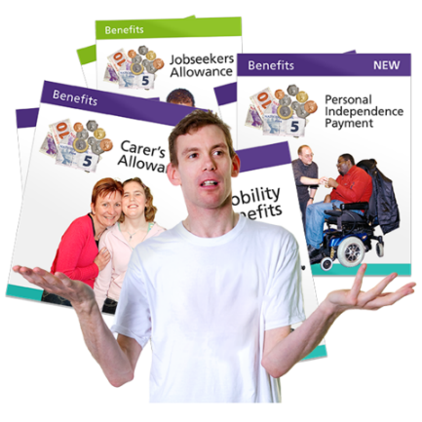
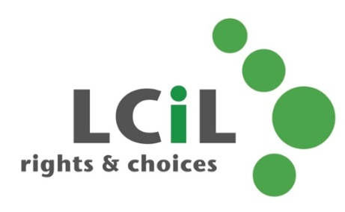
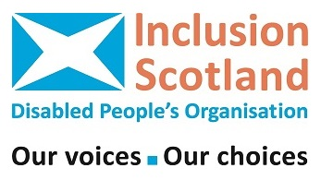
Purpose for the Powers: the future for Social Security in Scotland

SAVE THE DATE:
Wednesday, 22 June 2016

Registration 10:30am Event starts 11:00am

Event ends 4.00 pm

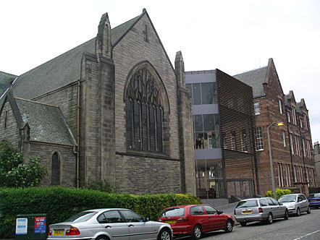
Where?
Norton Park Conference Centre,
57 Albion Road
Edinburgh
EH7 5QY

The event space is fully accessible. Car parking available. The event is FREE. Lunch and reasonable travel costs provided.
HAVE YOUR SAY on the new social security powers

Over half of the £22 billion of the cuts to benefits between 2010 - 2015 fell on disabled people and their families.

Disabled people are made to go through lots of assessments for their benefits. This can be stressful and upsetting.

The new Scottish disability benefit system should be designed with the help of disabled people. This is called co-production.

We will discuss:
- How the new system can be used to support disabled people?
- Disabled people’s needs?
- Extra costs?
- Barriers?
- What do dignity and respect mean to you?
- What other values should be used?
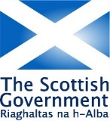
The Scottish Government will also be there to listen to your views and answer any questions.

To book your FREE place,
call Janice at inclusion Scotland 0141 559 5025
e-mail events@inclusionscotland.org
Register online at http://purposeforthepowers.eventbrite.co.uk
Remember to tell us if you have any access, communication or dietary needs.

