Know your rights workshop

Are you a disabled person, or someone with a long-term condition?

Do you want to:
- Improve your knowledge of your rights
- Increase your ability to self-advocate?
- Learn how to make a complaint if your rights aren’t met?
…and would you like to:
- meet new people?
- increase your confidence?

in a relaxed and friendly atmosphere…
…then come along to our workshop!

Where and When?

Know Your Rights Workshop
10.30am – 1.30pm, Wednesday 18th May 2016
Training Suite
Norton Park Conference Centre, Albion Road, Edinburgh EH7 5QY
At this workshop we’ll cover:
- the social model of disability
- where, when and how to get support
- where to go for support/advocacy with accessing benefits and services

Lunch and refreshments will be provided,
and if needed we can organise and pay for transport if you reside in Edinburgh or the Lothians .

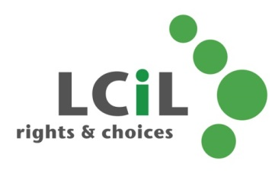

To find out more and to book, contact:
Emma Wynack at LCiL on 0131 475 2554
or email emma.wynack@lothiancil.org.uk

