Assertive communication workshops

Are you a disabled person, or someone with a long-term condition?
Do you want to learn how to:
- be more assertive?
- give yourself the best chance of getting what you need
by preparing well for meetings or assessments?
- challenge decisions?

…and would you like to:
I’d like …
- meet new people?
- increase your confidence?

in a relaxed and friendly atmosphere…
…then come along to our workshops!

There will be two sessions:

Assertiveness 1
10.30am – 1.30pm, Wednesday 8th June 2016
Norton Park Conference Centre, Albion Road, Edinburgh EH7 5QY

At this workshop we’ll cover different ways of communicating and their effects, and you’ll have a chance to think about and plan how to make a case for something you need.

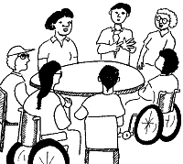
Assertiveness 2
10.30am – 1.30pm, Wednesday 22nd June 2016
Norton Park Conference Centre, Albion Road, Edinburgh EH7 5QY

This workshop will give you the chance to discuss how you used what you learned in Assertiveness 1 and to take your skills further.

Please note: you must do Assertiveness 1 before you do this workshop.

It’s great if you can come to both, but you’re welcome just to do Assertiveness 1 on its own.
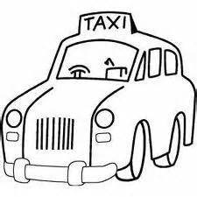
Lunch and refreshments will be provided,
and if needed we can organise and pay for transport if you reside in Edinburgh or the Lothians .

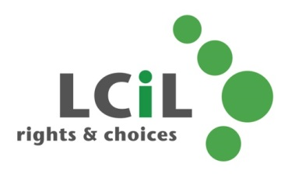

To find out more and to book, contact:
Emma Wynack at LCiL on 0131 475 2554
or email emma.wynack@lothiancil.org.uk

