The United Nations Convention
on the Rights of People with Disabilities
What does it mean for you?

Easy read

What is in this booklet page

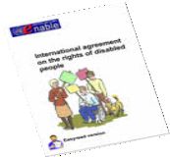
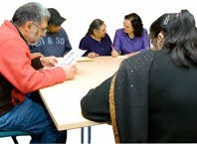
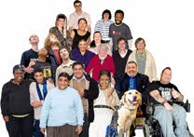
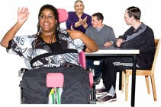
About this booklet 1
What do we mean by rights? 3
What the government has to do 5
Checking that people get their rights 6
How the Convention will help
disabled people
8
Using the Convention to change things 9
Getting involved in checking and reporting
what is happening
15

What is in this booklet page

Making a complaint if you think the
agreement has been broken
17
The Articles of the Convention 21

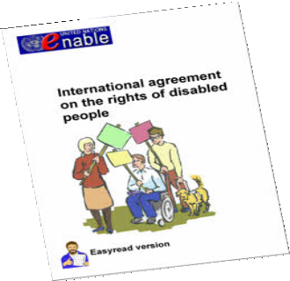
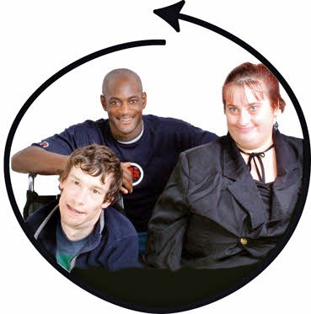

About this booklet

This booklet is about the United Nations Convention on the rights of people with disabilities.

The Convention is an agreement between different countries.

Rights are things that should happen for everyone.

Countries who sign the agreement must make sure disabled people get their rights.

1

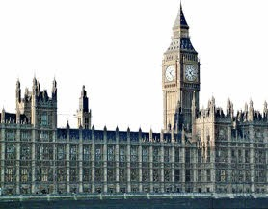
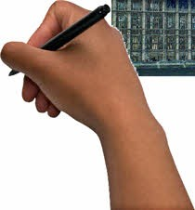
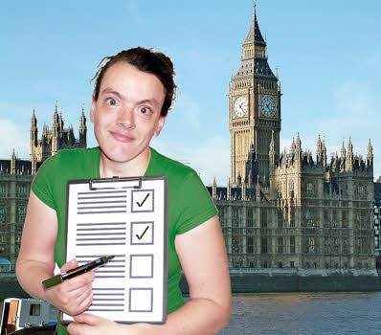
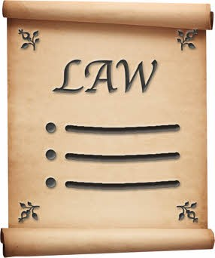
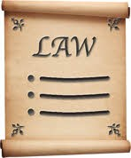
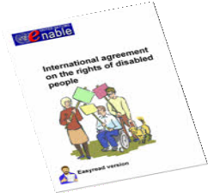
The United Kingdom government signed the agreement in 2007.

In June 2009 it was ratified. This means the government must now stick to the agreement.

The Convention does not give you new legal rights.
x

But it can be used with the laws we already have in each country to change things for disabled people.
+

2

What do we mean by rights?

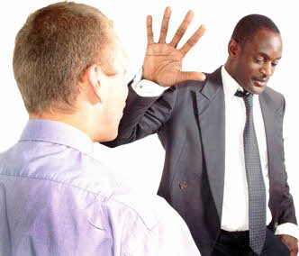
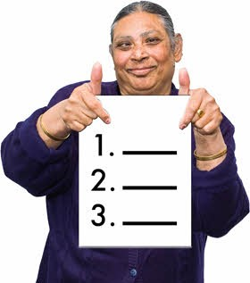
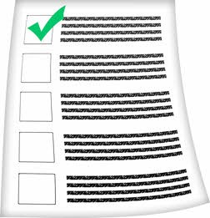
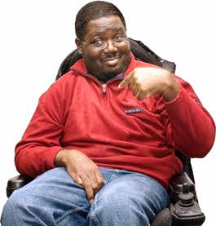
The Convention says countries will not treat people differently or unfairly because of their disability.
x

It does not give disabled people any new rights.
x

But it does say what countries should do to make sure disabled people get the same rights as everyone else.

These include the right to:

- life

- have the same chances and rights at work as other people

3

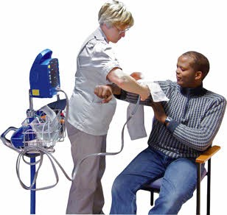
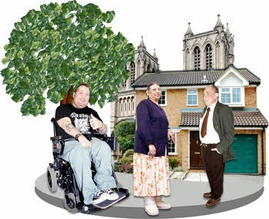
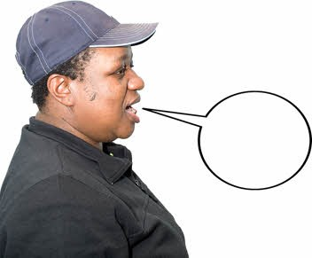
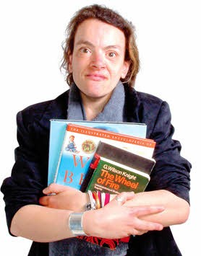
- have the best possible health

- live in the community

- say what you think

- go to school, college or university.

There is a full list of the rights on
page 21 of this booklet.

4

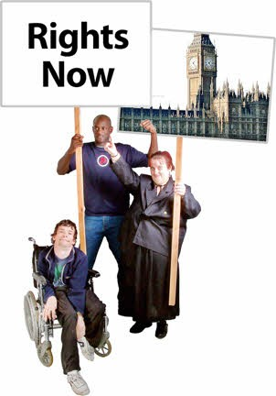
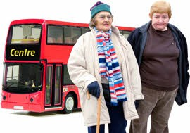
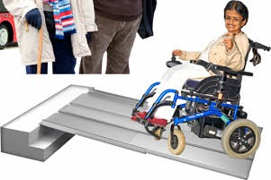
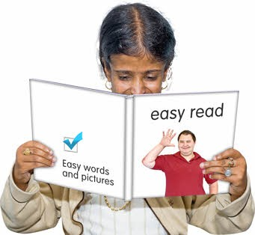

What the government has to do

The government must make sure disabled people get the rights listed in the Convention.

Different parts of the government and public organisations must work together to:

  - make sure disabled people can use transport and services and get into buildings

  - produce information in ways that disabled people can use and understand

  - make sure disabled people have the same chances and rights at work as other people

5

- make sure disabled people have a choice where they live.

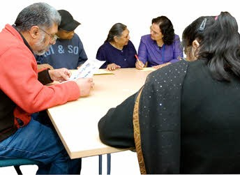
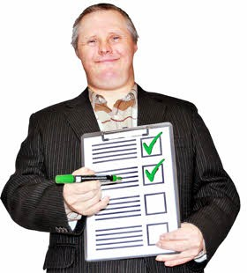
Checking that people get their rights

Every country must have an independent organisation to speak up for the rights of disabled people.

In England, Scotland and Wales this is the Equality and Human Rights Commission.

In Scotland, the Scottish Human Rights Commission also does this job.

They will check the government sticks to the agreement.

6

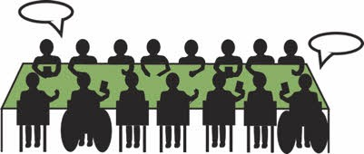
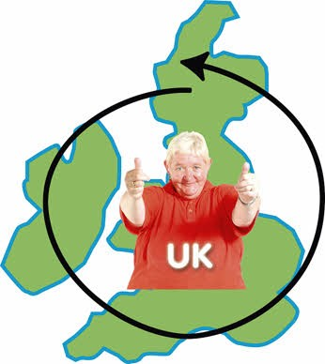
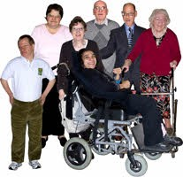
The United Nations Committee on the Rights of Persons with Disabilities will check that all the different countries stick to the agreement.

The United Kingdom government must tell this committee how they are making things better for disabled people in the United Kingdom.

The Equality and Human Rights Commission and disabled people and their groups will also send reports to the committee.

The Scottish Human Rights Commission will also send a report to the committee.

7

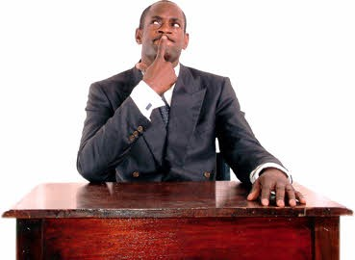
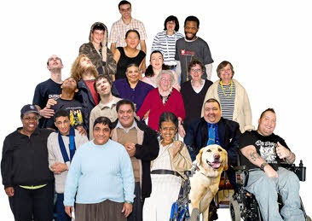
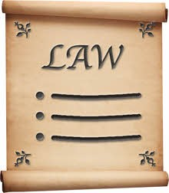
How the Convention will help disabled people

Governments and public organisations will have to think about the rights of disabled people when they plan or run services.

It will make everyone else think about the rights of disabled people.

Disabled people or organisations can use it to help them make the laws for disabled people stronger.

There are some times when people can make a complaint to the United Nations Committee.

The United Nations Committee will look at reports from the different governments and suggest ways that they could do things better.

8

Using the Convention to change things

There are different ways disabled people and organisations can use the Convention to change things.

Making sure people know what the agreement says about their rights

This includes:

- telling other disabled people about it

- reminding public organisations like schools, the police or hospitals about it.

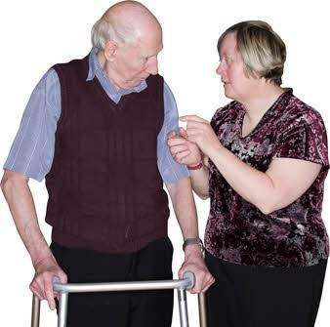
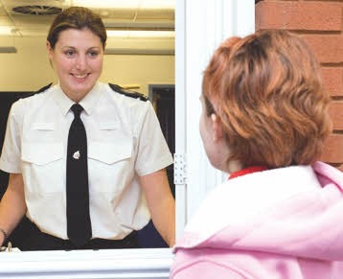
9

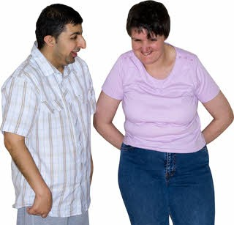
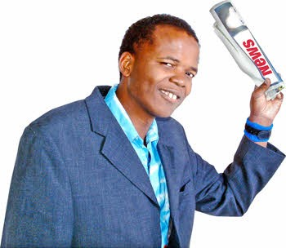
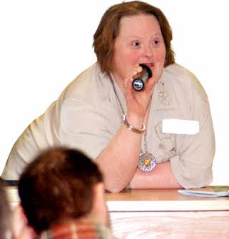
People could do this through:

- talking to people

- websites

- newsletters or newspaper articles

- asking people to speak about it at meetings

- plays or films.

10

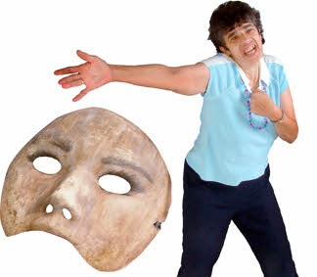
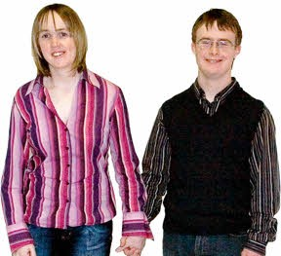
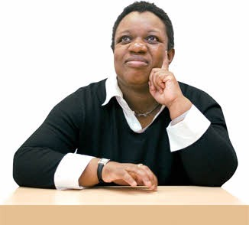

For example:

A play about a disabled woman in a care home who wants to get married was performed at a big conference.

Staff at the home did not respect her rights to:

  - marry

  - decide where to live

  - decide who to live with.

Using a real story helped staff working in health and social care to think about these rights.

11

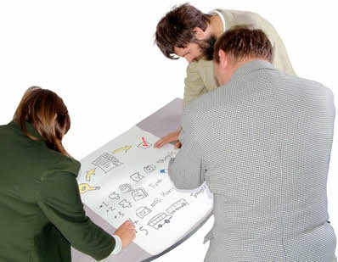
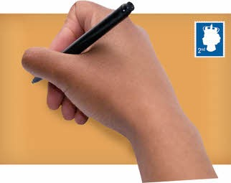
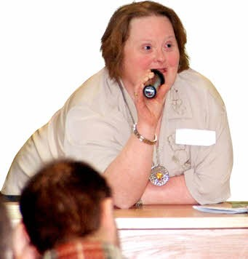
Making life better for disabled people

If people know what the Convention says, they can use it to change the way organisations plan things or make decisions.

You can do this by:

- writing letters

- speaking at public meetings

- writing reports

12

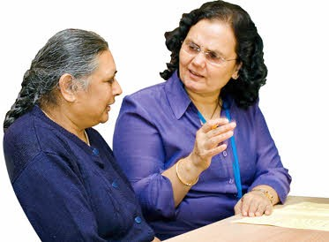
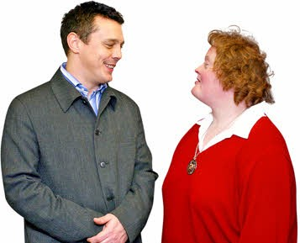
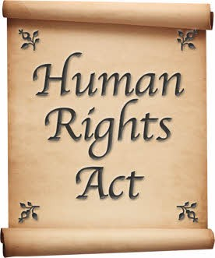

- talking to your local MP

- telling local services how the things they do affect disabled people

- using the Convention with laws like the Human Rights Act.

For example:

A disabled woman needed a special type of bed but was told she could only have a single bed.

This meant she could not sleep next to her husband.

13

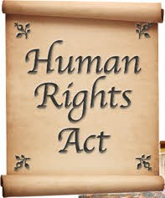

She used the Human Rights Act and her right to private and family life to change things.

She was given a double bed.

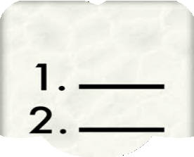
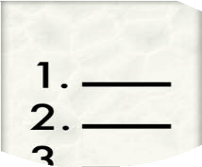
The important thing is to:

- decide which right in the Convention you are talking about

- say how the organisation is not meeting this right
x

- be clear about how they could change things.

14

Getting involved in checking and reporting what is happening

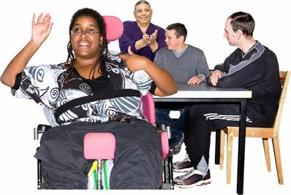
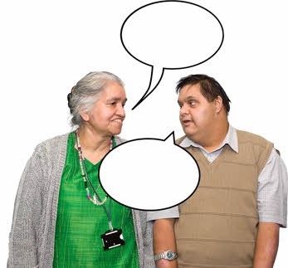
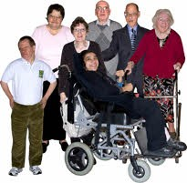
The Convention says governments must involve disabled people in checking they stick to the agreement.

This must be real involvement where people have a real say over what happens.

One way to do this is through shadow reports.

These are reports to the United Nations Committee that checks how governments are doing.

15

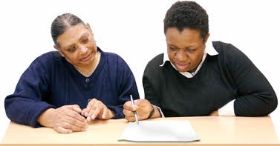
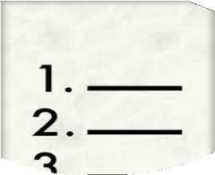
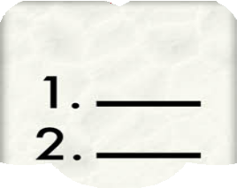
There is information about how to write a shadow report on the International Disability Alliance website:

www.internationaldisabilityalliance.

It is often better if disabled people join together to write one big report, instead of lots of separate reports on the same thing.

You could also write informal reports
to tell other people what is happening.

Again, it is really important to say:

- which rights you are talking about

- why you think people have broken
x the agreement.

16

Making a complaint if you think the agreement has been broken

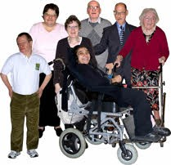
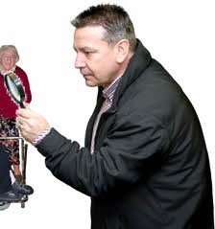
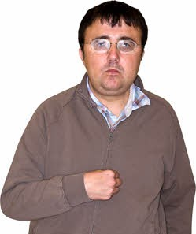
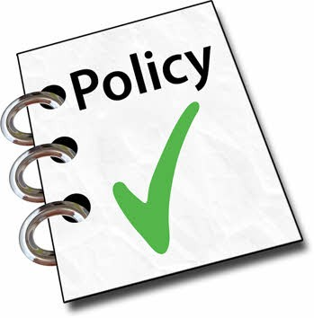
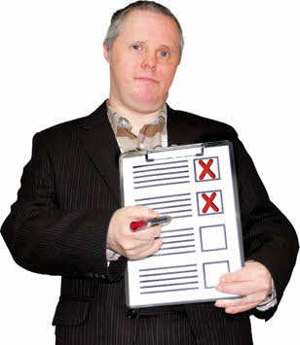
The United Nations Committee can look at what is happening for groups of disabled people.

It can also get involved sometimes if an individual person has not been given their rights.

There are rules about how you must do this.
Rules

You have to show that you have tried every other way of sorting things out.

17

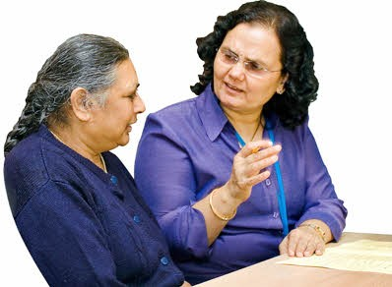
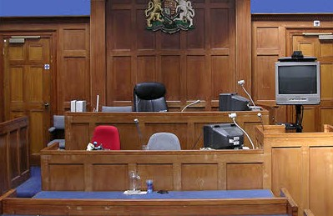
This includes:

- talking to the person or organisation you think should change things

- complaining to the organisation if you think they are not doing what they should

- contacting an organisation like the Care Quality Commission that checks services

- talking or writing to your local councillor, MP or disability group

- going to court in the United Kingdom, if there is a law about the problem.

18

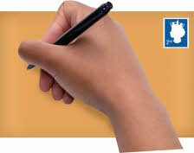

Going to court can be expensive.

You should talk to the Equality and Human Rights Commission first.

You can write to them at:

Freepost RRLL-GHUX-CTRX Arndale House
Arndale Centre Manchester M4 3AQ

Telephone:

08456 046 610

Textphone:

08456 046 620

Fax:

08456 046 630

Email:

englandhelpline@equalityandhumanrights.com

19

Rules

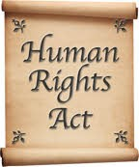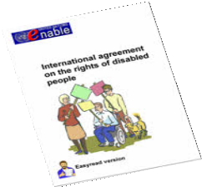
Remember:
+
The Convention is not a law but it can
help you to use other laws like the Human Rights Act to change things.
If you have tried everything else, you
can complain to the United Nations Disability Committee.

There are lots of rules about how to do this.

You can find out more by talking to the Equality and Human Rights Commission or:

Emailing:

crpd@ohchr.org

Writing to:

CRPD secretariat UNOG-OHCHR CH1211
Geneva 10 Switzerland

Looking on their website:

www.tinyurl.com/DisabilityCommittee

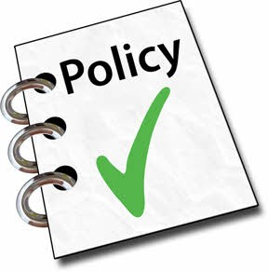
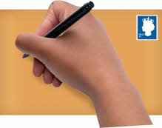
20

If you want to know more

The UN Enable website is all about the Convention on the Rights of People with Disabilities:

www.un.org/disabilities

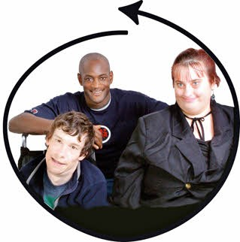
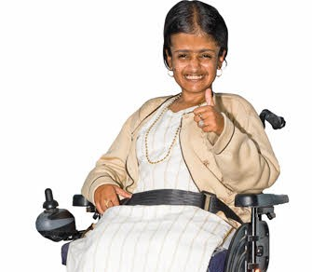
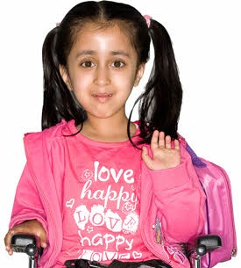
The Articles of the Convention

Here is a list of the rights in the Convention. These are known as Articles.

Article 5.
Being equal.

Article 6.
Disabled women being treated equally.

Article 7.
Disabled children being treated equally.

21

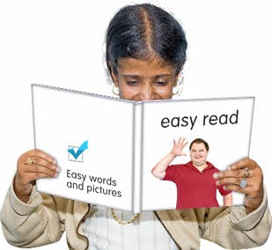
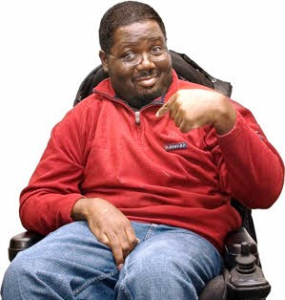
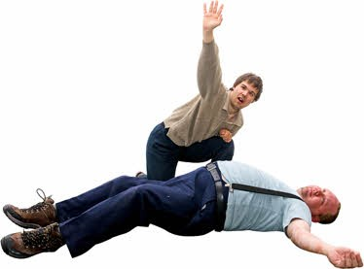
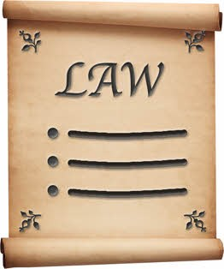
Article 8.
Making everyone aware that disabled people have the same rights as everyone else and showing them what disabled people can do.

Article 9.
Accessibility. Making sure disabled people have better access to things in all areas of life.

Article 10.
Right to life.

Article 11.
Emergencies. Making sure that disabled people are properly protected when there are risky situations for everyone, for example when floods happen.

Article 12.
Being treated equally by the law.

22

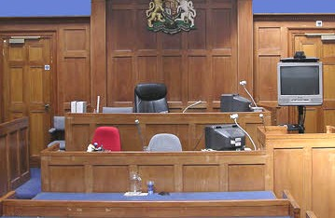
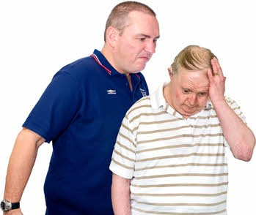
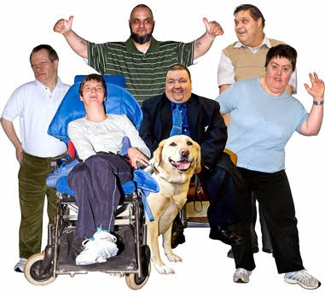

Article 13.
Getting justice.

Article 14.
Disabled people should be free and safe, the same as everyone else.
Disabled people should not be locked up just because they are disabled but only if the law says so for other reasons.

Article 15.
Not being tortured or treated cruelly.

Article 16.
Not being used or abused.

Article 17.
Treating disabled people as people first. Disabled people should be treated like anyone else, with the same respect and rights as others.

23

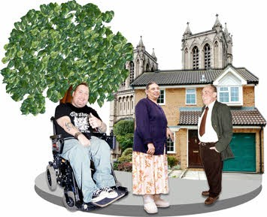
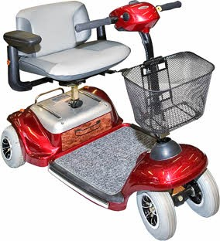
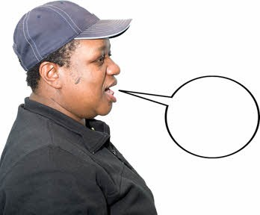
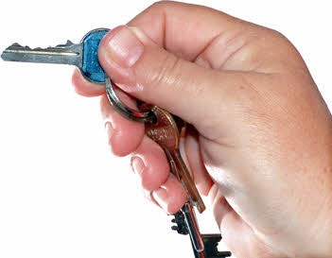
Article 18.
Moving around. Being able to move between countries and live where you want without discrimination.

Article 19.
Independent living and being part of the community. Disabled people have the same right as everyone else to live where and with who they want.

Article 20.
Getting about.

Article 21.
Saying what you want and access to information.

Article 22.
Right to privacy.

24

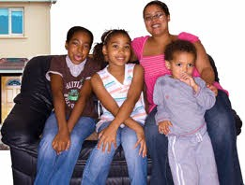
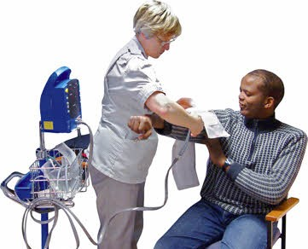
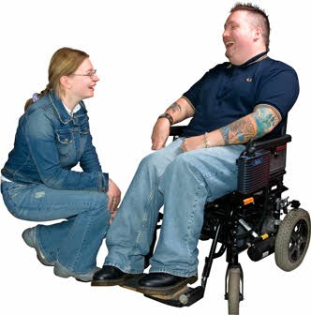

Article 23.
Respect for the home and the family. Making sure that disabled people have equal rights to marriage, a family and personal relationships.

Article 24.
Right to education.

Article 25.
Health. Making sure disabled people have the right to the best possible health and access to health services including family planning.

Article 26.
Services to help you be independent.

Making sure disabled people can lead an independent and healthy a life as possible and providing support in health, work, education and social services to help that happen.

25

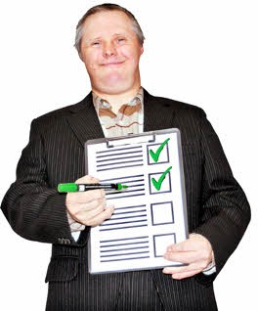
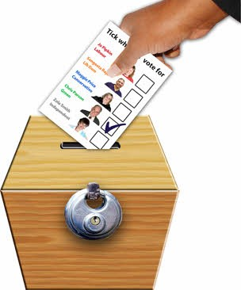
Article 27.
Having the same chances and rights at work as other people.

Article 28.
Standards of living. Disabled people should be able to get help to improve their standard of living the same as everyone else.

Article 29.
Being involved in politics.

Article 30.
Right to take part in sports and leisure.

26

Credits
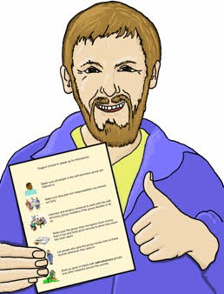
This paper has been designed and produced for the Equality and Human Rights Commission by the EasyRead service at Inspired Services Publishing Ltd. Ref ISL078/10. June 2010.

To contact Inspired Services:

www.inspiredservices.org.uk

27

Find out more about us and your rights

28

from our website www.equalityhumanrights.com

Telephone 1 of our helplines.

- They are open Monday to Friday 8am to 6pm.

England
• 08456 046 610
• Textphone 08456 046 620
• Fax 08456 046 630

Wales
• 08456 048 810
• Textphone 08456 048 820
• Fax 08456 048 830

Scotland
• 08456 045 510
• Textphone 08456 045 520
• Fax 08456 045 530

© Equality and Human Rights Commission
Published July 2010
ISBN 978 1 84206 280 7

