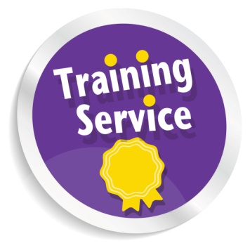**Participant Feedback:**

****“I found it informative from start until the end! Great time!!!”

Introducing

Essential Employers Skills

&

Training 4 Personal Assistants (T4PAs)

Training

🟋🟋🟋🟋🟋🟋🟋🟋🟋🟋🟋

Essential Employer Skills: 9th & 10th December 2015

Training 4 Personal Assistants (T4PAs): 9th & 10th December 2015

🟋🟋🟋🟋🟋🟋🟋🟋🟋🟋🟋

This is a unique opportunity for both PAs and PA Employers to

undertake training in different spaces at the same time.

On the last day of both courses everyone will come together

to share knowledge and experiences

“I was not thinking of becoming a PA until I came on the

course with my partner but, now I am full-time PA and I

love my Job”

“Everyones experience was useful”

“It just came at the right time”

“I Feel supported, not alone”

**Are you eligible for ILA funding?  If so, you can use it**

**to pay for the T4PA course.**

To find out more, visit [www.myworldofwork.co.uk](http://www.myworldofwork.co.uk)

or visit the LCIL website Now!

[www.lothiancil.org.uk](http://www.lothiancil.org.uk) for ILA 200 Eligibility Criteria.

For non-ILA holders, the cost will be £195 for the two days

(there are a limited number of Big Lottery funded places

available for those who **cannot** access any other funding)

****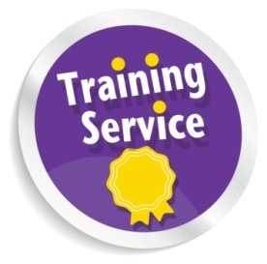** Thinking about becoming a PA?**

**FREE Essential PA Employer Skills Training! Or**

**Want to brush up on your PA skills?**

Are you a disabled person or a person with long-term This course will enhance your prospects of employment

condition? as a PA or, if you are already a PA, helps you to be more

Thinking about employing Personal Assistant(s) to support effective in your role

you?

Or, if you are already a PA employer, want to refresh your Topics covered include:

employer skills? **Disability and Equality**

The **Essential Employer Skills** is a 3 day course that **Social Model of Disability**

provides disabled employers of Personal Assistants with an **Understanding the importance of appropriate** l**anguage**

understanding of the essential responsibilities and roles **Exploring roles and relationships**

required of a good employer. **Knowing the Relationship Boundaries**

**Exploring potential dilemmas**

**When:** **9th & 10th December** **2015! 10.30am-3.30pm Responding to Your Employer’s Needs**

**LUNCH PROVIDED**  **When:** **9th & 10th December 2015! 10.30am-4.00pm**

**TRANSPORT CAN BE ARRANGED IF REQUIRED Where:** **Norton Park, 57 Albion Road, Edinburgh**.

**Where:** **Norton Park, 57 Albion Road, Edinburgh**. **Cost: Please see overleaf (Lunch Provided)**

**To register your interest or for an informal chat,**

**please contact LCiL on 0131 475 2350 or email**

**either** [elspeth.ferguson@lothiancil.org.uk](mailto:elspeth.ferguson@lothiancil.org.uk)

or [kelly.jack@lothiancil.org.uk](mailto:kelly.jack@lothiancil.org.uk)

**For more info please email:**

[amanda.beech @lothiancil.org.uk](mailto:kelly.jack@lothiancil.org.uk)

**or phone Amanda Beech on** **0131 475 2510**

**www.lothiancil.org.uk**